Kia-Dealers
Dealers Admin User Manual
Table of Contents
1. Back-office Login 4
2. Dealer Management 7
Dealer List View 7
Dealer Creation Screen 9
Dealer Detail View /Edit Screen 26
3. Zone/District Management(Dealer Regional Management) 41
Zone/District Management View 41
Zone/District Creation, Modification, and Deletion 43
Excel Upload (Bulk Update) 44
4. Dealer Distribution Group Management 48
Dealer distribution group List View 48
Dealer Distribution Group Creation 49
Dealer Distribution Group Detail View 50
Dealer Distribution Group Editing 52
5. Holding Company Management 54
Holding Company List View 54
Holding Company Creation 55
Holding Company Detail View 56
Holding Company Editing 58
6. Job Management 60
Job List View 60
Job Creation 61
View Job 64
Job Editing 67
7. Dealer employee Management 68
Dealer Employee List View 68
Dealer Employee Creation 70
8. Menu Management 85
Menu List View 85
Menu Creation 87
Menu View 100
Menu Editing 102
Menu Deletion 105
9. Bulletin Board Management 107
Bulletin Board List 107
Bulletin Board Creation 110
Bulletin Board View 125
List Setting View 133
List Setting Editing 134
10. Post Management 137
Bulletin Board Search & Result 139
Post List View 141
Post Editing 163
Post View 170
11. Weekly Bulletin Summary Email Management 183
Bulletin Summary Settings 184
Bulletin Summary List View 190
12. Dealer User Change History 192
13. Dealer Employee Troubleshooting 196
14. Bulletin Post Report 203
15. HMG-Notice (Notifications, Terms of Use, and FAQ) 208

1. Back-office Login
Dealers Admin User Manual
- While connected to the VPN, access the URL: https://dealers-admin.kia-corp.io/ca
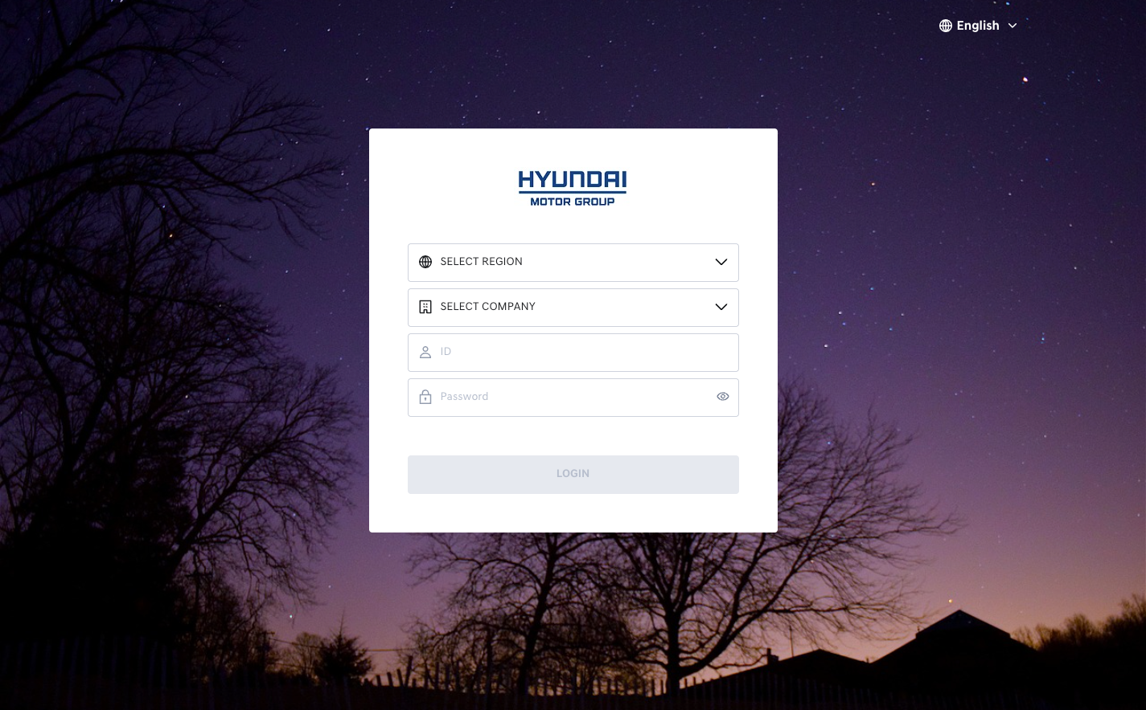
Login screen
On the login screen, proceed with the following steps:
- Select your region
- Select your company
- Enter your ID and password
- Click Login to sign in
- Select a project – Kia Dealers_BO
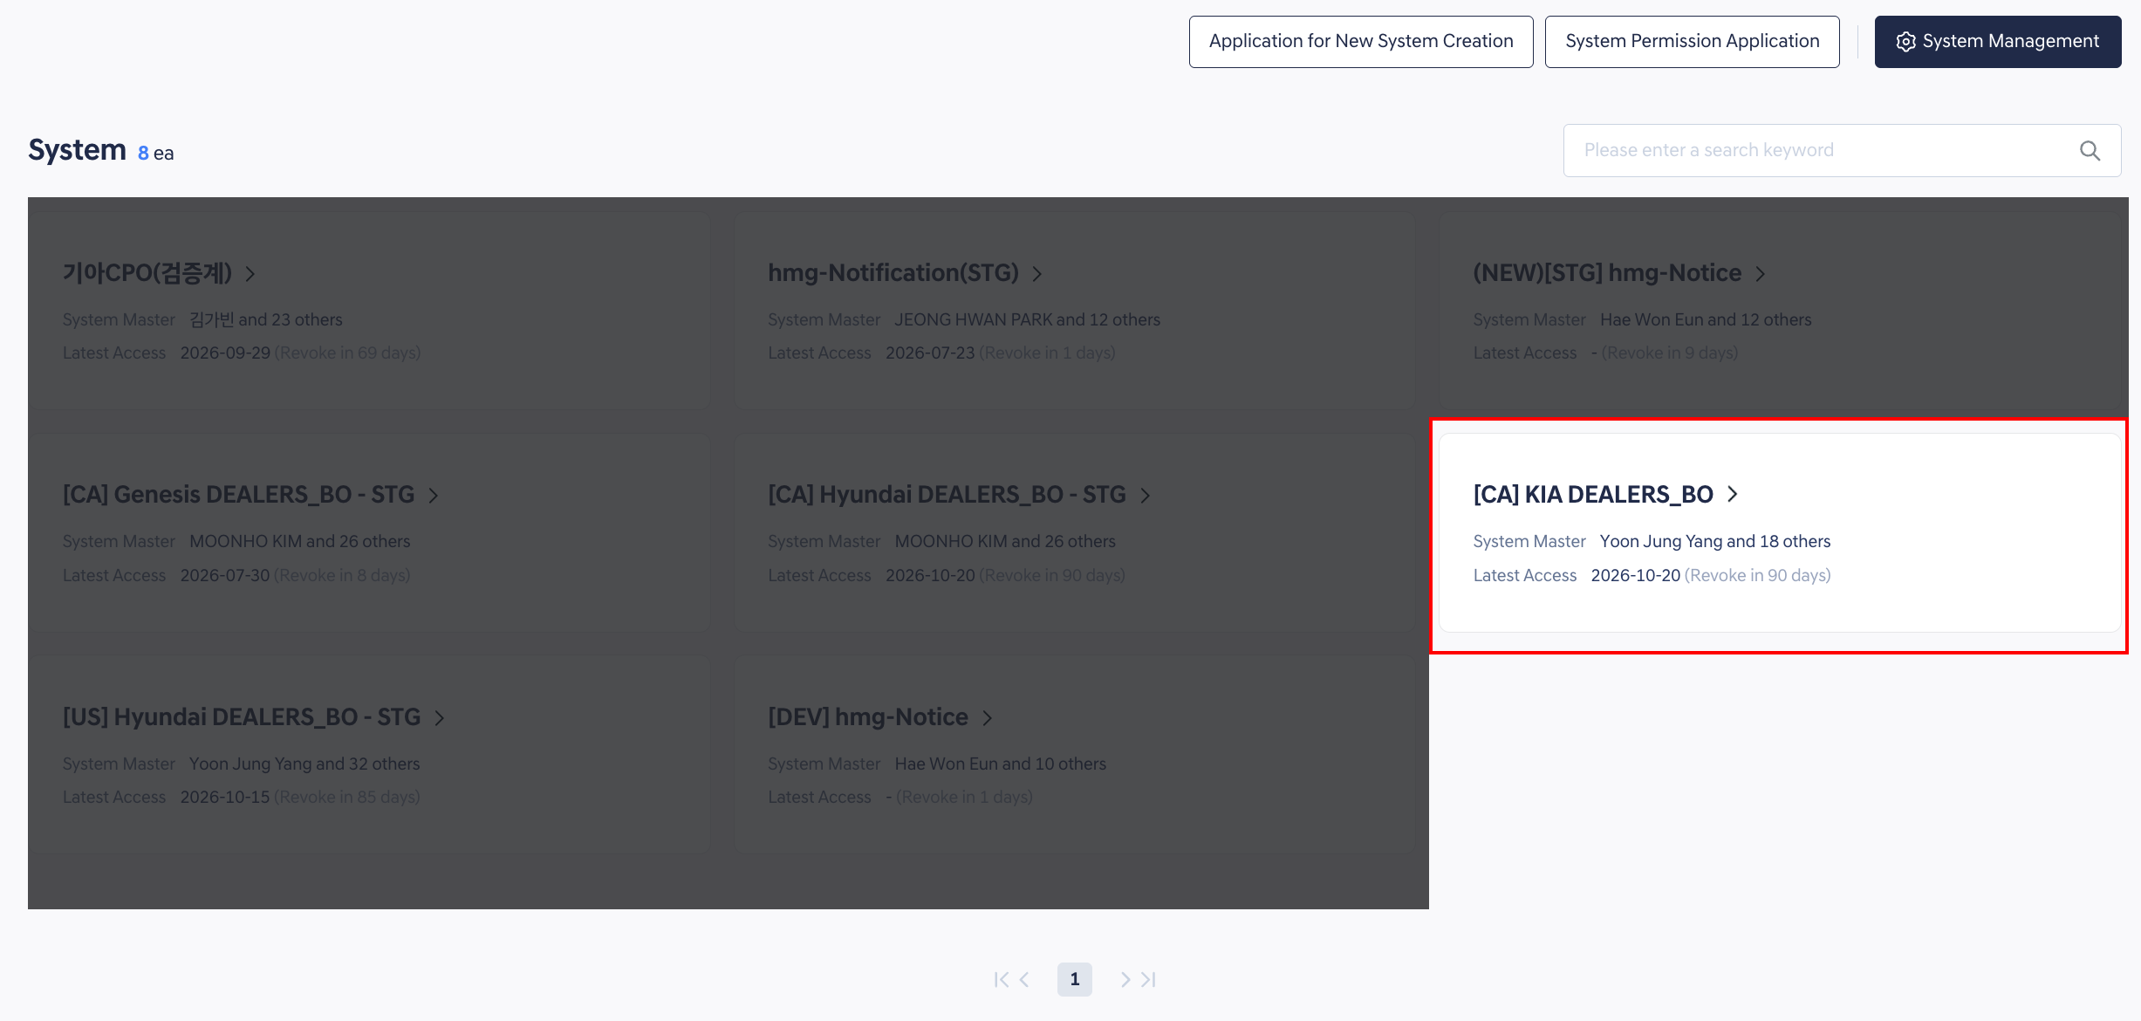
HMG Admin
Back Office Main Screen
HMG Admin Head area
- The project name is displayed at the top-right corner of the Back Office.
- To the right of the project name, the current user's Back Office role is shown.
- If the user has multiple roles, selecting one will display the menus and features associated with that role.
- Click Request to add new role to submit a request for additional role permissions.
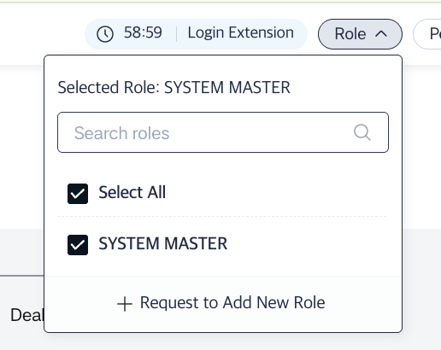
HMG Admin role
- The remaining time of the login session is displayed. If there is no activity for 60 minutes, the session will be automatically logged out. Click Login extension to extend the session by another 60 minutes.
- The current admin's language setting is displayed. The Back Office supports English and French by default.
- The affiliation and name of the logged-in user are displayed.
- A Settings button is available, where the user can log out.

2. Dealer Management

Dealer List View
- This screen provides a list of all registered dealers.
- You can create a new dealer, or view and edit details of existing dealers.
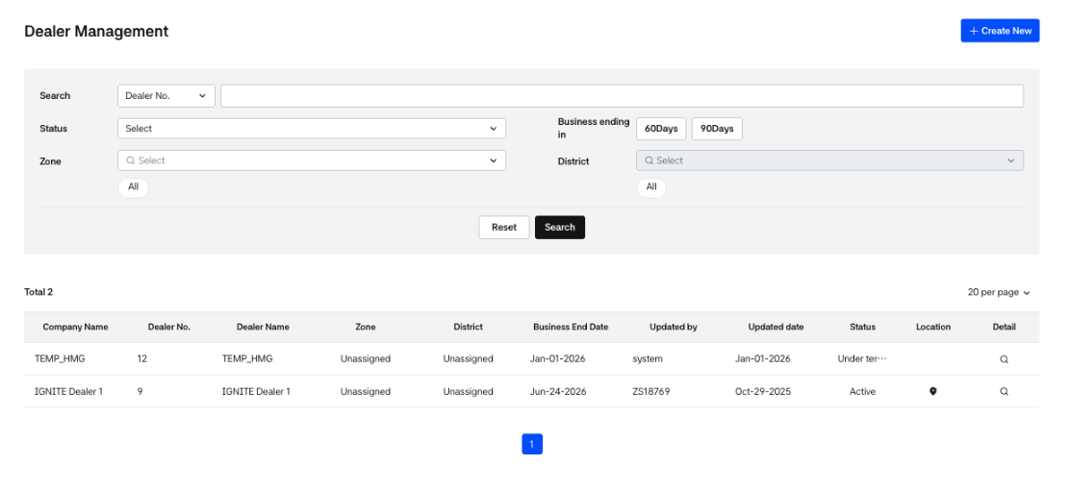
Dealer List
Dealer Information Columns
- Company name: The official dealer company name registered in HMG Partner.
- Dealer No.: Dealer Number managed within the Dealers system.
- Dealer name: The name of the dealer company.
- Zone: Indicates the dealer’s assigned zone. If no zone is assigned, it will be displayed as “Unassigned.”
- District: Indicates the dealer’s assigned district. If no district is assigned, it will be displayed as “Unassigned.”
- Business end date: The latest business end date among all business info associated with the dealer.
- Updated by: The ID of the user who created or last modified the dealer information.
- Updated date: The date the dealer was created or last modified.
- Status: Current status of the dealer.
  - Draft: Dealer creation in progress. Information is not yet finalized.
  - Active: Dealer is active and allowed to use services.
  - Inactive: Dealer is inactive and not allowed to use services.
  - Under termination: Dealer contract has expired, temporarily accessible.
  - Terminated: Dealer contract has expired and temporary access is also ended. The status automatically changes after 180 days from the Under termination status. Dealer employees belonging to the dealer cannot use the service.
- Click the Location icon to open a popup showing the registered address of the dealer.
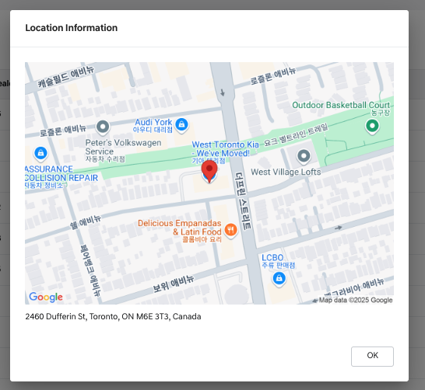
Location Popup
- Detail: Opens the detailed view of the dealer.
- If the dealer status is Draft, two additional icons are available:
  -  :Continue the dealer creation process (navigates to the edit screen).
  - :Delete the draft dealer. Deleted draft information cannot be restored.
- Click the [create] button at the top of the page to register a new dealer.

Dealer Search & Filters
- You can search for dealers by specific criteria.
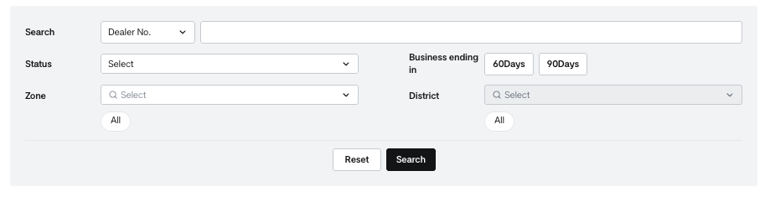
Dealer List - Search
- Choose one of the following fields to perform a keyword search:
  - Dealer No: Dealer number assigned by the Dealers system
  - Dealer name: Registered name of the dealer
  - Company no.: Dealer company number registered in HMG Partner
  - Company name: Official company name registered in HMG Partner
- You can filter dealers by Business end date:
  - View dealers whose business end date is within 60 or 90 days from today.
- You can filter by Status of the dealer.
- Click [Search] to apply the selected filters and view results.
- Click [Reset] to clear all filter conditions.

Dealer Creation Screen
- This screen is used to register a new dealer and consists of 4 steps in total.
- You can proceed to the next step without entering all required information, and it is possible to temporarily save the form with only partial information entered.
- During this process, the dealer's status becomes "Draft", and the dealer will appear in the Dealer List as a draft entry.
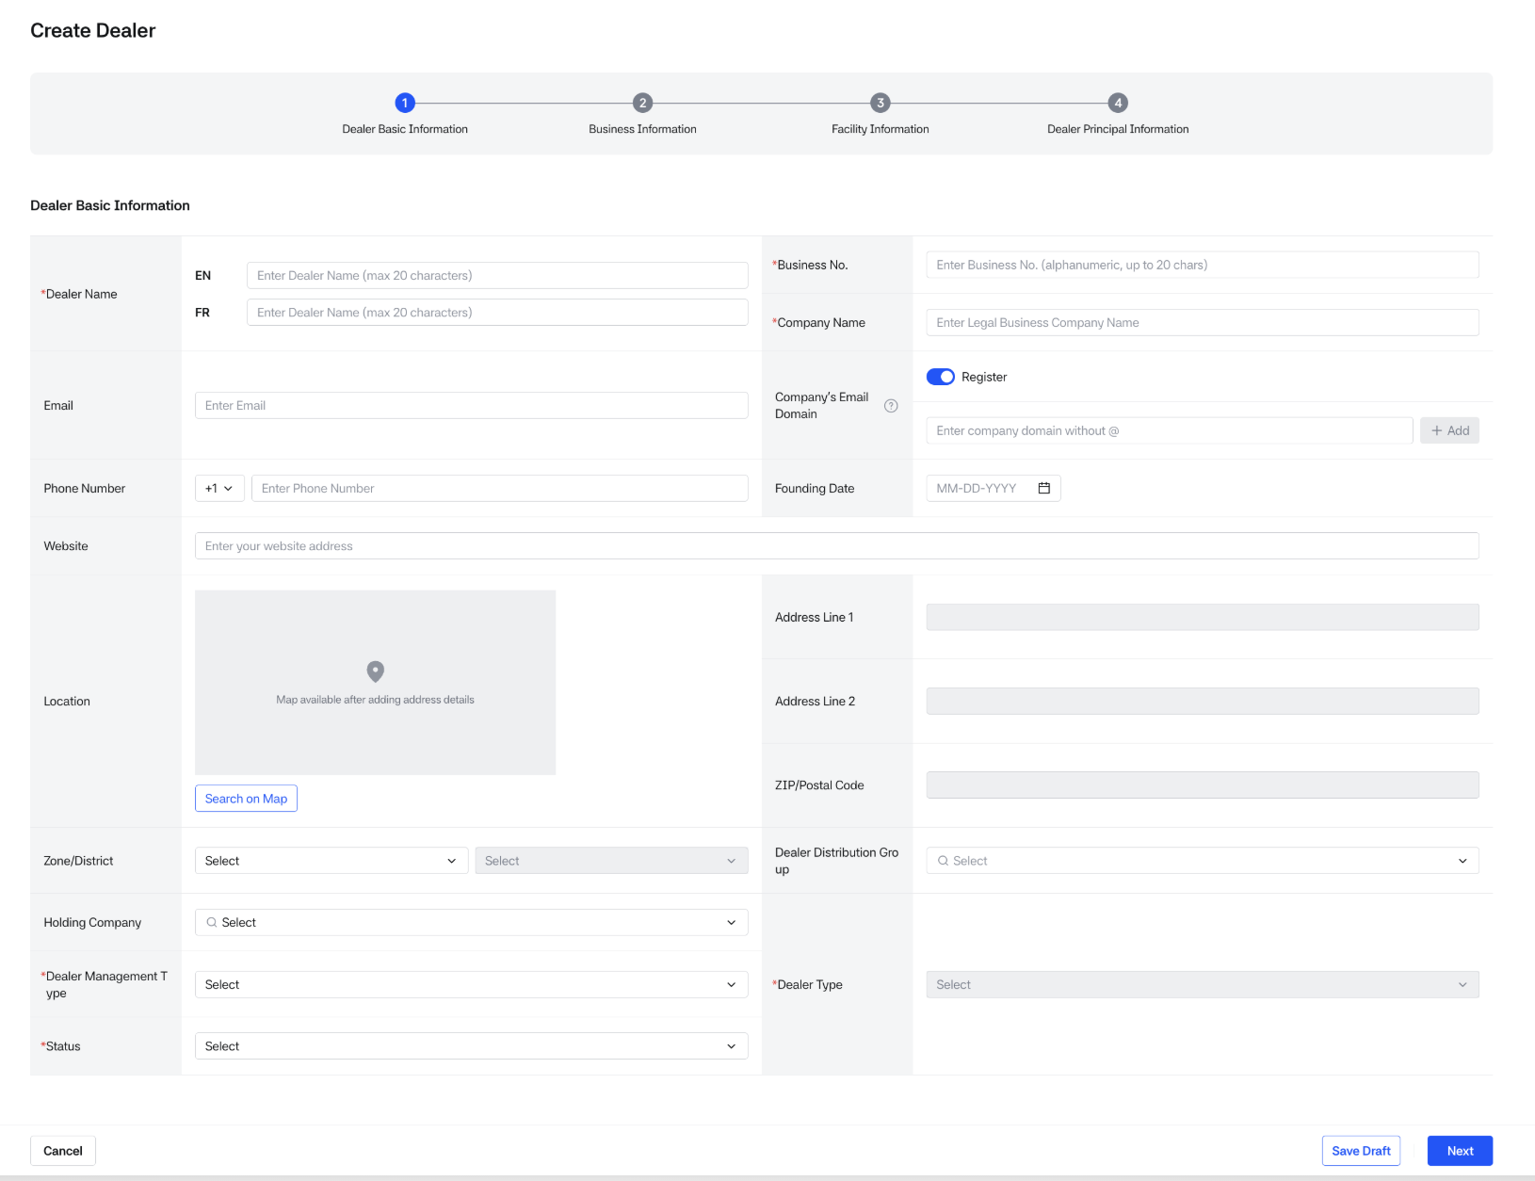
Creating Dealer- Basic Information

Dealer basic information
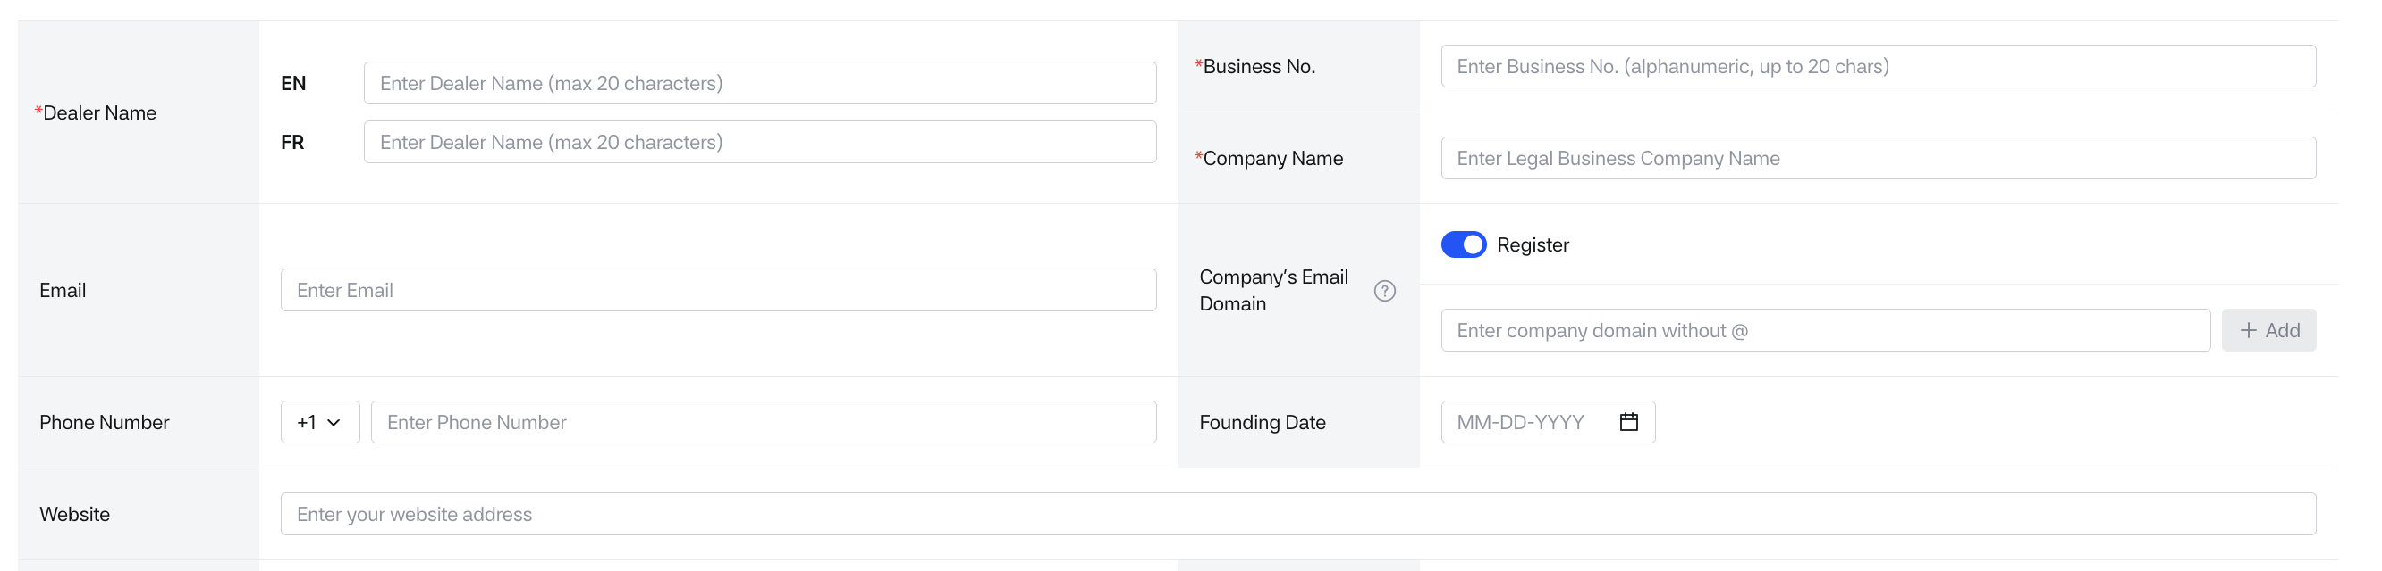
Dealer Basic Information1
- Dealer name:
  - Required field.
  - Internal name used for management purposes.
  - Fields available in both English and French.
  - Maximum 20 characters per language.
- Business No.:
  - Required field.
  - Must be an alphanumeric combination (English letters and digits), up to 20 characters.
  - Must be unique.
- Company name:
  - Required field.
  - Official name of the dealer company.
  - This is the name visible to end users on the front-end.
- Email:
  - Optional field.
  - Email address of the dealer company.
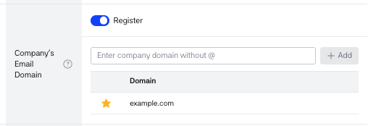
Company’s Email Domain
- Company’s Email Domain:
  - Optional field, used to manage the dealer's business email domains.
  - Decide whether to use company email domains for this dealer (default: On).
  - When On, register 1–20 domains in SLD.TLD format (e.g. canada.ca, max 30 characters) and set one default.
  - Registered domains are listed; the default domain is used in Business Email select boxes for dealer employees.
  - When domain usage is turned Off, existing domain data is retained and restored when turned back On.
- Phone number:
  - Optional field.
  - Contact number of the dealer.
  - Country code options: 1 (USA/Canada) and 82 (South Korea) are available.
- Founding date:
  - Optional field.
  - Founding date of the dealer company.
- Website:
  - Optional field.
  - Official website URL of the dealer.
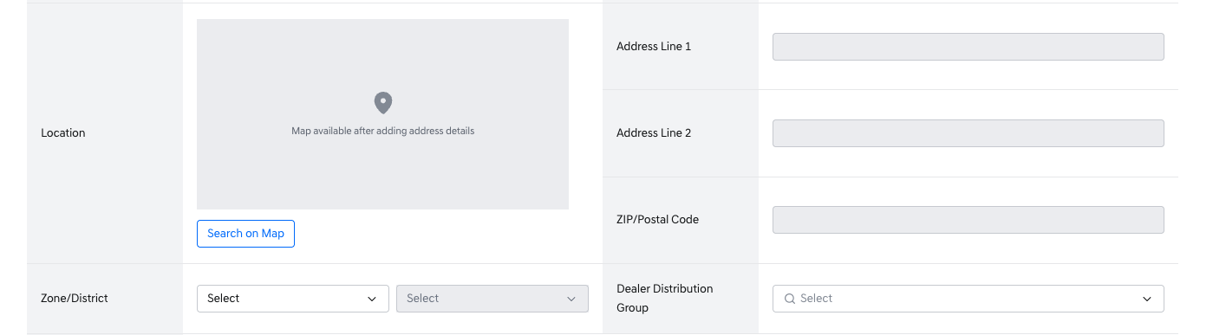
Dealer Basic Information2
Location:
- Optional field.
- Address information of the dealer.
- The address is entered by searching on Google Maps.
- Click [Search on map] to search for the desired address.
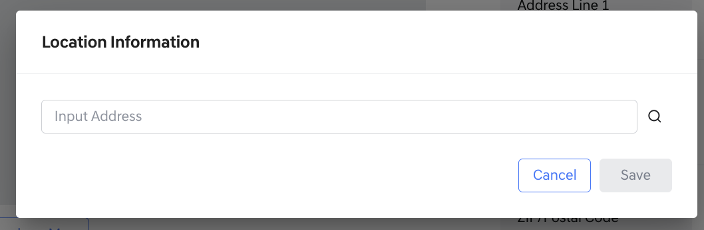
Location popup1
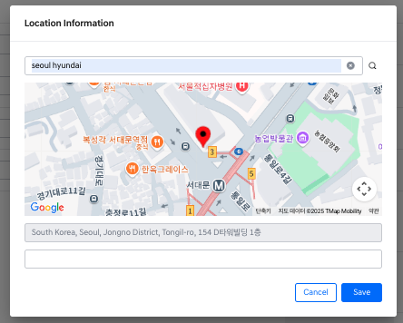
Location popup2
- The corresponding location is displayed on Google Maps.
- Select the appropriate address from the search results and save it.
- If additional address details are needed, a popup window will appear where extra information can be entered and saved.
- The entered information is reflected on the screen and can still be edited via the input fields even after it is saved.
- Zone / District
  - Optional field.
  - Select the Zone and District to which the dealer belongs.
  - A District can only be selected after selecting a Zone, as Districts are subordinate to Zones.
  - It is also possible to select only a Zone without assigning a District.
- Dealer Distribution Group
  - Optional field.
  - Select the Dealer Distribution Group(s) the dealer belongs to.
  - Multiple groups can be selected.
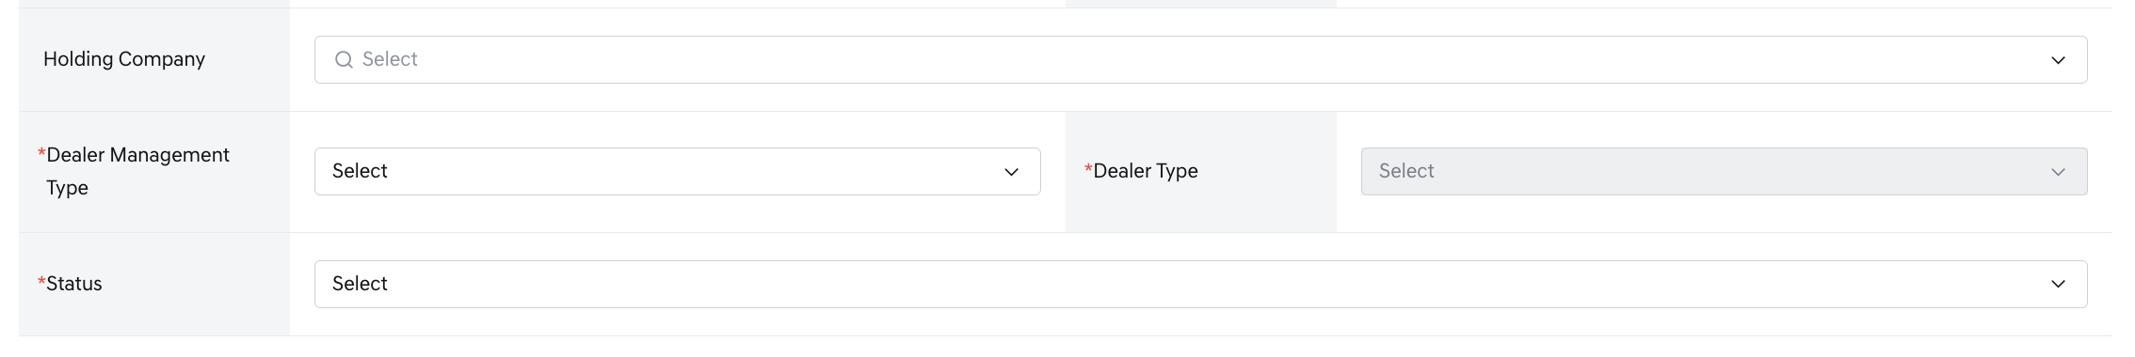
Dealer Basic Information3
- Holding company
  - Optional field.
  - Select the holding company the dealer is affiliated with.
  - Only one holding company can be selected.
- Dealer management type
  - Required field.
  - Select the management type of the dealer.
    - Official dealer
    - Associate dealer
- Dealer type
  - Required field.
  - Indicates the type of dealer.
  - This field becomes available only after selecting a Dealer management type.
  - The options shown in this field will vary depending on the selected management type:
- If Official dealer is selected:
  - Main
  - Sub
  - Satellite
- If Associate dealer is selected:
  - Authorized Reseller
  - Authorized Service Partner
- Status
  - Indicates the current status of the dealer.
  - The status affects service accessibility for users within the dealer organization.
  - Active: The dealer is active. Dealer users can access and use services.
  - Inactive: The dealer is inactive. Dealer users cannot use services.
Action Buttons
- [cancel]: Discards all entered information and resets the screen.
- [Save Draft]: Temporarily saves the information entered so far.
- [Next]: Moves to the next input screen.

Business information
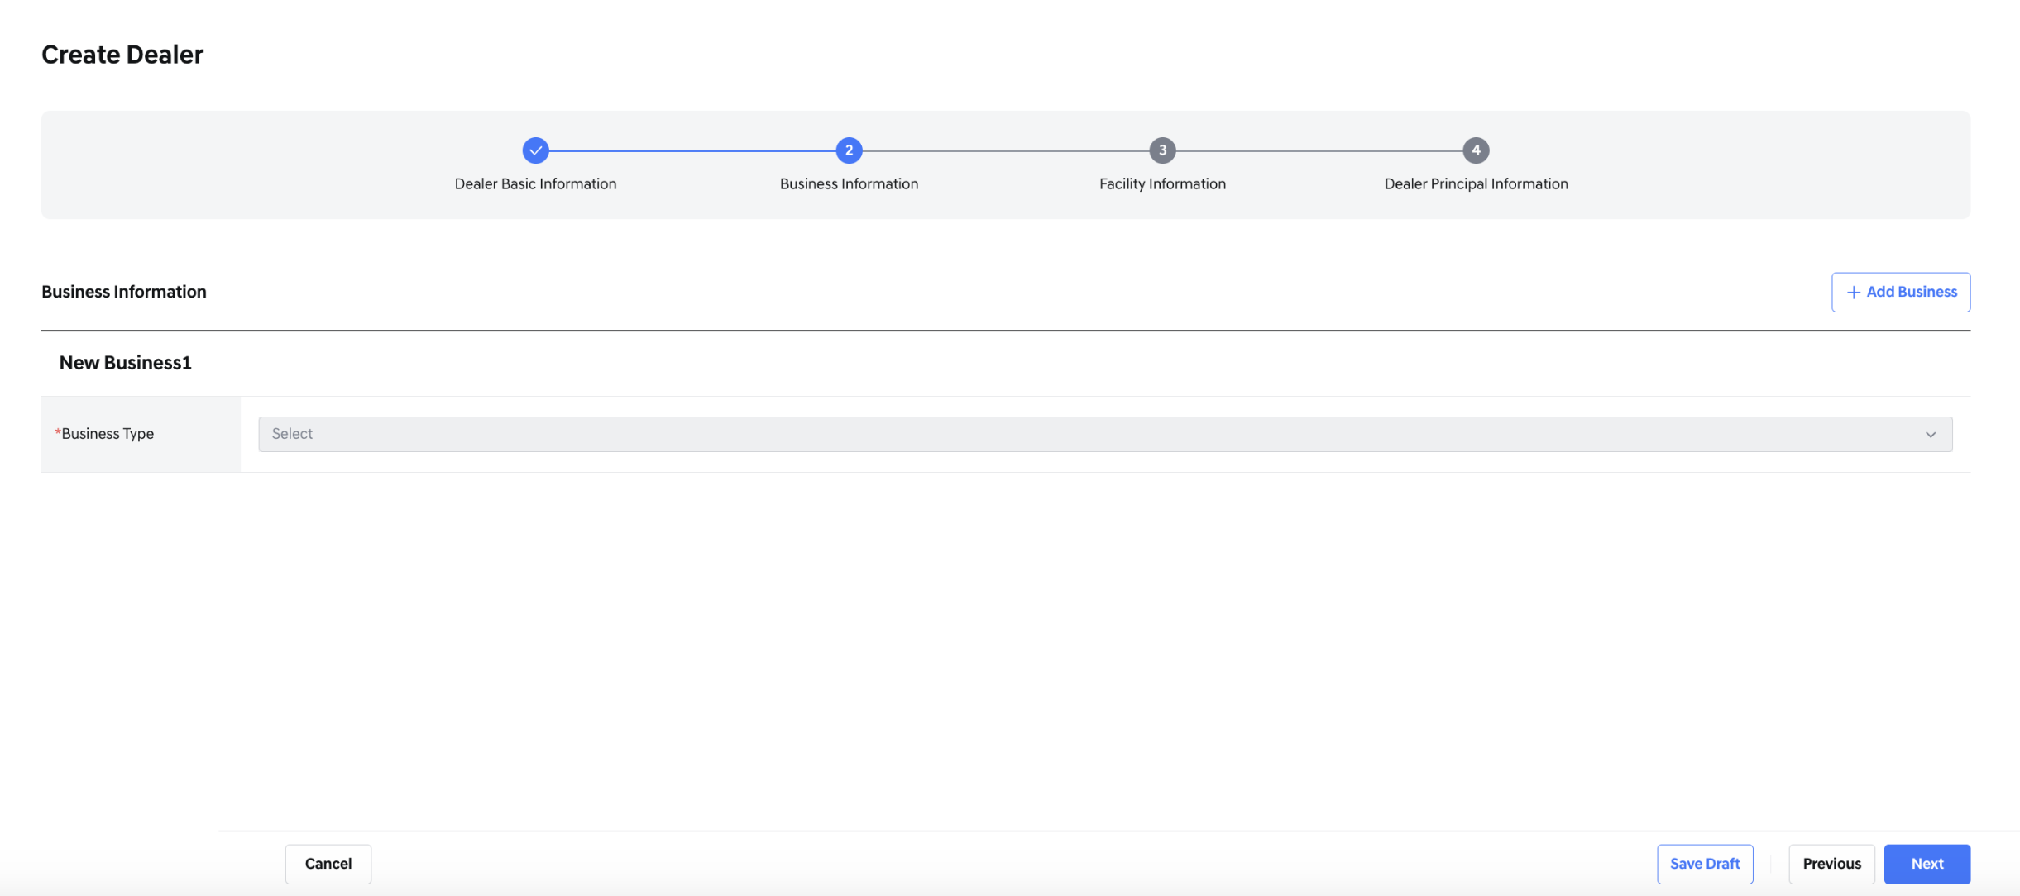
Creating Dealer - Business Information
- If the dealer management type field has a value on the main dealer screen, the Business Type field in the business information section becomes enabled for selection.
- When you select a Business Type, the remaining required fields will be displayed.
- A minimum of 1 and a maximum of 2 business entries can be added.
- Click the [add business] button to add a second set of business information fields.
- If two business entries have already been added, the [add business] button will no longer be visible.
- In the creation screen, the second business entry can be deleted.
- However, once the dealer has been created, business information can no longer be deleted.
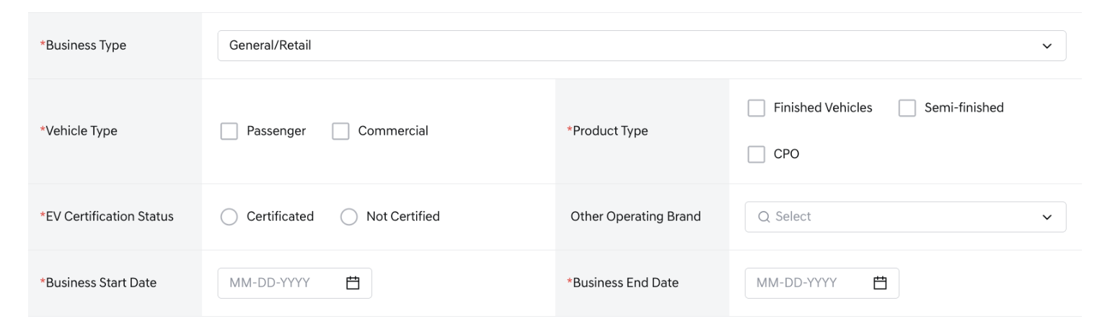
Dealer Business Information
- Business type
- Select one of the following business types:
  - General/Retail
  - After Service
  - Agency (only available when Dealer management type is “Official dealer” and Dealer type is “Main”)
  - When creating two business entries:
    - If one entry is set as General/Retail, the other cannot be set as Agency.
    - A value already selected in another business entry cannot be selected again.
- Vehicle type
  - Required
  - Select one or more applicable vehicle types:
    - Passenger
    - Commercial
- Product type
  - Required
  - Select one or more product categories:
    - Finished Vehicles
    - Semi-finished
    - CPO
    - EV
- EV Certification Status
  - Required
  - Select the EV certification status:
    - Certificated
    - Not Certificated
- Other Operating Brand
  - Optional
  - Select other brands currently operated by the dealer. Multiple selections allowed.
- Business Start Date
  - Required
  - Enter the business operation start date
- Business End Date
  - Required
  - Enter the business operation end date
- Action Buttons
  - [cancel]: clears all input fields
  - [previous]: returns to the previous step without saving current inputs
  - [Save Draft]: Temporarily saves the information entered so far.
  - [Next]: Proceeds to the next input screen.

Facility information
• This is the third step of the dealer creation process
• Enter information about the assets owned or managed by the dealer
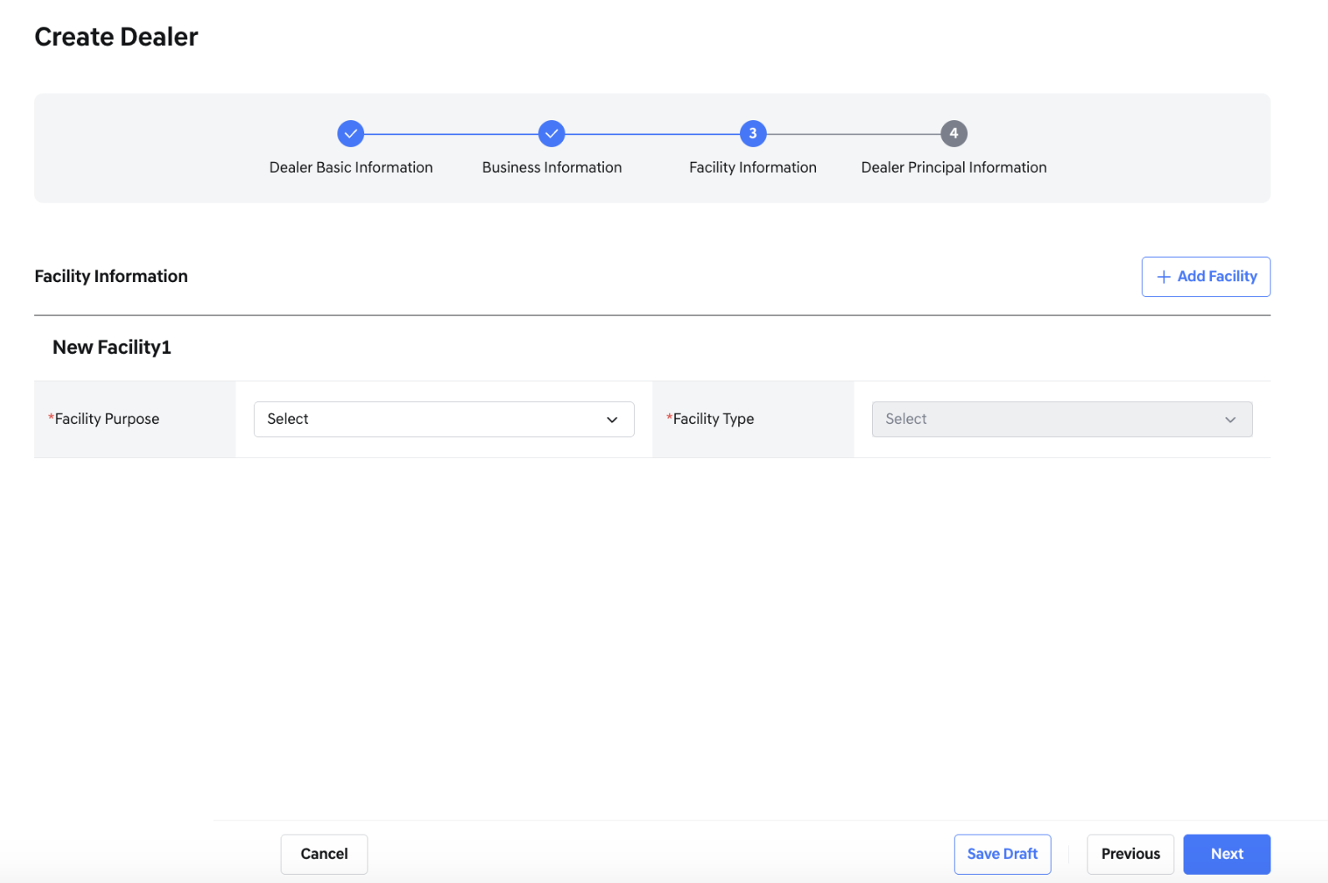
Creating Dealer - Facility Information entry screen
- The remaining input fields will be displayed only after selecting values for both the Facility Purpose and Facility Type fields.
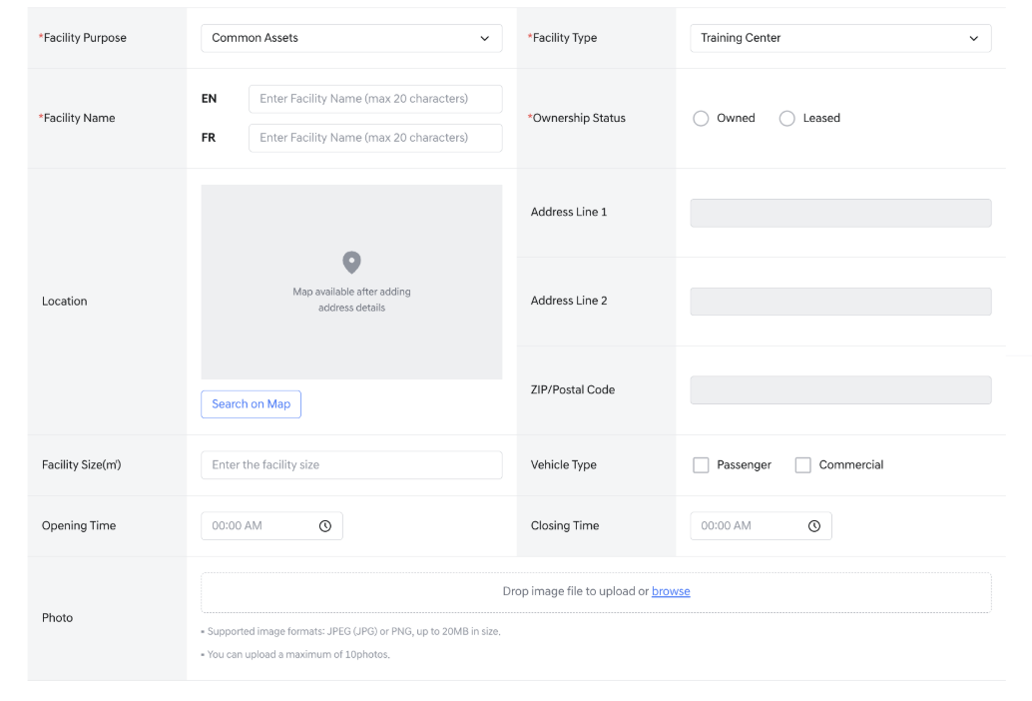
Facility Information
• Click [add facility] at the top to add a new asset
• Each asset is registered through the “Register New Facility” form
Dealer Facility Information1
- Facility purpose
  - required
  - Select the intended purpose of the facility
  - Options are:
    - Common Assets
    - Sales Assets
    - Service Assets
- Facility type
  - Required
  - Select the facility type
  - The next field, facility space type, appears based on this selection
  - Options include:
    - Training Center (no additional options provided)
    - Workshop
- Facility space type (for Customer Lounge, Gate reception, Repair Shop)
  - Required
  - A facility space type field will be generated
  - Select one value for each of the following categories: Customer Lounge, Gate reception, and Repair Shop
    - Standalone
    - Solid-wall
    - Multi-brand
    - None
    - Showroom
- Facility space type (for showroom)
  - Required
  - A facility space type field will be generated
  - Select one value for each of the following categories: Showroom
    - Standalone
    - Solid-wall
    - Multi-brand
    - None
Dealer Facility Information2
- Facility name
  - Required
  - Enter the name of the asset
  - Both English and French fields must be filled
  - Maximum 20 characters per language
- Ownership status
  - required
  - Select the ownership type of the asset
  - Options are:
    - Owned
    - Leased
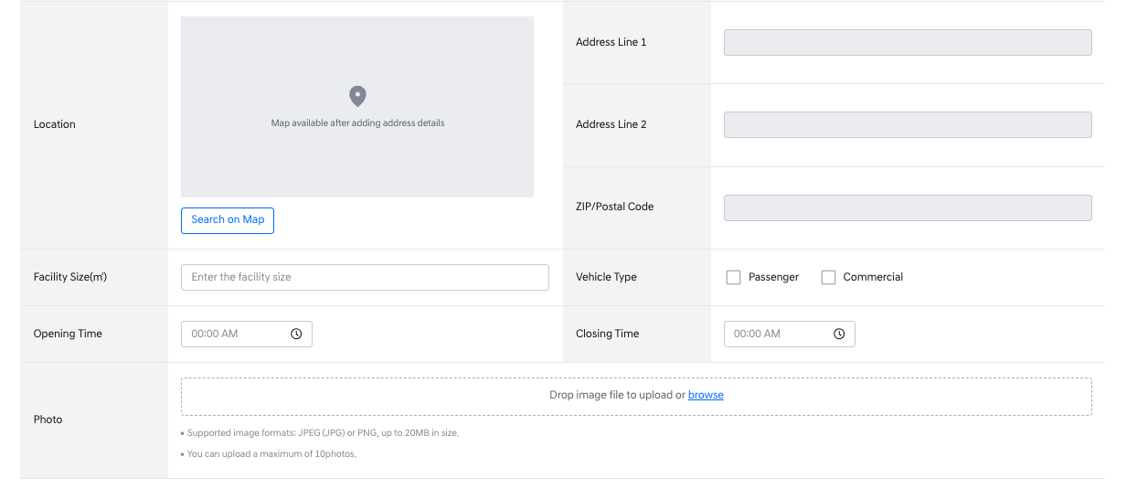
Dealer Facility Information4
- Location
  - Optional
  - Register the address information of the facility
  - Click [search on map] to look up the address using Google Maps
    - Select the appropriate result from the map and save it
    - If there are additional address details, enter them in the popup window
    - The entered address will appear on screen and can be edited directly afterward
- Facility size
  - Optional
  - Enter the size of the facility
- Vehicle type
  - Optional
  - Select one or more types of vehicles managed at the facility
  - Options are: Passenger, Commercial
- Opening time
  - Optional
  - Select the opening time of the facility
- Closing time
  - Optional
  - Select the closing time of the facility
- Photo
  - Optional
  - Upload images of the facility
  - Up to 10 images can be uploaded
  - Drag and drop images or click the upload area to select files
- Action Buttons
  - [cancel] clears all entered data
  - [previous] returns to the previous step
  - [Save Draft]: Temporarily saves the information entered so far.
  - [Next]: Proceeds to the next input screen.
Dealer principal information
- This is the final step of the dealer creation process
- Enter information about the dealer principal of the new dealer
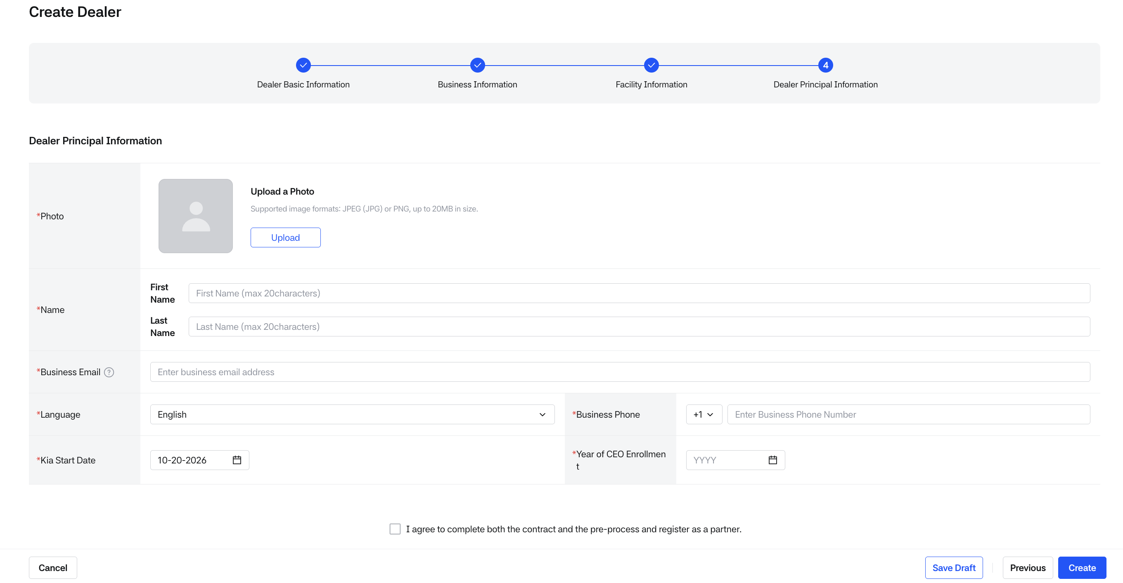
Creating Dealer - Dealer Principal
- On this screen, only the essential information for dealer employees, dealer principal is entered. Account creation for accessing Dealers is not performed on this screen.
- Although an account is not created, the employee information is saved.
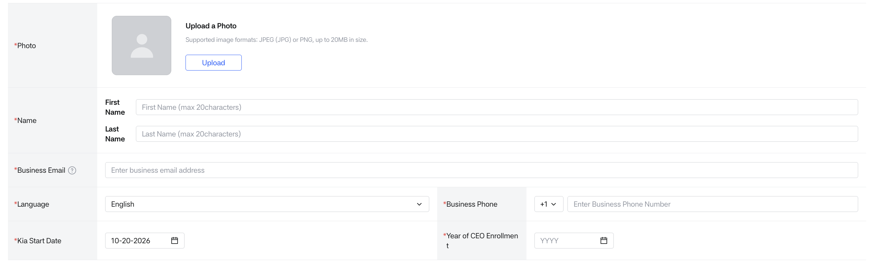
Dealer Principal Information
- Photo
  - Required.
  - Upload a photo of the dealer principal. Supported formats: JPEG (JPG) or PNG, up to 20MB in size.
- Name
  - Required
  - First name: Maximum 20 characters
  - Last name: Maximum 20 characters
- Language
  - Required
  - Select the preferred language for the dealer principal
  - Determines the language shown on login screens and email communications
  - English is selected by default. Options are English and French
- Business Phone
  - Required
  - Enter the dealer principal’s work phone number
  - Select a country code from 1 or 82 (default is 1)
- Business Email
  - Required notification email address for the dealer principal.
  - If Company’s Email Domain is enabled in Dealer Basic Information:
    - Business Email is entered as local-part + domain select box.
    - The default domain is preselected. If no default is set, the first registered domain is preselected.
  - If Company’s Email Domain is disabled:
    - Business Email is provided as a free-text email field.
    - Email format is validated and up to 50 characters can be entered.
  - When toggling Company’s Email Domain usage during dealer creation:
    - If an existing email contains @ and the local-part length is 20 characters or less, the local-part is preserved and the domain is reset to the default (or first registered) domain.
    - If the existing local-part length is greater than 20 characters, the local-part is cleared.
- Kia Start date
  - Required
  - Automatically filled with the current date when the dealer principal’s employee information is first entered.
- Year of CEO Enrollment
  - Required
  - The year the CEO began working at this dealership. This field is to be entered by the Dealer Principal only.
- Dealer Principal's Job Title (not a field on the screen)
  - Users registered as dealer principals are automatically assigned the job title 'Dealer principal'.
Dealer creation consent
- Dealer Creation Consent Items
  - As the final step to create a dealer, consent must be given to register dealer information in HMG Partner.
- Action Buttons
  - [cancel] clears all entered data
  - [Save Draft] Saves the currently entered items.
  - [Previous] returns to the previous screen
  - [Create] finalizes and creates both the dealer and the dealer principal account

- Dealer Information Creation Process
- When dealer creation fails
  - If all required information is not entered when creating a dealer: A popup will appear, notifying you of the missing required information and indicating which step is missing the data.
    - [Save Draft]: Temporarily saves the information entered so far.
    - [Review Fields]: Returns to the first screen with missing required information. On that screen, any required fields will be highlighted in red.
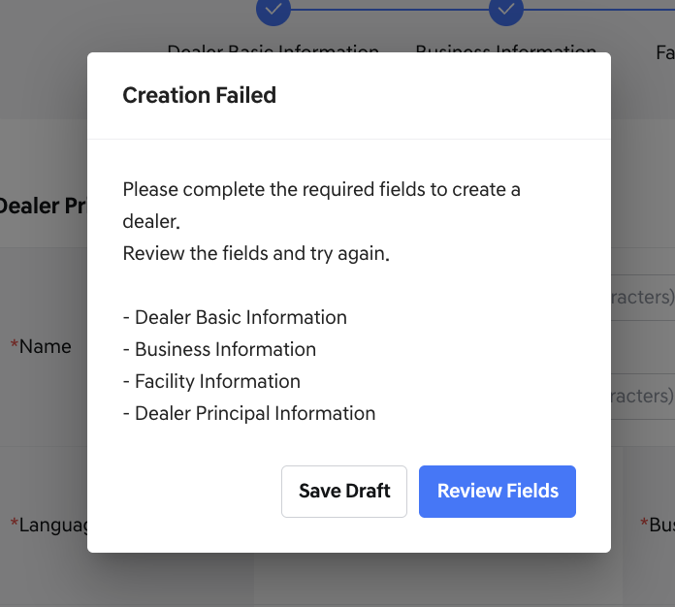
- When dealer creation succeeds
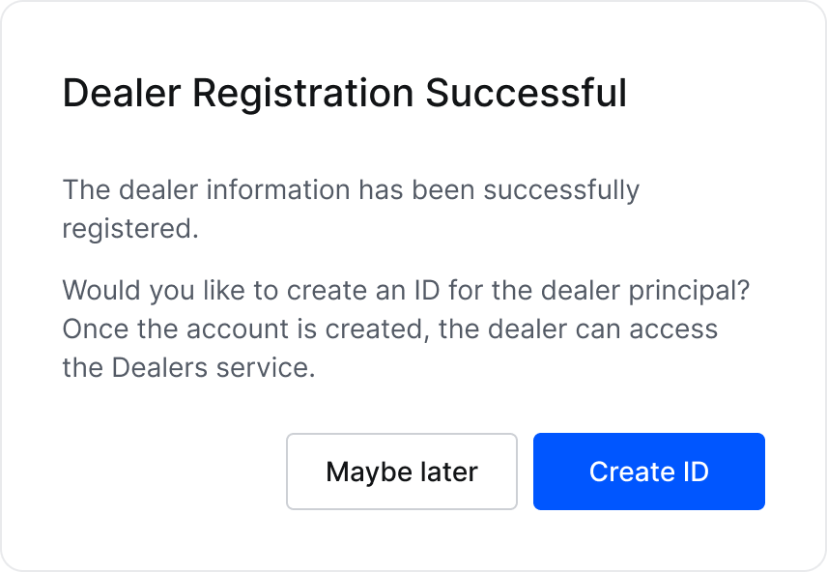
Dealer Registration Notice
- Once the dealer creation is complete, a confirmation message will be displayed, prompting you to proceed with the creation of the Dealer Principal’s ID.
- Dealer employees must have an ** ID** to access the Dealers service.
  - Therefore, if immediate access is required after dealer creation, an account should be created right away.
- [Maybe Later]: Completes the creation of the dealer and the Dealer Principal’s information.
  - The dealer information will be saved and can be viewed in the Dealer List screen.
  - The Dealer Principal’s information will also be registered under Dealer Employee Information.
- [Create ID]: Navigates to the Dealer Employee Management screen to create the Dealer Principal’s ID.
  - information and Dealer Principal’s information have already been successfully saved. Even after navigating to another screen, both the dealer information and Dealer Principal’s information have already been successfully saved.

Dealer Detail View /Edit Screen
- Clicking [View Detail] from the dealer list opens the detailed information screen of the selected dealer.
- Each section of the dealer’s information is shown in tabs.
- Each tab can be edited separately depending on the type of information.
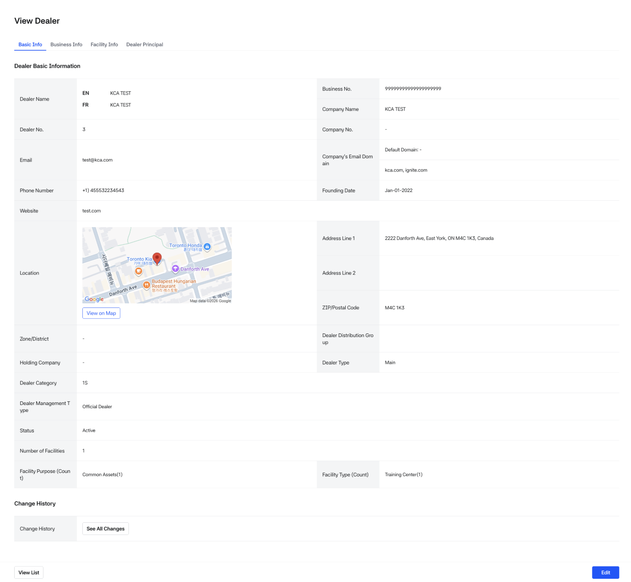
Dealer Detail - Basic Information
- Dealer basic information
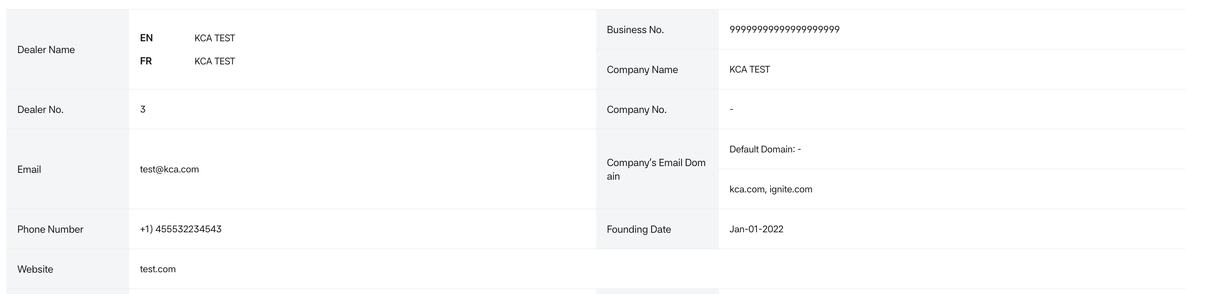
Dealer Basic Information1
- Dealer name: Internally managed name.
- Business No: The Business No. assigned to the dealer.
- Company name: Official name of the dealership.
- Dealer no.: Dealer number issued by the Dealers system.
- Company no.: Company number issued by HMG Partner.
- Email: Email address of the dealership.
- Company’s Email Domain:
  - Displays the company email domains registered for this dealer.
  - If a default domain is set, it is shown separately above the list.
- Phone number: Telephone number of the dealership.
- Founding date: Date the dealership was established.
- Website: Website of the dealership.
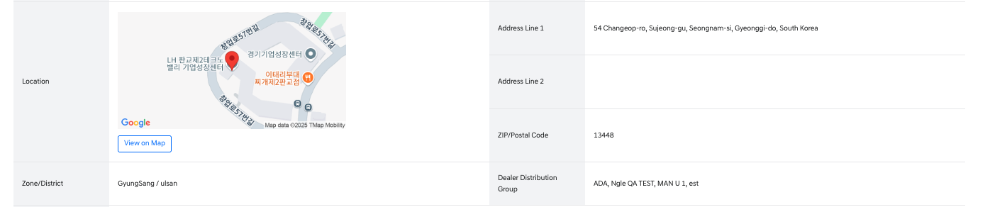
Dealer Basic Information2
- Location
  - Detailed address is displayed as address line 1, address line 2, and zip/postal code.
  - Clicking 'View on map' opens a map with the location.
- Zone/district: Region where the dealer is assigned.
- Dealer Distribution Group: The distribution group to which the dealer belongs.
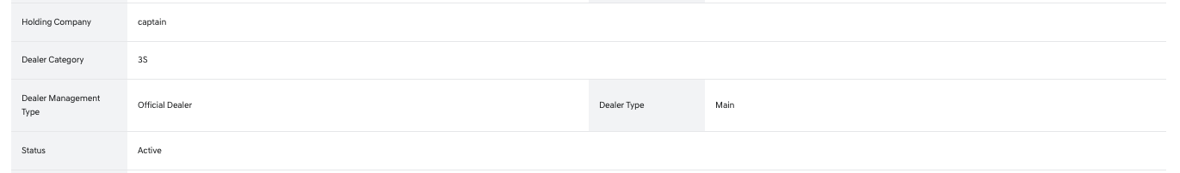
Dealer Basic Information3
- Holding company: The name of the holding company that the dealer is affiliated with.
- Dealer category: Automatically calculated based on business type.
  - 1S: Only General/retail or Agency registered.
  - 2S: Only After service registered.
  - 3S: Both General/retail (or Agency) and After service registered.
- Dealer management type
  - Official dealer or Associate dealer.
- Dealer type
  - If management type is 'Official dealer': Main, Sub, Satellite.
  - If management type is 'Associate dealer': Authorized Reseller or Authorized Service Partner.
- Status: Status of the dealer.
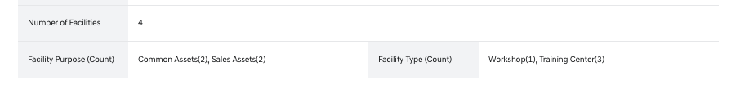
Dealer Basic Information4
- Number of facilities: Number of registered assets.
- Facility Purpose (Count): Number of assets by purpose.
- Facility Type (Count): Number of assets by type.
- change History
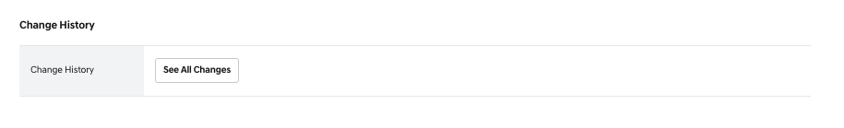
Dealer Change History
- This section allows you to view changes made to the dealer information after the dealer has been created.
- Clicking the [See All Changes] button opens a pop-up where you can view a chronological list of changes, starting from the most recent.
- Only changes made to the Basic Info section and Dealer Principal information are recorded and displayed.
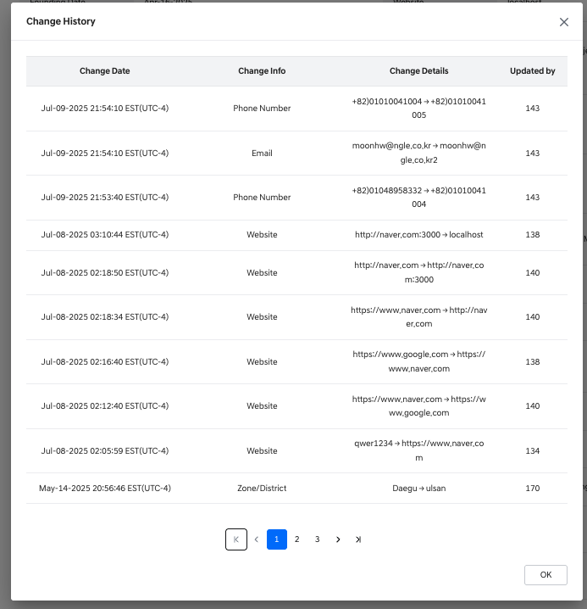
Dealer Change History Detail
- Change Date: The date and time when the change occurred.
- Change Info: The specific field or item that was modified.
- Change Details: Displays the value before and after the change.
- Updated By: The employee number of the user who made the change.

- Action buttons
  - Clicking 'View List' returns to the dealer list screen.
  - Clicking 'Edit' switches to the edit mode.
- Edit Dealer Management (Basic Info)
- Clicking the [edit] button from the basic info screen switches the view into edit mode.
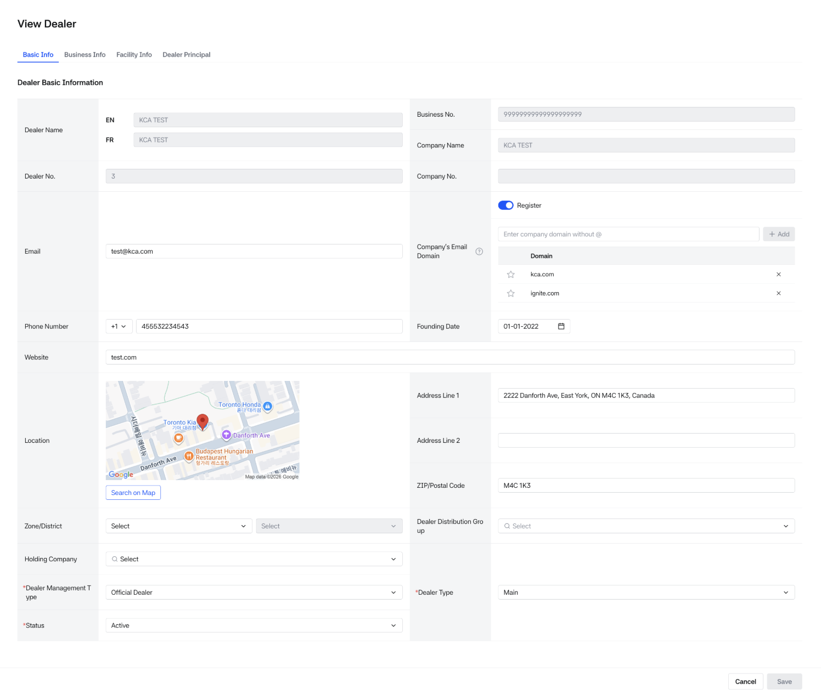
Edit Basic Info
Editing Dealer - Basic Information
- The edit screen provides the same columns as the creation screen and allows new values to be selected.
- Dealer name, company name, company number, DUNS Number and dealer number cannot be modified.
Dealer Business Information View
This screen can be accessed by clicking the Business Info tab.
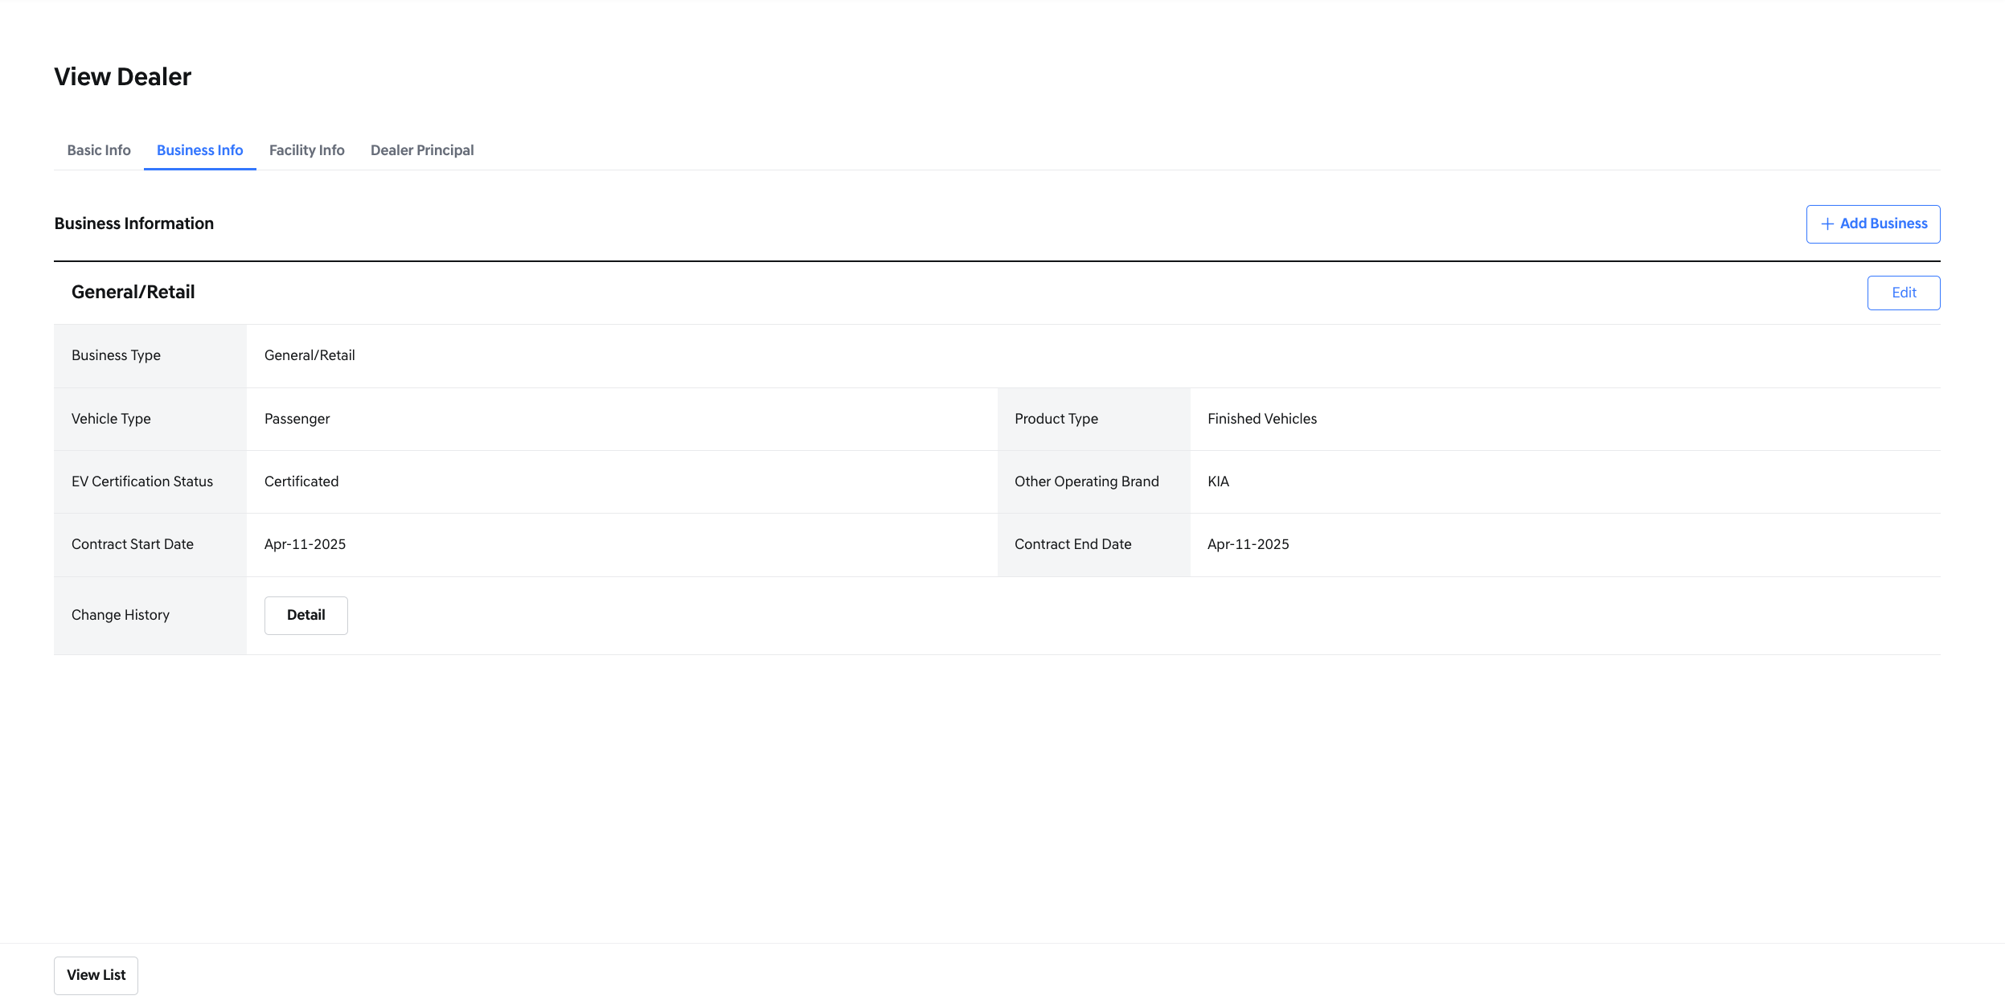
Dealer Detail - Business Information
- Business information
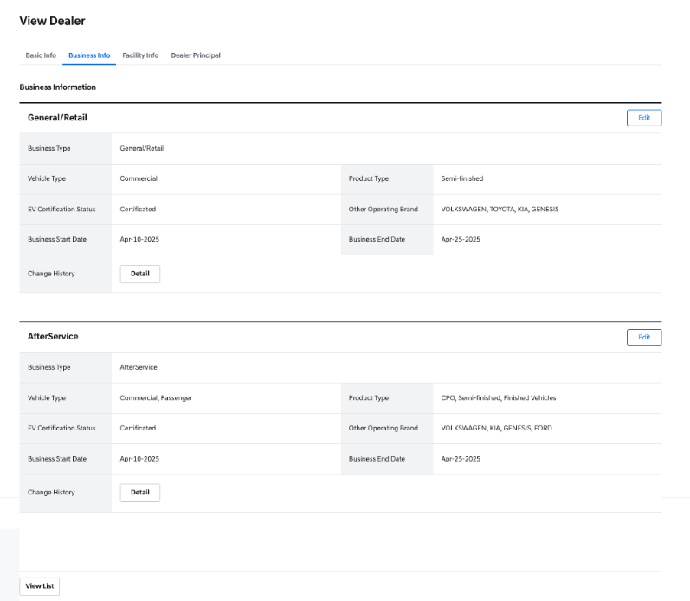
Dealer Details - 2Business case
- Business type
  - General/retail
  - After service
  - Agency
- Vehicle type
  - Passenger
  - Commercial
- Product type
  - Finished vehicles
  - Semi-finished
  - CPO
- EV Certification status
  - Certificated
  - Not Certificated
- Other operating brand
  - Brands other than Kia currently handled by the dealership
- Business start date
  - Start date of this business activity
- Business end date
  - End date of this business activity
- If only one business entry is registered, an [add business] button appears.
- You can register a new business directly from this screen.
- Each business entry has its own [edit] button.
- If a business entry has an edit history, a “change history” column is displayed.
- Clicking [detail] opens a popup showing edit history.
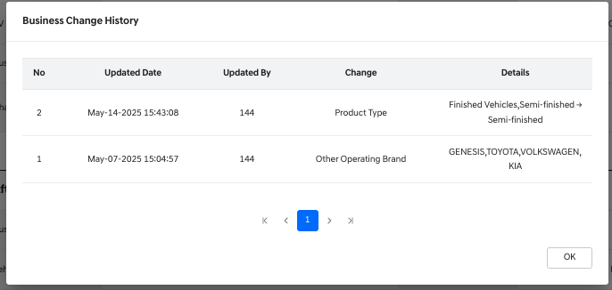
Business Change History
- The popup displays the following information:
  - Updated Date: The date when the change was made.
  - Updated By: The employee number of the person who made the change.
  - Change: The field or item that was modified.
  - Details: Shows the value before and after the change.
- Add New Business
  - Clicking [add business] generates a new input section at the top of the screen.
  - All fields and rules are the same as in the business creation screen (refer to dealer creation screen).
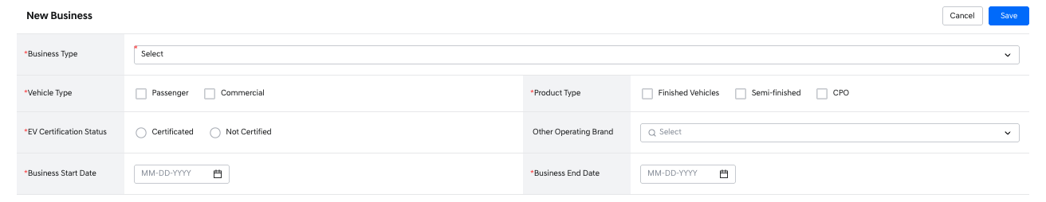
Adding Business Information
- Clicking [cancel] cancels the new entry.
- Clicking [save] registers the new business information.

Edit Existing Business
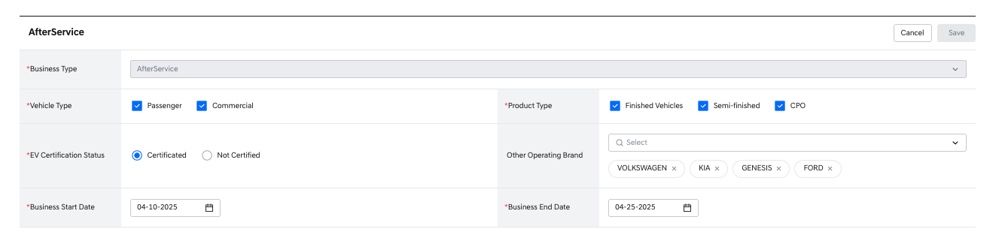
Editing Business Information
- Clicking [edit] puts the business entry into editable state.
- Business type cannot be changed.
- Clicking [save] applies the changes.
- Clicking [cancel] discards the changes and returns to the view screen.

Facility info
- When you select "Facility Info" in the tab, it moves to the asset information view screen.
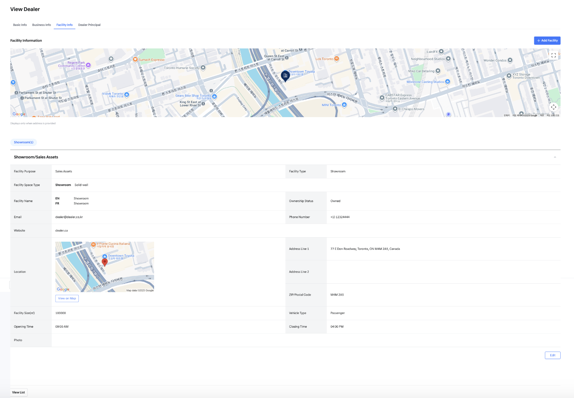
Dealer Detail - Facility Information
- Full Asset Information Map
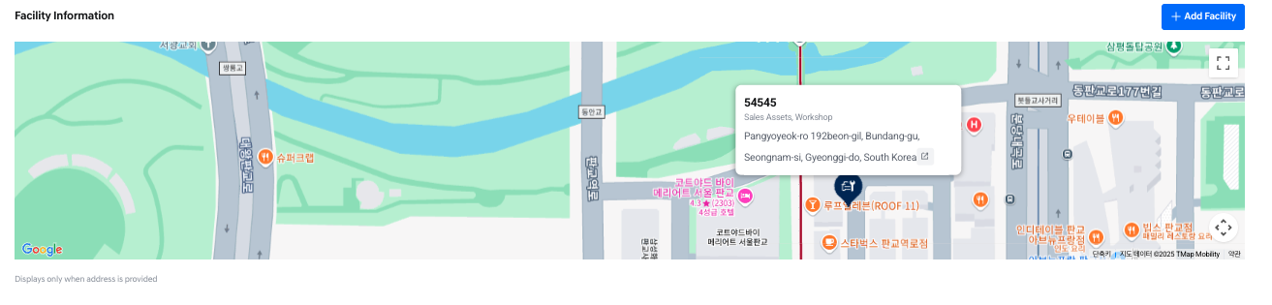
Facility Location Map
- If the asset's address information is registered, a map showing the location of all assets is provided at the top.
- Different icons are displayed depending on the facility type
- In order: Showroom, workshop, training center
  - 
- When you click on an icon on the map, it provides asset information and an external link icon to move to Google Maps.
- Clicking on the full screen changes the map to full view on the monitor screen.
- Information on all assets
  - Provided in tabs according to facility type
  - Displayed in order of Workshop, showroom, training, and tabs are only provided for facility types that have corresponding assets
  - Registered assets can be opened and closed in accordion form
- Facility information
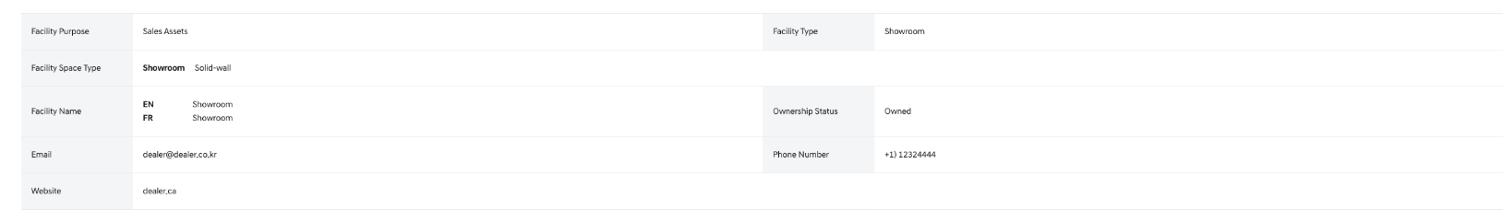
Dealer Facility Information1
- Facility purpose
  - Common Assets
  - Sales Assets
  - Service Assets
- Facility type
  - Training Center
    - Facility space type column is not provided.
  - Workshop
    - Facility space type column is provided.
    - Provides one value corresponding to each item: Customer Lounge, Gate Reception, Repair Shop
      - Standalone
      - Solid-wall
      - Multi-brand
      - None
  - Showroom
    - Facility space type column is provided.
    - Provides one value corresponding to the item: showroom
      - Solid-wall
      - Multi-brand
      - None
  - Facility name: the name of an asset entered in English and French.
  - Ownership status
    - Owned
    - Leased
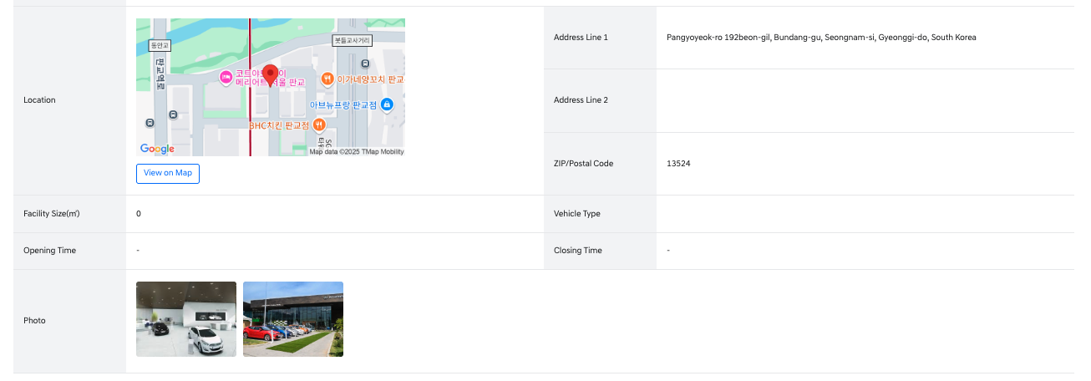
Dealer Facility Information2
- Location: Address information of the asset.
- Vehicle type
  - The type of vehicle managed at this asset.
    - Passenger
    - Commercial
- Opening time: The time when operations begin.
- Closing time: The time when operations end.
- Facility size: The area value of the corresponding asset.
- Photo: Image information of the asset.
- An [Add Facility] button is provided at the top, allowing immediate addition of assets when needed.
  - When this button is clicked, a popup is created where one asset can be added.
  - The input fields are the same as the values entered during creation
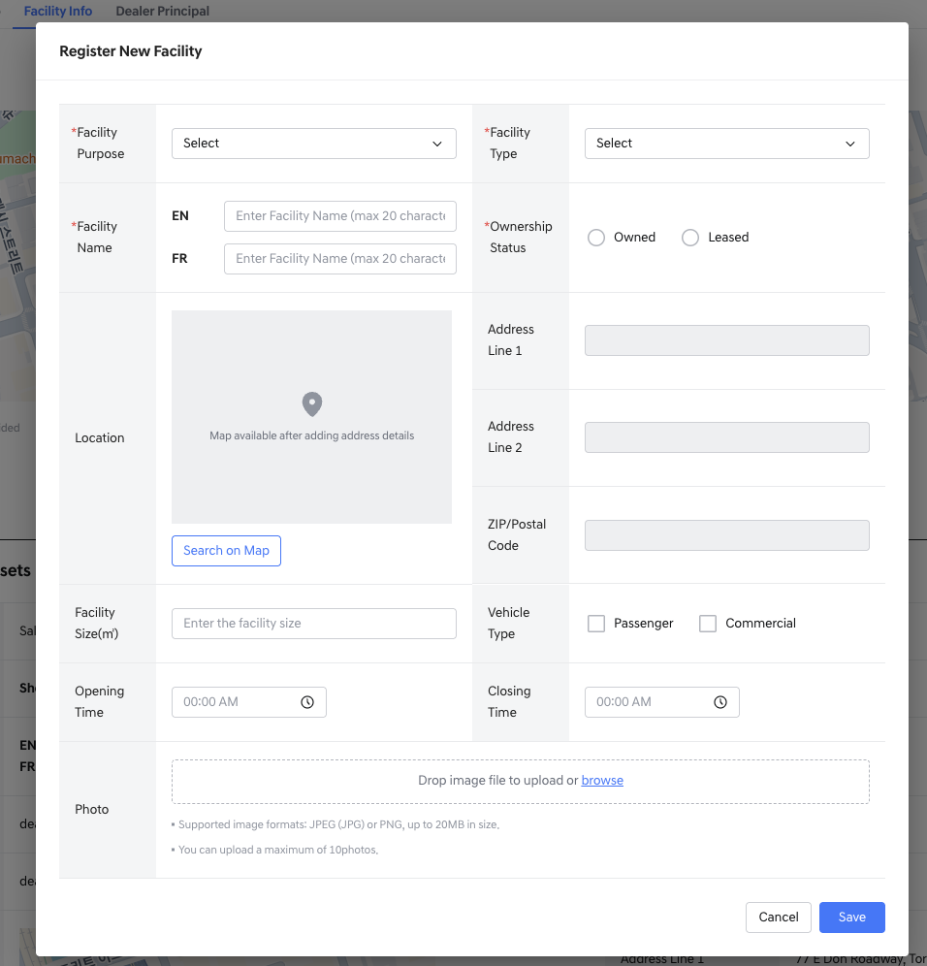
Adding New Facility Information
- Facility Information Modification and Deletion
- If you need to modify or delete the content of a specific asset, click the [Delete] and [Edit] buttons at the bottom.
  - At least one Facility entry is required, so the [Delete] button is not available when only one entry remains.
- Once deleted, you cannot restore the deleted content.
- When modifying, only that asset can be modified and the items entered during the original registration are displayed as they were.
- After modification, pressing [Save] will apply the changes and return to the inquiry screen.
- Clicking [Cancel] will return to the inquiry screen without applying the changes.
Dealer principal information View
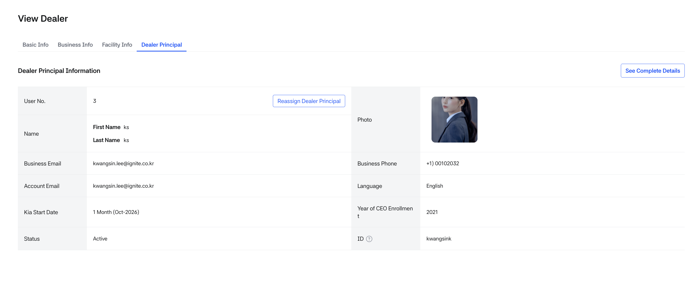
Dealer Detail - Dealer Principal
Dealer principal information
- Clicking the [See Complete Details] button allows you to view the Dealer Principal’s detailed information on the Dealer Employee Management screen.
- User No: The User Number of the Dealer Principal.
- Business phone: Work phone number of the representative.
- Name: Name of the dealer representative.
- First name
- Last name
- Language: Language setting of the representative.
- Business email: The business email address of the employee.
- Kia Start Date: Displays the period calculated based on the date the representative started working at Kia up to today.
  - The working period is displayed by calculating only the year and month information.
  - Calculated as 1 month from the month when employment began.
- Year of CEO Enrollment: The year the CEO began working at the dealership.
- Status: The account status of the dealer employee.
- ID: The ID (Account) of the dealer employee, managed through hmg-PartnerID. A tooltip next to the field explains this.
  - If no account exists, the message "No account found" will be displayed.
- Change Dealer Principal:
Clicking the [Reassign Dealer Principal] button next to the User No. opens a pop-up where you can change the Dealer Principal.
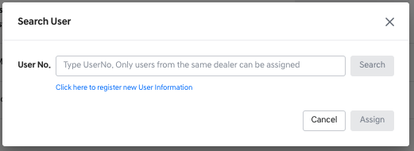

Search User Popup
- The dealer principal can only be selected from among dealer employees belonging to that dealership.
- Enter the user No of the user you want to newly designate and press assign.
- When the Dealer Principal is changed, the job of the newly assigned Dealer Principal is automatically updated to Dealer Principal.
- The previous Dealer Principal will have their status changed to Inactive, and their job assignment will be removed.
- Therefore, if the previous Dealer Principal still needs access to Dealers, please review and update their status and permissions on the Dealer Employee Management screen.
- If you need to update the Dealer Principal’s information, click the [See Complete Details] button and make the changes on the Dealer Employee Management screen.
- Pressing [View List] moves to the dealer list screen.

3. Zone/District Management(Dealer Regional Management)

Zone/District Management View
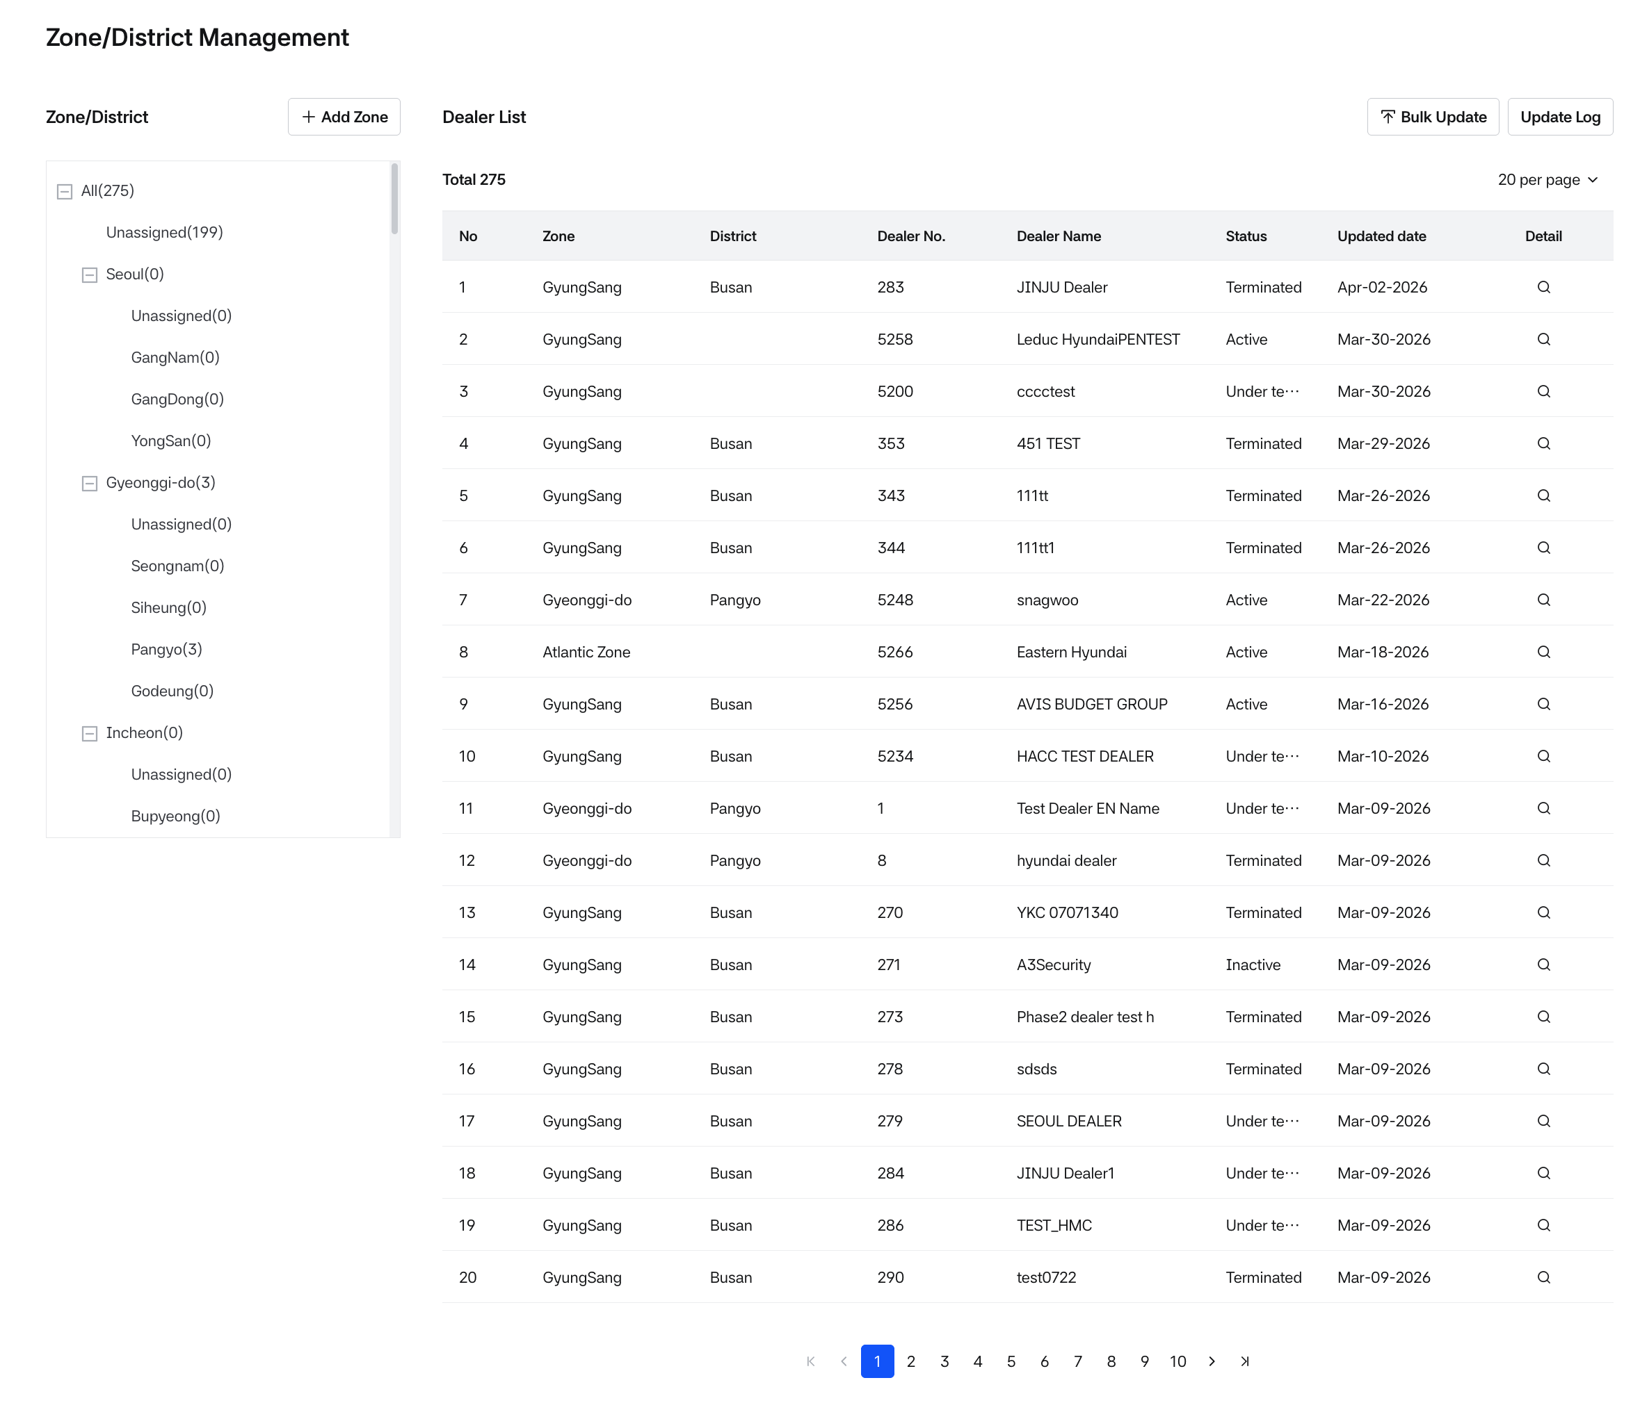
Zone/District List
- You can view the Zone/District to which the dealer is assigned.
- You can create, edit, and delete Zones and Districts.
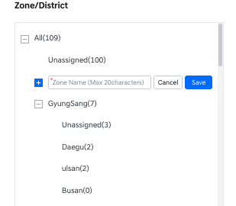
Adding Zone
- All created Zones and Districts can be viewed.
- The number of dealers assigned to each Zone and District is displayed in parentheses next to the name.
- Use the +/- button to expand or collapse the structure.
- Clicking on a Zone or District will display the list of dealers assigned to the selected area on the right panel.
  - ALL: Displays a list of all created dealers.
  - Unassigned: Dealers that are either not assigned to a Zone, or belong to a Zone but not assigned to any District.
  - Dealer list is sorted in order of most recently assigned.
  - No: The sequence number of the dealer list.
  - Zone: The name of the assigned Zone.
  - District: The name of the assigned District.
  - Dealer no.: The dealer’s identification number.
  - Dealer name: The name of the dealer.
  - Status: The current status of the dealer.
  - Updated date: The date when the Zone/District information of the dealer was last updated.
  - Detail: Provides a detailed view of the dealer.

Zone/District Creation, Modification, and Deletion
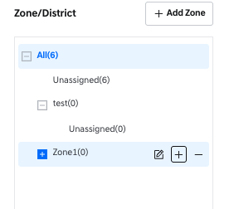
Zone on Hover
- Click the [add zone] button at the top to add a Zone in the box below.
- Zone names must be unique and cannot be duplicated.
- Hovering over a Zone will display a + button. Clicking this will create a new District under the selected Zone.
- District names must also be unique within the same Zone.
- Hovering over a Zone will display a pencil icon. Click this icon to edit the name.
- Hovering over a Zone will also display a – button. Clicking this will delete the Zone.
- Deleting a Zone will also delete all its associated Districts.
- Hovering over a District will display a – button. Clicking this will delete the District.
- If a District is deleted, the dealers previously assigned to that District will retain the Zone assignment but will no longer belong to any District.
- The order of Zones and Districts can be rearranged.
- Click and hold the item you want to move for 1 second to activate drag-and-drop.
- When a Zone is moved, its sub-Districts will move together.
- Districts can only be moved within the same Zone.

Excel Upload (Bulk Update)
- The Excel Upload (Bulk Update) function allows authorized users to bulk update dealer Zone/District assignments using the official Excel template.
- The Upload / Bulk Update button is displayed only to users with write permission.
How to Upload
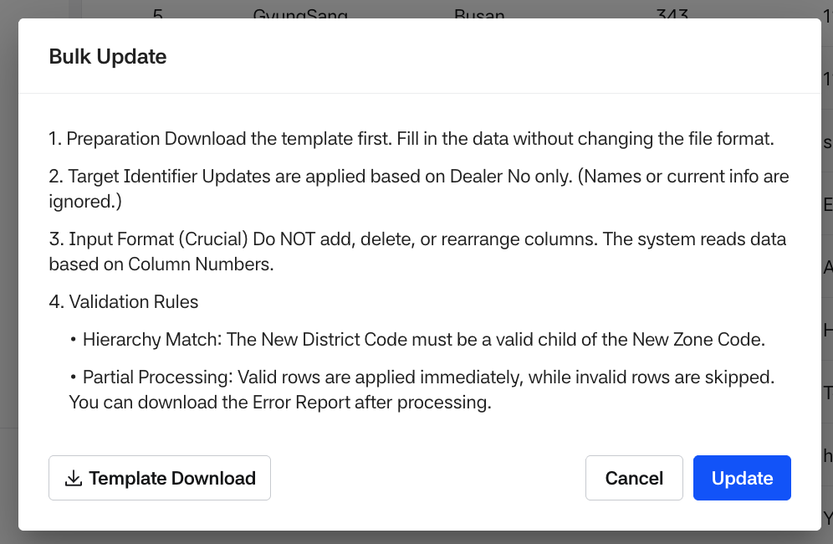
Upload guide
- Click Bulk Update to open the guide modal.
- Click Template download and fill in the template.
- Click Update and select the completed Excel file.
- The system starts processing and shows a Processing Upload modal.
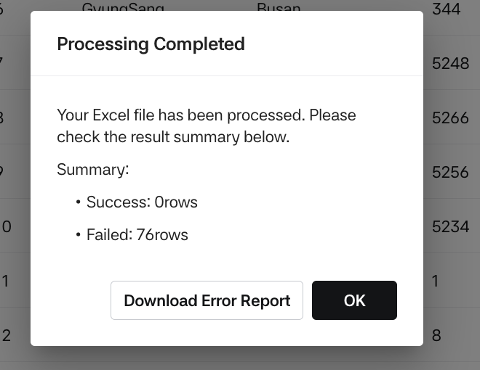
Processing completed
- After processing completes, a Processing Completed modal displays the result summary.
- File Requirements
  - Allowed format: .xlsx only
  - Maximum size: 20MB
  - The system validates and reads only these columns from Sheet 1 (must exist in the same column order):
  - Dealer No.
  - New Zone Code
  - New District Code
  - Sheet 2 is optional (upload works even if Sheet 2 is missing).
- Processing Policy (Key Rules)
  - Upload is processed row-by-row:
  - Valid rows are applied.
  - Invalid rows are skipped (no update for that row).
  - The uploaded file may contain only some dealers (it does not need to include all dealers in the system).
  - Upload can only map to existing Zone/District codes (cannot create or delete Zones/Districts).
- Asynchronous processing:
  - Upload continues even if the user navigates away from the page.
  - While one user is uploading, other users can still perform actions.
  - If multiple uploads occur, the most recently uploaded result is reflected.
  - The system checks the following during upload:
- Template structure: required columns and order must match the official template
  - Required fields: Dealer No / New Zone Code / New District Code must not be empty
  - Code validity: Zone/District codes must exist (including invalid non-numeric input)
  - Hierarchy: the District must be a valid child of the selected Zone
- Result, Error Report, and Log
  - Successful rows
  - Successfully updated rows are saved internally with:
  - Timestamp, uploaded user ID, dealer no, zone/district code, file name
  - After upload, the Updated Date on the screen is updated to the upload completion time.
  - Updates are also reflected in Dealer Management, and its change history is recorded.
  - The uploaded file can be downloaded again from Update Log.
- Failed rows (Error Report)
  - If any rows fail, the system generates an Error Report Excel:
  - File name: upload_error_list_yyyymmddhhmmss.xlsx (based on completion time, EST)
  - Contains failed row number and failure reason (English)
  - The error report can also be downloaded again from Update Log.
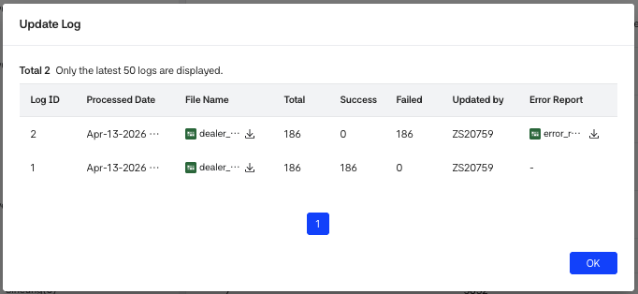
Updated Log
- A log entry is created when processing starts.
- Regardless of success/failure, if processing started, it is stored in Update Log.

4. Dealer Distribution Group Management

Dealer distribution group List View
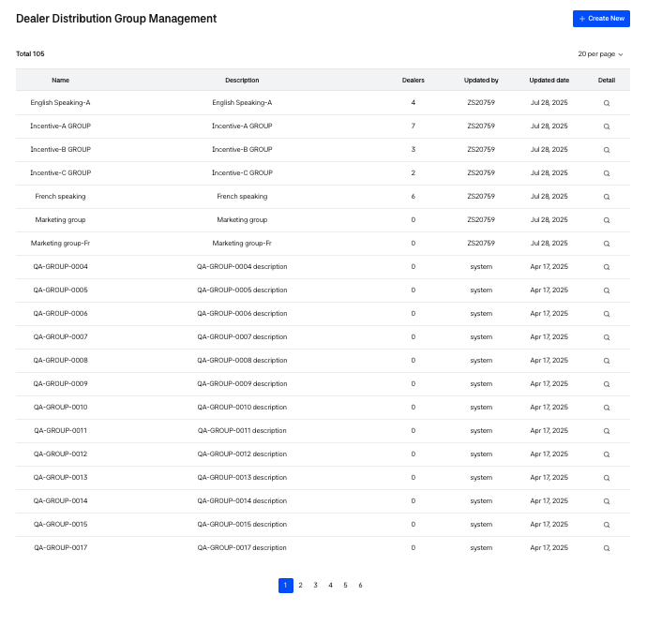
Dealer Distribution Group List
- This screen allows you to create, modify, delete, and view dealer distribution groups for managing dealers.
- You can view existing dealer groups.
  - Name: Name of the dealer group.
  - Description: Description of the dealer group.
  - Dealers: Number of dealers belonging to the group.
  - Updated by: ID of the user who created or last updated the group.
  - Updated date: Date when the dealer group was created or last updated.
  - Detail: Navigates to the detailed view of the dealer group.
- Click the [create new] button on the list view to navigate to the new group creation screen.

Dealer Distribution Group Creation
This screen is for creating a new dealer distribution group.
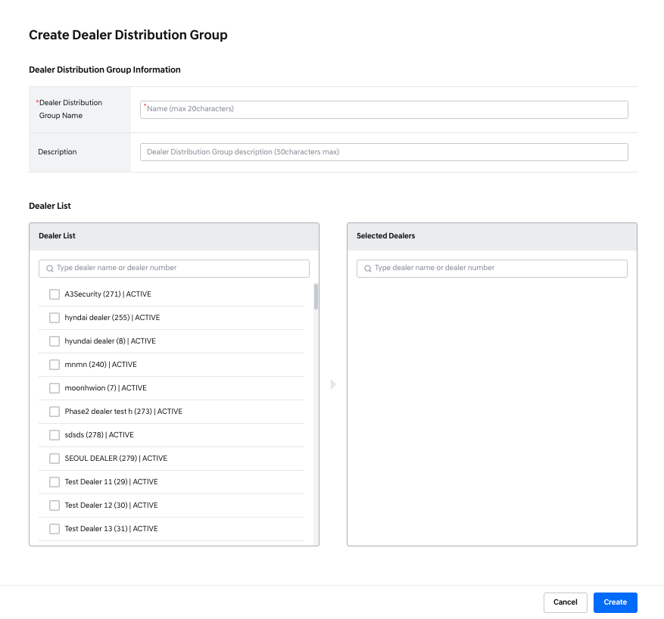
Creation Group
Dealer group information
- Dealer distribution group Name:
  - Required field.
  - Up to 20 characters.
  - Duplicate names are not allowed.
- Description:
  - Optional field.
  - Up to 50 characters.
- Dealer list
  - Displays the full list of available dealers.
  - You can select dealers to include in the group.
  - Each dealer entry shows: name, dealer number, and status.
  - Dealers are displayed in the following status priority: Active, Under Terminated, Inactive, Terminated and then sorted alphabetically by dealer name.
  - You can search dealers by name in both the Dealer list and Selected dealers.
    - When a dealer is checked in the Dealer list, they appear in the Selected dealers section.
    - Unchecking a dealer or clicking the x button in Selected dealers removes them from the selection.

Dealer Distribution Group Detail View
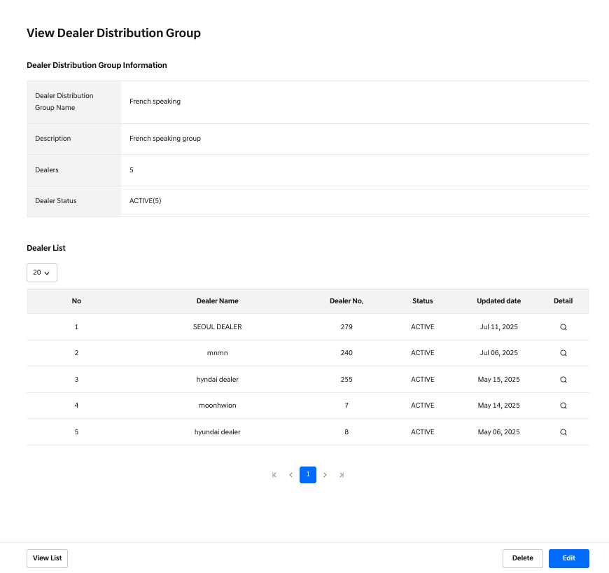
Group Detail
- Selecting Detail in the list view opens the group’s detail screen.
Dealer group information
- Dealer group name: Group name.
- Description: Group description.
- Dealers: Number of dealers assigned to this group.
- Dealer status: Number of dealers by status.
Dealer list
- Displays the list of dealers assigned to the group.
  - No: Sequence number.
  - Dealer name: Dealer name.
  - Dealer no.: Dealer number.
  - Status: Dealer status.
  - Updated date: Date the dealer was added to the group.
  - Detail: Navigates to the dealer’s detailed view.
Action buttons (bottom of the screen)
- [delete]: Deletes the dealer group.
  - When deleted, all dealers are unassigned from the group.
- [edit]: Navigates to the edit screen for the group.
- [view list]: Returns to the group list screen.

Dealer Distribution Group Editing
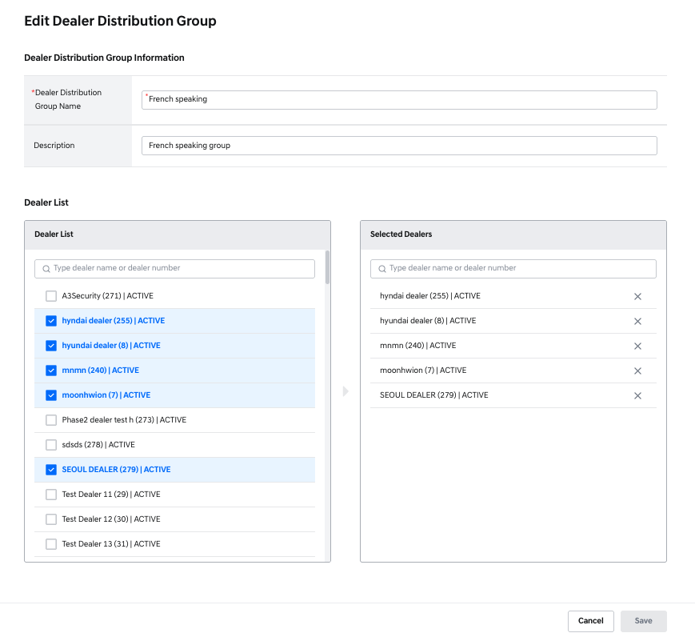
Editing Group
- You can edit the dealer group name, description, and assigned dealers.
Dealer group information
- Dealer group name: Can be edited.
- Description: Can be edited.
Dealer list
- Displays the full list of available dealers.
- Dealers already assigned to the group are pre-selected.
- Shows dealer name, number, and status.
  - Status display order: Active, Under Termination, Inactive, Terminated then sorted alphabetically.
- Dealers can be searched by name.
- Checked dealers are added to Selected dealers.
  - Unchecking or pressing x removes them from Selected dealers.
- If there are changes in the dealer list and you click the [save] button, a popup will appear.
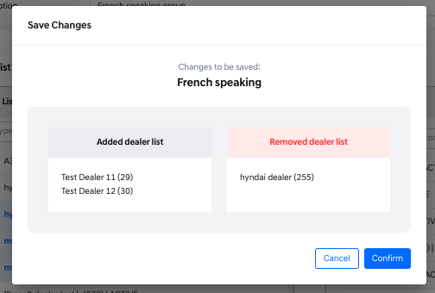
Change Save Popup
- The popup shows the names and numbers of dealers added or removed.
- Click [confirm] to apply the changes.
- Click [cancel] to discard the changes and return to the edit screen.
- Pressing the [cancel] button discards any changes and returns to the previous screen.

5. Holding Company Management

Holding Company List View
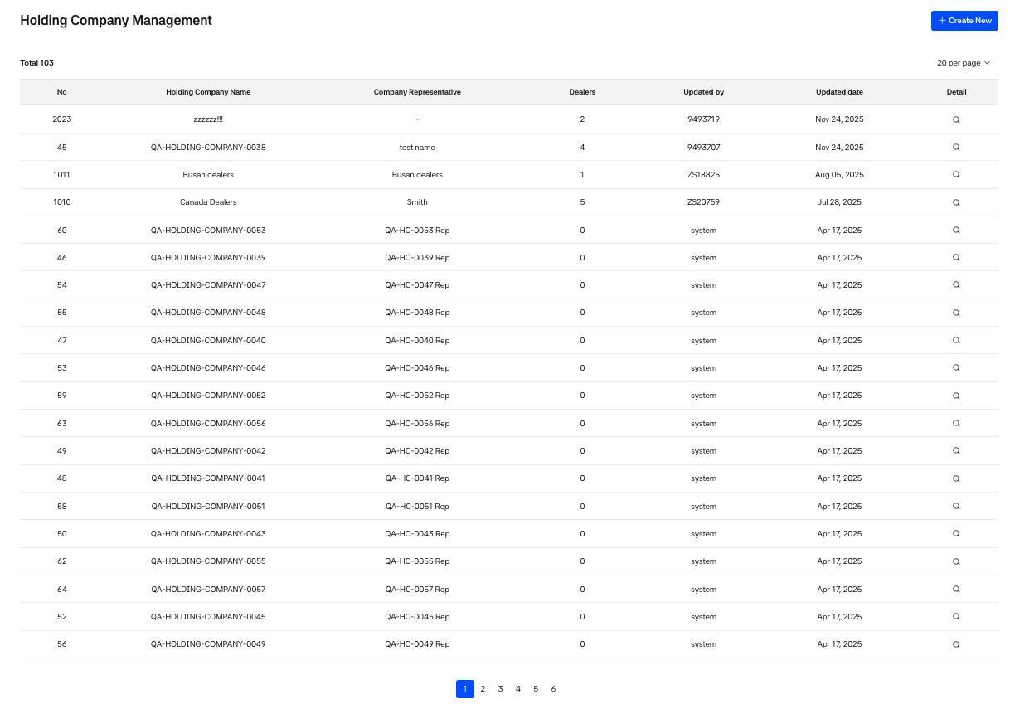
Holding Company List
- This screen allows you to create, edit, delete, and view information about holding companies.
- You can view the list of registered holding companies.
  - No: Internal holding company number managed by the dealer system.
  - Holding company name: Name of the holding company.
  - Company representative: Name of the holding company’s representative.
  - Dealers: Number of dealers assigned to the holding company.
  - Updated by: ID of the user who created or last modified the holding company.
  - Updated date: Date when the holding company was created or last updated.
  - Detail: Navigates to the detail view of the holding company.
- Click the [create new] button to move to the creation screen for a new holding company.

Holding Company Creation
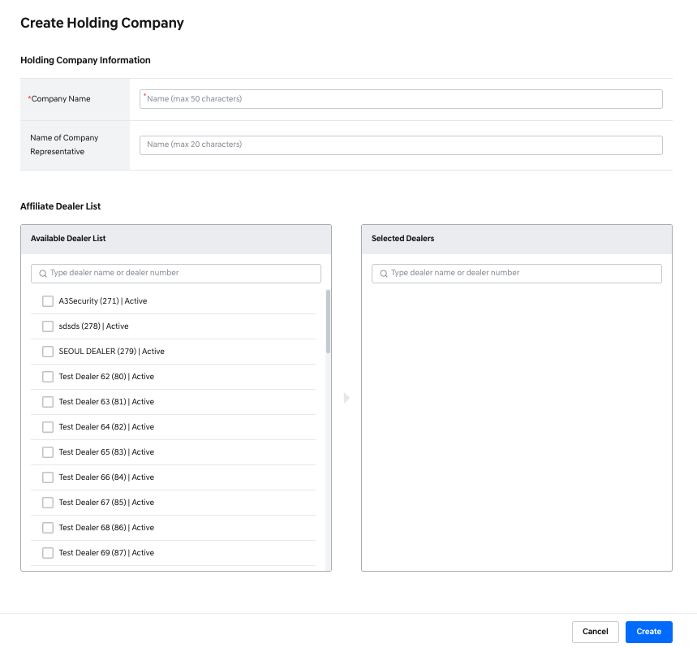
Creating Holding Company
- This screen is for registering a new holding company.
Holding company information
- Company name
  - Required field.
  - Maximum 50 characters.
  - Duplicate names are not allowed.
- Name of Company Representative
  - Optional field.
  - Maximum 20 characters.
Affiliate Dealer List
- A dealer can belong to only one holding company.
- The Available Dealer list shows dealers that are not currently assigned to any holding company.
- Each dealer entry shows: name, dealer number, and status.
  - Dealers are displayed in the following status priority: Active, Under Termination, Inactive, Terminated then sorted alphabetically.
- You can search by dealer name within both the Available Dealer list and Selected dealers.
- When a dealer is selected from the Available Dealer list, it will appear in the Selected dealers section.
  - Unchecking a dealer or clicking the x button removes them from the Selected dealers list.

Holding Company Detail View
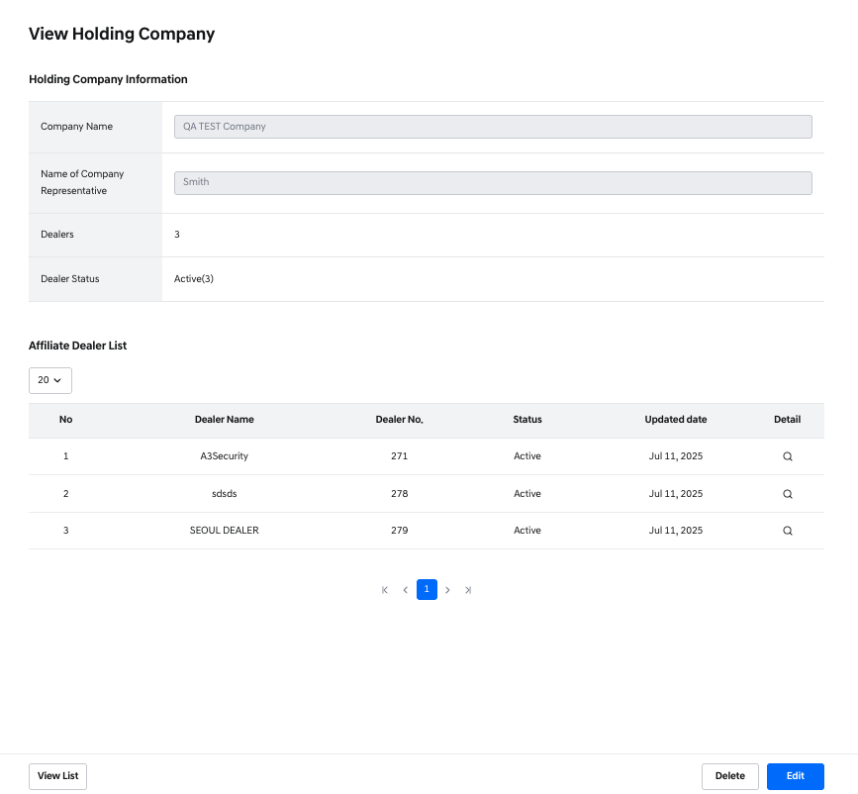
Holding Company Detail
- Selecting Detail from the list view opens the holding company's detailed view screen.
Holding company information
- Company name: Name of the holding company.
- Name of company representative: Name of the representative.
- Dealers: Number of affiliated dealers.
- Dealer status: Number of dealers by status.
Affiliate Dealer List
- Shows the list of dealers affiliated with the holding company.
  - No: Sequence number.
  - Dealer name: Name of the dealer.
  - Dealer no.: Dealer number.
  - Status: Dealer’s status.
  - Updated date: Date the dealer was affiliated with the holding company.
  - Detail: Navigates to the dealer's detailed view.
Action Buttons
- [delete]: Deletes the holding company.
  - If deleted, all affiliated dealers will become unassigned from any holding company.
- [edit]: Opens the edit screen for the holding company.
- [view list]: Returns to the holding company list view.

Holding Company Editing
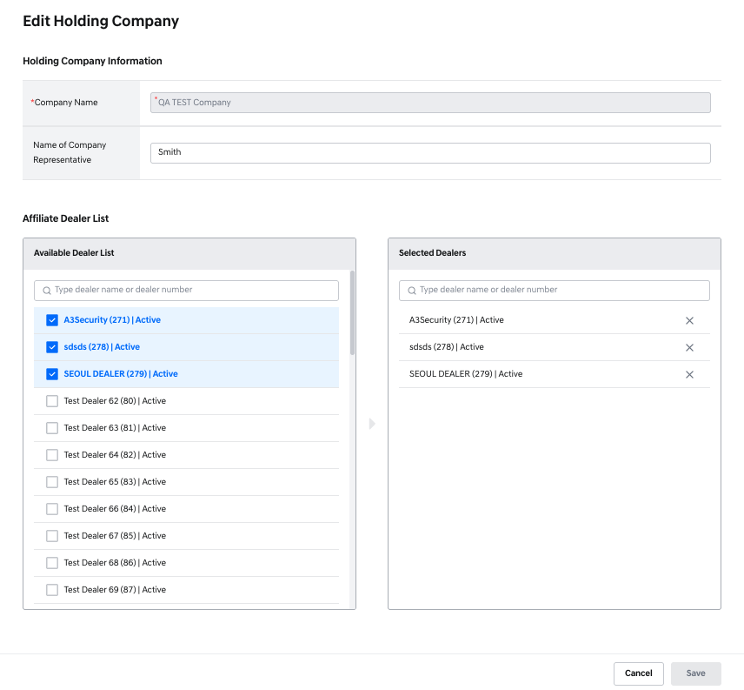
Editing Holding Company
- This screen allows modification of holding company information.
Holding company information
- Company name: Cannot be edited.
- Name of company representative: Can be edited.
Affiliate Dealer List
- The Available Dealer list includes dealers eligible for addition and dealers already affiliated.
- Dealer name, number, and status are shown.
  - Dealers are displayed in the following status priority: Active, Under Termination, Inactive, Terminated then sorted by name.
- Search dealers by name in both the Available Dealer list and Selected dealers.
- Checked dealers are added to Selected dealers.
- Unchecking or clicking the x removes them from Selected dealers.
Action Buttons
- [cancel]: Discards any changes and returns to the previous screen.
- [save]: Triggers a popup displaying the names and numbers of dealers added or removed.
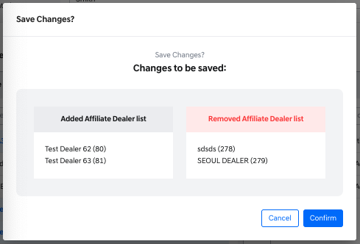
Change Save Popup
- Click [confirm] to apply the changes.
- Click [Cancel] in the popup to discard the changes and return to the edit screen.
- Clicking the [cancel] button on the main screen will also discard all changes and navigate back.

6. Job Management

Job List View
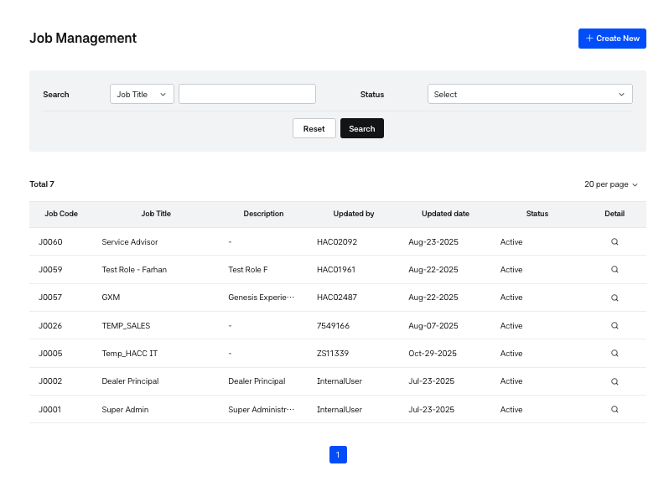
Job List
This screen allows you to view all created Jobs.
- Job Code: A unique code automatically assigned when a job is created.
- Job Title: The name of the job.
- Description: A brief explanation of the job's role or purpose.
- Updated Date: The ID of the last user who updated the job.
- Status: Indicates whether the job is active or inactive.
  - Active: The job is active and will appear as an available option in the Job selection dropdown on the Dealer Employee Management screen.
  - Inactive: The job is inactive and will not appear as a selectable option in the Dealer Employee Management screen.
- Dealer employees who were already assigned to an inactive job can still log in, but cannot use the service.
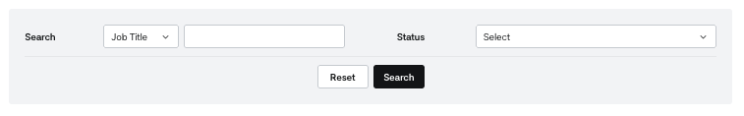
Job List - Search
Job Search Filters
The Job List screen provides search filters to help you find specific jobs.
- Job Title: Search by job title.
- Job Code: Search by job code.
- Status: Filter by job status (Active/Inactive).
- Reset: Clears all selected filter conditions.
- Search: Performs a search based on the selected filters.
[Create New]: Click to navigate to the Job Creation screen.

Job Creation
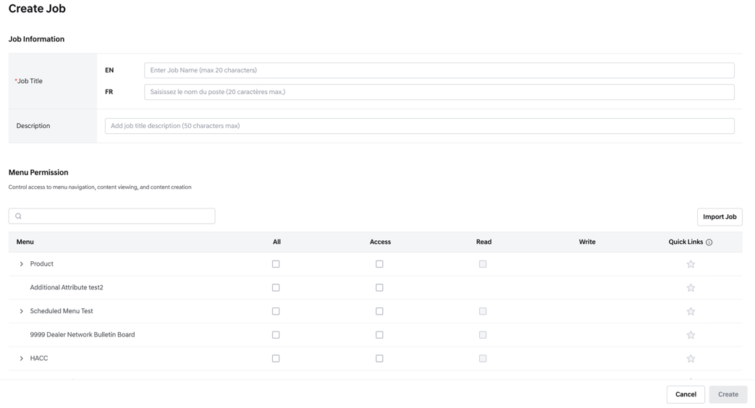
Creating Job
Job Information
• Job Title
- This is a required field.
- Must be entered in both English and French.
- Maximum length: 20 characters.
• Description
- This is an optional field.
- Provides a brief explanation of the job role.
- Maximum length: 50 characters.
Menu Permission
- Only Active menus are displayed.
- Displays the permissions that have been configured in the Menu Management screen.
- Define the menu permissions to be mapped to the job being created.
- Menu permissions follow a hierarchical structure:
  - The parent menu must have at least Access permission to allow permission assignment to its child menus.
  - Access permission is required to add Read permission.
  - Read permission is required to add Write permission.
  - The All button selects all available permissions for that menu.
- Permission options are displayed as checkboxes:
  - (Empty): Permission can be granted.
  - (Partially enabled): Can be granted if the parent permission is assigned.
  - (Checked): Permission has been granted.
- Enter keywords in the search bar to quickly find a specific menu.
  - The menu’s hierarchy structure is also visible for context.
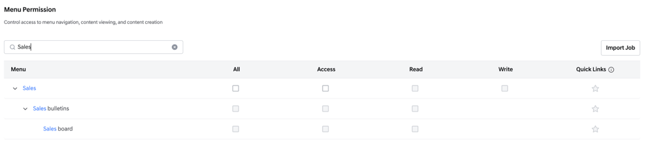
Searching Keywords
Quick Link Preset
- This is a feature that allows administrators to predefine Quick Links for each Job.
- When a dealer employee is assigned to a Job for the first time, and there are no existing Quick Links, the preset Quick Links for that Job are automatically applied.
- Editing the preset for a Job does not affect users who already have their own Quick Links.
- If a user loses access permission to a menu, the corresponding Quick Link is automatically removed.
- A tooltip is provided to check the permission requirements for registering a Quick Link.
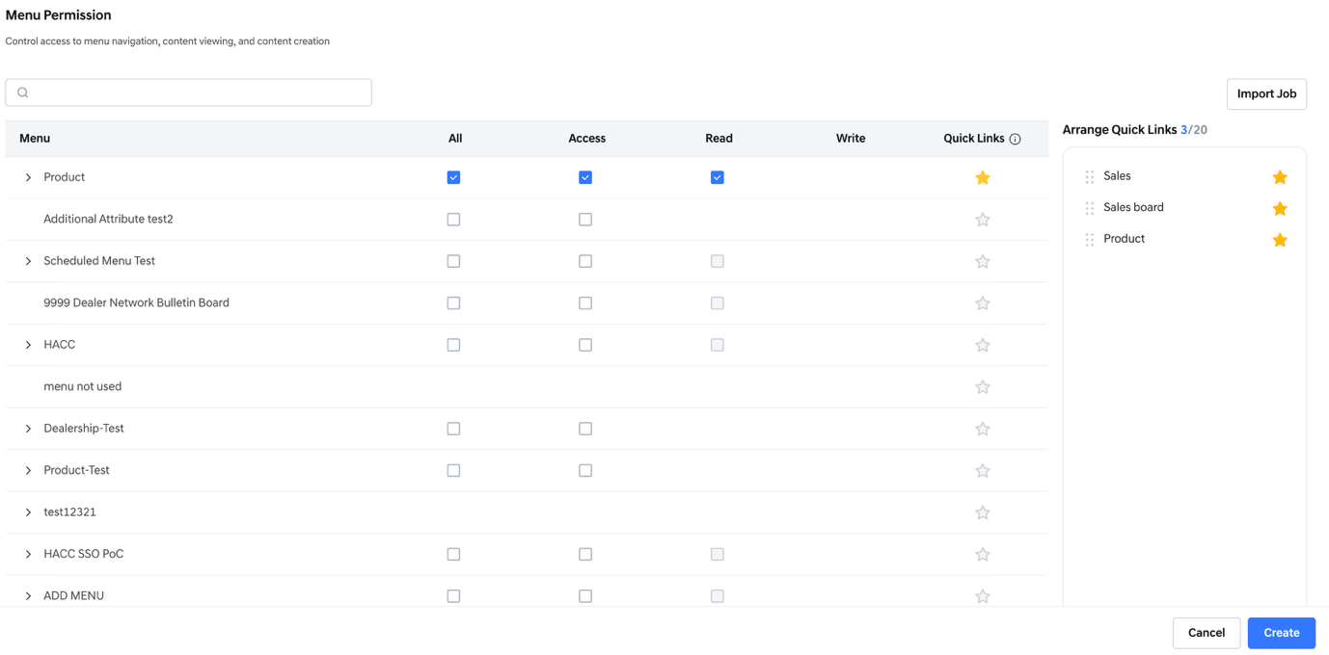
Quick Link Preset Management
- Up to 20 Quick Links can be registered for each Job.
- Clicking the star icon next to a menu adds it to the Quick Link preset.
-  : Status of being added to quick link
-  : Status of not being added to quick link
-  : Status requiring permission to add Quick Link
- Clicking the star icon next to a menu adds it to the Quick Link preset.
- Selected menus are displayed in the Quick Link list on the right side of the screen.
- Clicking the six-dot icon and dragging changes the order of Quick Links.
- When 20 items are already registered, an alert is displayed: “You can add up to 20 items.”
- Clicking the star icon again removes the menu from the Quick Link list.
Import Job
- A feature that allows you to copy the permissions from an existing job.
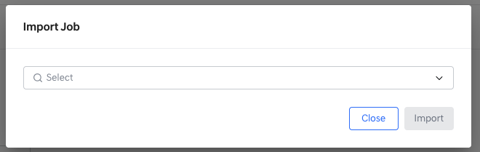
Import Job popup
- The [Import Job] button on the right allows you to load the permission list from an already existing job.
- Select a job and click [Import] to apply its permissions.
- The Quick Link presets configured for that job are imported together.
- If any job permissions have already been configured on the current screen, they will not be overwritten by the import.
Action Buttons
- [Create]: Creates a new job. A unique Job Code will be generated upon creation.
- [Cancel]: Cancels the creation process. Any entered information will not be saved.

View Job
- In the Job Management List screen, clicking [Detail] allows you to view the detailed information of the selected job.
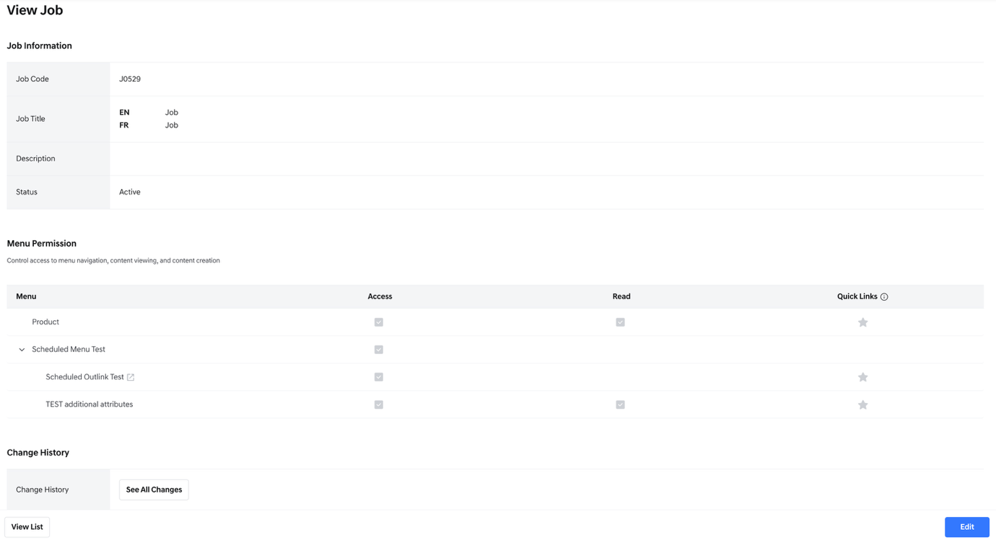
Job Detail
Job Information
- Job Code: The code automatically assigned when the job is created.
- Job Title: The name of the job, provided in both English and French.
- Description: A brief explanation of the job role.
- Status: The current status of the job. When first created, the status is set to Active by default.
Menu Permission
- Displays the list of menu-specific permissions and Quick Links mapped to the job.
- On the view screen, only menus (e.g., bulletin boards) with assigned permissions will be shown.
- Change History
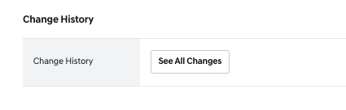
Job - Change History
- If a job has been modified after creation, you can view its edit history.
- Clicking [See All Changes] will open a pop-up displaying the full list of changes.
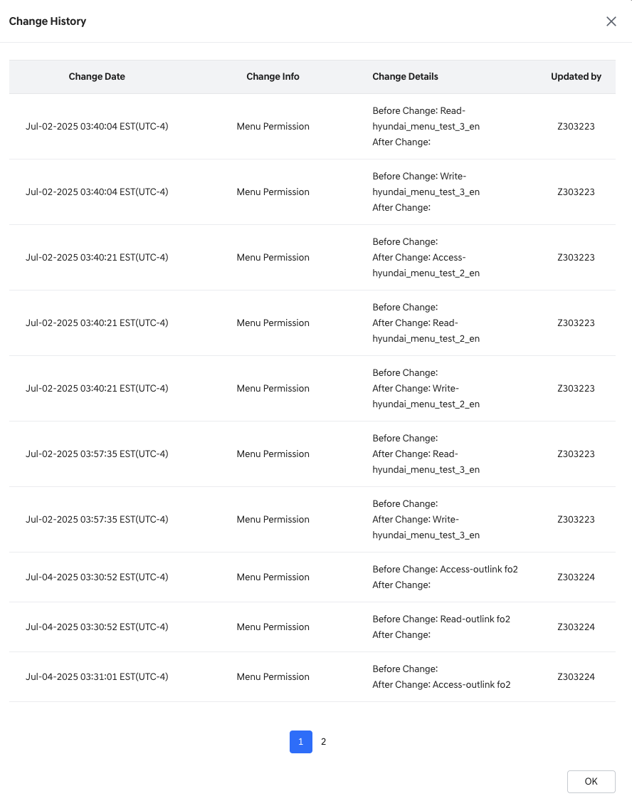
Change History Popup
- Change Date: The date and time when the change occurred.
- Change Info: The specific field or item that was modified.
- Change Details: Displays both the before and after values of the change.
  - Permission Change Format:
  - Changes are displayed in the format: [Permission Name – Bulletin Board Name].
  - If a permission was added, it will appear under After Change with the permission and bulletin name.
  - If a permission was removed, it will appear under Before Change.
  - Updated By: The employee number of the user who made the change.
- Action Buttons
  - [View List]: Navigates to the Job List screen.
  - [Edit]: Opens the Edit Job screen for the selected job.
    - If the job is Super Admin or Dealer Principal, an alert will indicate that editing is not allowed.

Job Editing
- From the View Job screen, clicking [Edit] will take you to a screen where you can modify the job details.
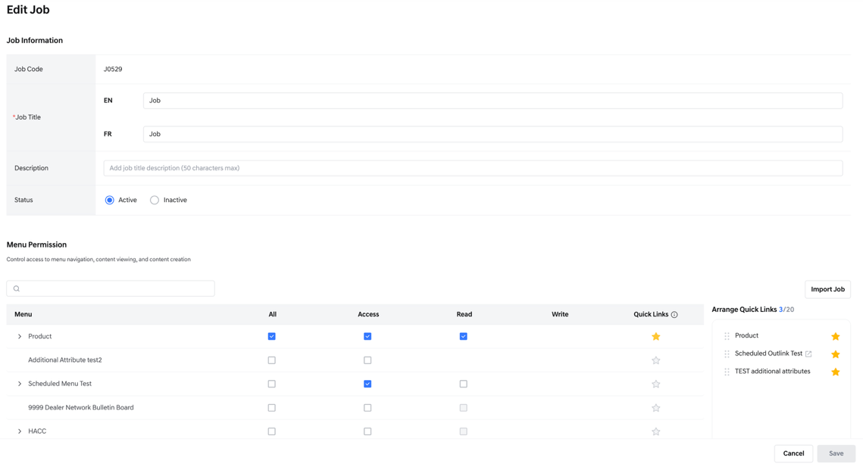
Editing Job
- Job Code: Displayed as read-only and cannot be edited.
- Job Title: Editable in both English (EN) and French (FR).
- Description: Editable field to update the job description.
- Status:
  - Active: The job is active and will be available in the Job selection dropdown on the Dealer Employee Management screen.
  - Inactive: The job is inactive and will not be available as a selection option on the Dealer Employee Management screen.
Menu Permission & Quick Links
- The menu permissions and Quick Links appear the same as when the job was originally created.
You can review and modify them if needed.
Action Buttons
- [Cancel]: Cancels the action and returns to the previous screen.
- [Save]: Becomes active only when changes are made. Saves and applies the modifications.

7. Dealer employee Management

Dealer Employee List View
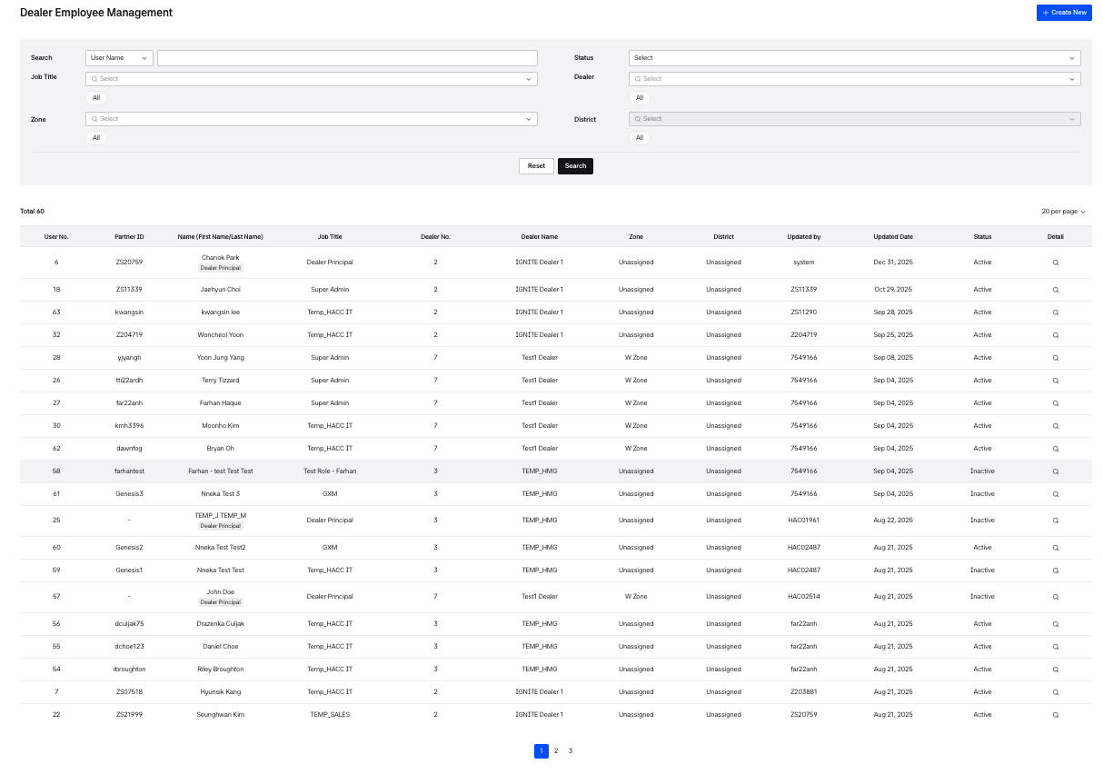
Dealer Employee List
This is a page where you can create, view, and modify the accounts and information of all users registered in Dealers.
- UserNo.: The user's No.
- ID: The user's ID. If the user has no ID, “-” is displayed.
- Name(first name/last name): The user's name
- Job title: The job title assigned to the user
- Dealer no.: The number of the dealership to which the account belongs
- Dealer name: The name of the dealership to which the account belongs
- Zone: Shows the user’s assigned dealer zone. If none is assigned, “Unassigned” is displayed.
- District: Shows the user’s assigned dealer district. If none is assigned, “Unassigned” is displayed.
- Updated by: The ID of the user who created or recently modified the account
- Updated date: The date the account was created or recently modified
- Status: The status value of the account
  - Active: Account is in active state
  - Inactive: Account is in inactive state
- Detail: Screen to view detailed information of the employee
- Clicking [Create New] moves to the screen for creating new dealer employee information.
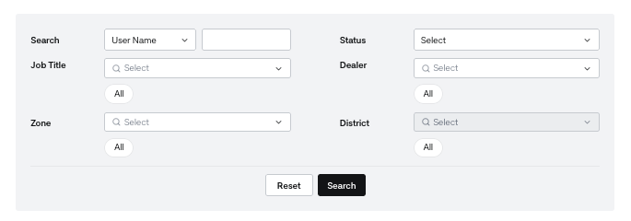
Dealer Employee - Search
You can search for employees according to specific conditions.
- User Name: You can search by the user's name
- User No.: You can search by the user's user No.
- ID: You can search by the user's ID
- Job title: Select the job title assigned to the user. Multiple selections are possible, and selected items are displayed in the job title area below.
  - If no Job is assigned, you can search by selecting ‘None’.
- Status: You can search according to the status of the user account
You can also search using the information of the dealer the user is assigned to.
- Dealer: You can search by the user's Dealer.
- Zone: You can search by the zone information of the dealer the user is assigned to.
- District: You can search by the district information of the dealer the user is assigned to. The district field is enabled only after a zone is selected, and by default, all districts are selected.
- [Reset] initializes the filter conditions and resets the search results.
- [Search] displays search results for users that match the set conditions.

Dealer Employee Creation
- This is the Create Dealer Employee screen for creating a new dealer employee account.
- Click [Create New] on the dealer employee list to open it. Dealer employees cannot be deleted.
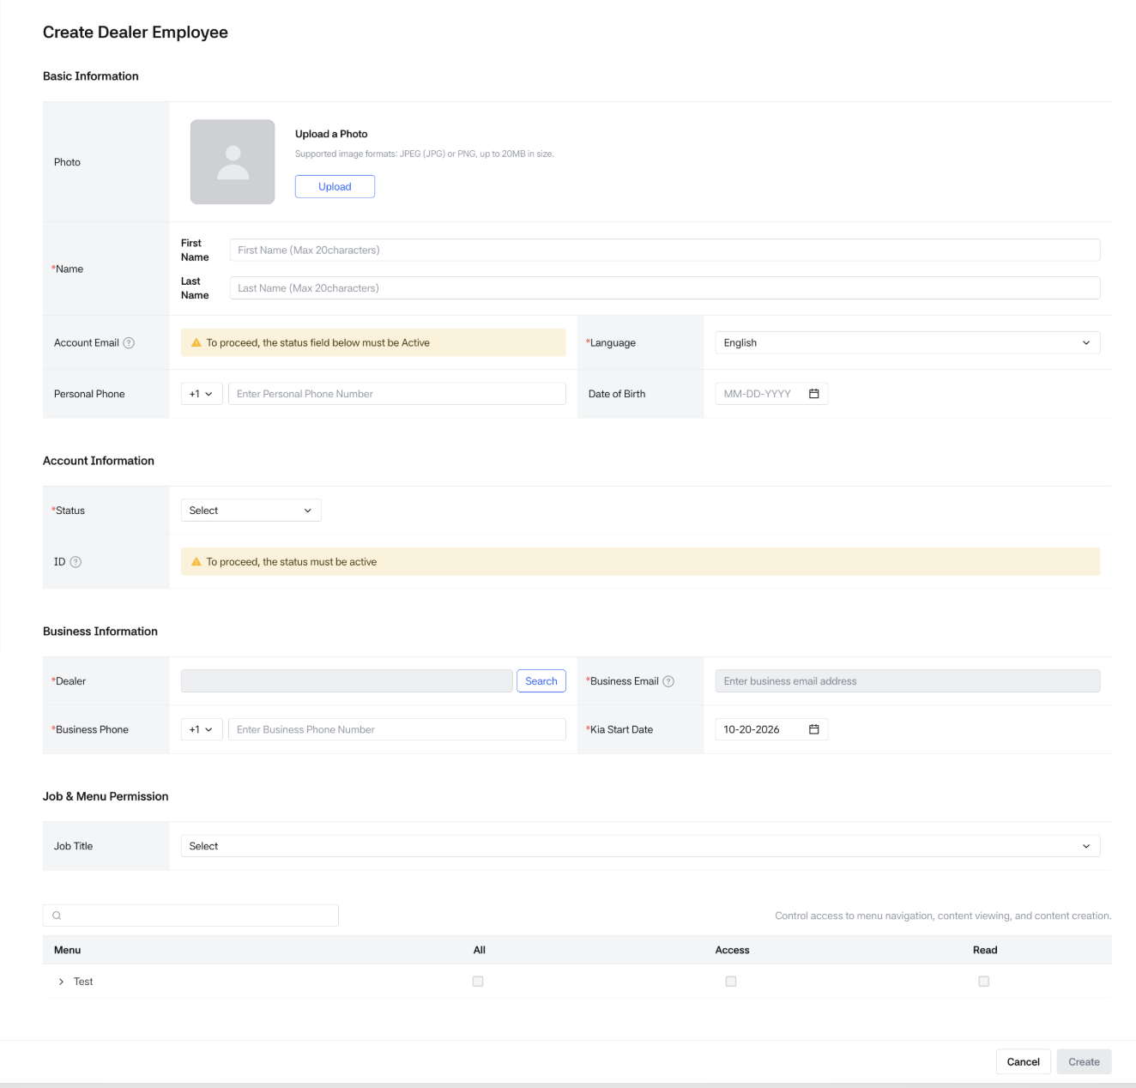
Creating Dealer Employee
Basic Information
- Photo:
  - Optional. Register one photo of the dealer employee.
  - Required for the Dealer Principal. If not uploaded, the error "Please upload a photo" is shown.
  - If no photo is registered, an auto-generated initial avatar is displayed for the employee on the View screen.
- Name:
  - First name: Required. 20 characters allowed. Leading/trailing spaces and special characters or digits are not allowed.
  - Last name: Required. 20 characters allowed. Leading/trailing spaces and special characters or digits are not allowed.
- Language:
  - Required. Value for setting the dealer employee's language.
  - Determines the language displayed on the user's login screen and the emails sent.
  - Select English or French. The default is English.
- Personal Phone: Optional. Enter the dealer employee's personal phone number.
  - Country code must be selected from either +1 or +82, with +1 provided as the default value.
  - Up to 15 characters; only digits and "-" are allowed.
- Date of Birth:
  - Optional.
  - The dealer employee's birthday information. Select it from the calendar (MM-DD-YYYY).
- Account Email:
  - Required when creating an ID.
  - Tooltip: "This email is used to manage HMG Partner ID, including sending password reset requests."
  - Up to 50 characters, must include "@" and ".", and the domain must be at least 2 characters.
Account Information
- Status: Required. Select Active or Inactive. An ID can be created only when the status is Active.
  - Active: Active state.
  - If the account is initially set to Active, an ID can be created.
- New Account option: Used when creating a new ID.
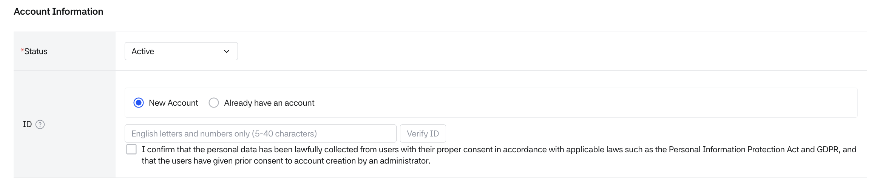
Status - Active
- ID
  - The ID required to access the Dealers service.
  - This is a mandatory field when the account is initially Active.
  - Users can log in to the service using this ID.
  - Must create an account with 5-40 characters combining English letters and numbers
  - Account duplication check is required.
  - Account creation consent is required.
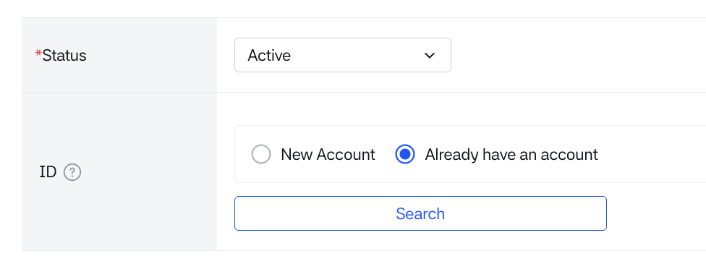
Already have an account option
- Already have an account option:
  - Select this when the employee already has an ID created as a member of another dealer and you want to add information for affiliation with an additional dealer.
  - Search for the ID previously used by an existing dealer employee.
  - When you click the [Search] button next to the input field, the Search Partner ID popup window will open.
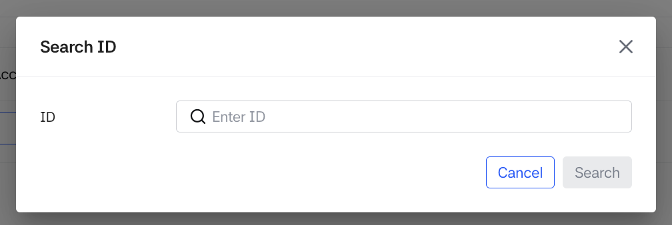
Search existing HMG PartnerID
- When you enter and search for the ID you want to link, some user information will be displayed so you can verify if it is the correct user.
- For privacy, the last character of the name and the last 2 characters of the email’s local part are masked with *.
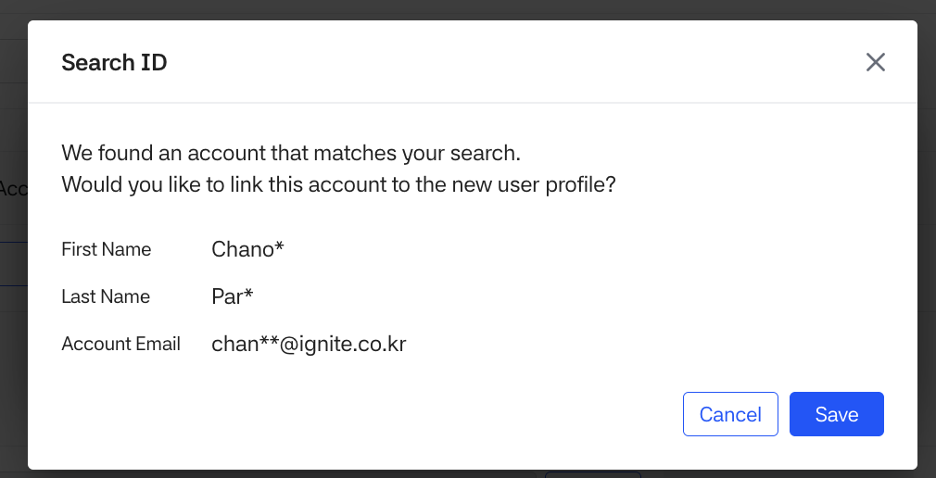
- [Save]: some information for the employee will be imported:
  - Name / Email / Language details
  - If you edit this information, the changes will be applied to all employees sharing the same ID.
- [Cancel]: Cancels this action.

- Inactive: Inactive state.
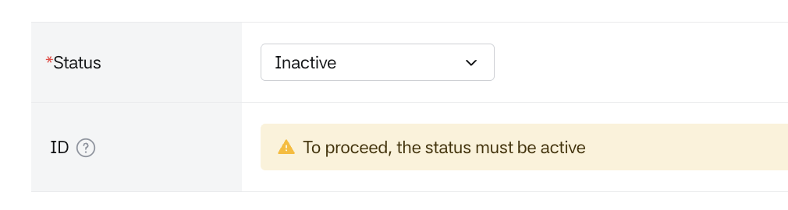
Status - Inactive
- If the account is initially set to Inactive, ID creation is not allowed.

Business Information
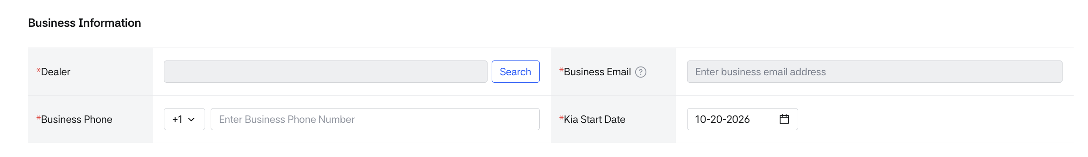
Business Information
- Dealer: This is the item for selecting the dealership to which the dealer employee belongs.
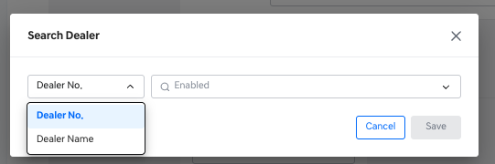
- When you click the [Search] button, a popup is created where you can search for the dealership to which the dealer employee will belong.
- Business Email
  - Required. The business email address of the employee.
  - If a company's email domain is registered for the selected dealer, the available domains are provided as a dropdown for selection.
  - Notification emails for posts published on Dealers will be sent to this email.
  - Disabled until a dealer is selected.
  - When a domain is provided, the default is the default domain set in Dealer Management. The local part allows up to 20 characters.
- Business Phone: Required. Dealer employee's work mobile phone number.
  - Country code must be selected from either +1 or +82, with +1 provided as the default value.
  - Up to 15 characters; only digits and "-" are allowed.
- Kia Start Date :
  - Required. Select the date when the dealer employee started working at the brand.
  - Today's date is automatically entered when the form is first opened, and it can be changed from the calendar.

Job & Menu Permission
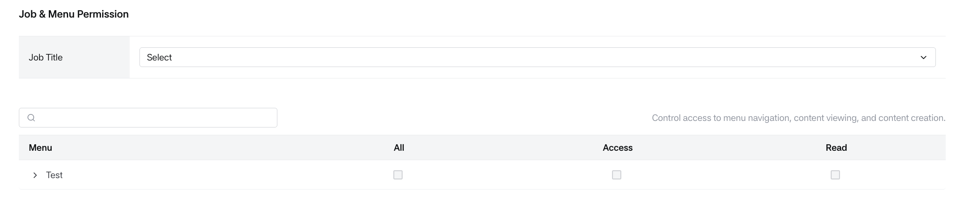
Job & Menu permission
- Job title: User permissions can be granted through job title.
  - Required when the Status is Active, optional when Inactive. Only active jobs from Job management are listed, and Dealer Principal is not listed.
  - Until a job is selected, the 1st-level menus are collapsed and permissions cannot be granted.
  - Changing the job resets all settings.
  - The permissions of the selected job are displayed in the Menu Permission section below.
- Menu Permission
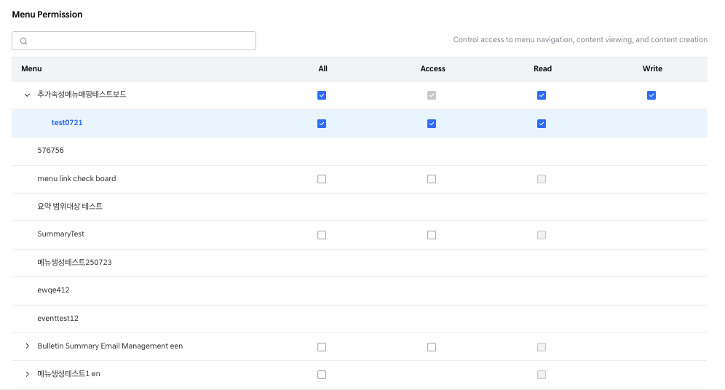
Menu Permission
- This section displays the menu-level permissions mapped to the selected job.
- Use the menu search box to find a menu by name. If nothing matches, "No results found. Try different search terms." is shown.
- In addition to the permissions granted via the job, individual permissions can also be added manually if necessary.
- Permission Descriptions:
  - All: Grants all available permissions for the selected menu at once.
  - Access: Makes the menu visible to the employee.
  - Read: Allows the user to view the bulletin board and read the details within the menu area.
  - Write: Allows the user to create, edit and delete the content.
- How to Grant Permissions
  - You must have at least Access permission for a 1st-level menu in order to assign permissions to its 2nd-level menus.
  - If a 2nd-level menu has existing permissions, you cannot remove all permissions from its parent 1st-level menu.
  - Access permission is required before Read permission can be granted.
Similarly, Read permission is required before Write permission can be granted.
  - If both Access and Read permissions are granted, you cannot uncheck only Access.
  - Unchecking Access will also remove Read permission.
- : Indicates a permission defined by the job. It cannot be modified.
- : Indicates that additional permissions can be assigned.
- : Indicates that a lower-level permission is required before this can be added.
- : Indicates a permission that was manually granted to the individual. This can be unchecked to remove it.
- Action buttons are provided at the bottom.
- Pressing the [Create] button at the bottom checks the entered values and creates the dealer employee account.
- On success, the screen returns to the list.
- When a dealer employee account is created with a new ID, a welcome invitation email is automatically sent to the registered Account Email
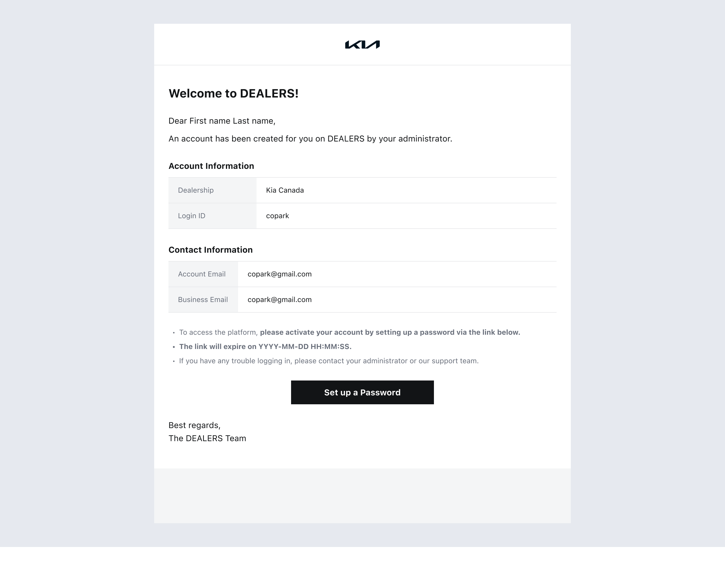
Welcome Invitaiton Email
Dealer Employee View
- From the dealer employee list, you can view detailed information about a dealer employee by clicking on their ID or name.
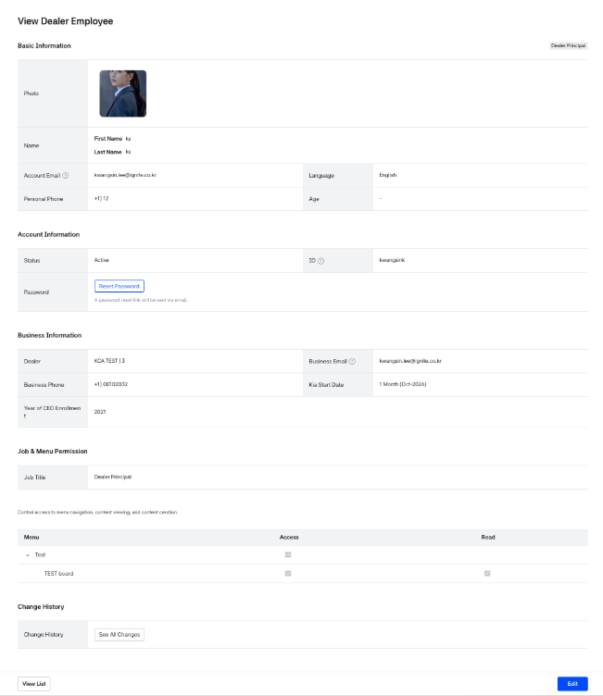
Dealer Employee Detail
- If the dealer employee is registered as a 'dealer principal', a 'dealer principal' badge is displayed at the top.
- If the dealer employee's ID has not been created, an " ID Required" badge will be displayed.
- If registering the employee's permissions failed, a "Job Assignment Needed" badge will be displayed.
Basic information
- User No.: A system-generated user number.
- Name: Employee's name information is displayed
- Status: The status of the account
- ID
  - If not created: The message "Account creation is required" will be displayed.
  - If created: The ID will be displayed.
- Resend Invitation
  - Resends the account activation email to employees who have not completed registration.
  - Displayed when the employee has an ID and is in Not Registered status.
  - The system checks the employee's current registration status via the ID.
  - If still Not Registered → requests HMG Notification to resend the email
  - If already Registered → hides the Resend Invitation and Resend Invitation Log buttons.
- Resend Invitation Log
  - Shows a list of successful manual resend attempts only.
  - Available only while the employee has not completed registration.
  - When the employee completes registration, the Resend Invitation feature and its log are no longer displayed.
- Password:
  - Provides a [Reset Password] button to reset the password.
  - sending a URL to set a new password to the registered email address.
- Account Email: Employee's email information. The email address linked to the ID.
- Business phone: Employee's work phone number
- Personal phone: Employee's personal phone number
- Language: Employee's language setting value
- Age: Displays the age calculated based on the dealer employee's birthday information
- Kia Start Date: Displays the period calculated based on the date the employee started working at Kia up to today.
  - The working period is displayed by calculating only the year and month information.
  - Calculated as 1 month from the month when employment began.
- Year of CEO Enrollment: The year the CEO began working at the dealership. This column is displayed only for the Dealer Principal.
Business information
- Dealer: The name of the dealership to which the employee belongs is indicated.
- Business Email: The business email address of the employee. Notification emails for posts published on Dealers will be sent to this email.

Job & Menu Permission
- Job title: Displays the job title assigned to the account.
- Displays the menu-level permissions granted through the employee’s job assignment as well as any individually added permissions.
- Only the menus and permissions assigned to the employee will be shown.

Change History
- Shows any changes made after the employee account was created.
- Clicking the [See All Changes] button allows you to view the employee’s change history.
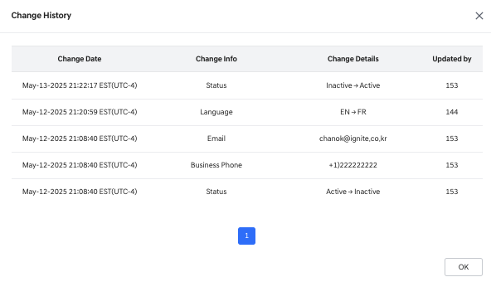
Change History Popup
- Change Date: The date and time when the change occurred.
- Change Info: The specific field that was updated.
- Change Details: Detailed information about what was changed.
- Updated By: The User ID of the person who made the change.
  - If the change was made from the FO (Front Office), the ** ID** will be shown.
  - If the change was made from the BO (Back Office), the Login ID will be shown.
- Action buttons are provided at the bottom
- Clicking [View List] at the bottom returns to the inquiry screen
- Pressing the [Edit] button modifies the employee's information
Dealer Employee Editing
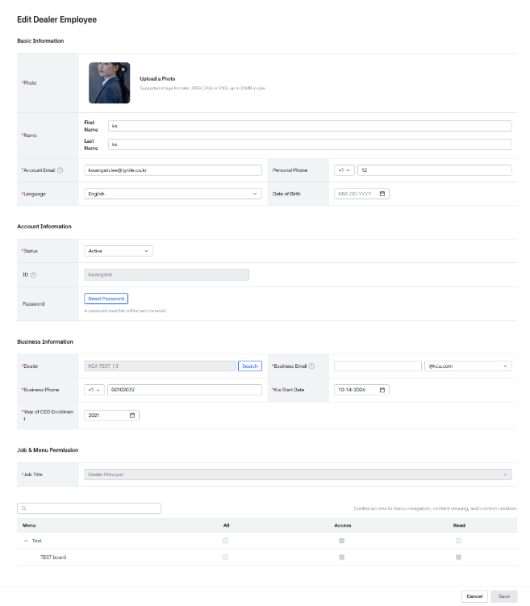
Editing Dealer Employee
- When modifying dealer information, the screen displays the fields entered during dealer creation, and most are provided in a form that can be modified.
- If ID has not been created, changing the status to Active will enable ID creation.
- As shown on the creation screen, you can either create a new ID or link a user who already has an existing ID.
- The account creation process will follow the same flow as in the Dealer Employee Creation screen.
  - If you link an existing user, the values connected to the ID—such as name, email, and language—will be imported from the other registered account.
  - If the user is associated with multiple dealers,
    - editing this information will also update the data for all employees sharing the same ID.
    - Name (First/Last Name)
    - Account Email
    - Language
  - When creating a new account
    - Must create an account with 5-40 characters combining English letters and numbers.
- Account duplication check is required. If not duplicated, the verify ID button changes to [Verified].
- Account creation is completed only after the user provides consent.
- The [Reset Password] function is also available on the Dealer Modification screen.
- Business Information
  - Dealer: You can change the dealer the employee is affiliated with.
    - If the employee is a Dealer Principal, the affiliated dealer cannot be changed.
    - If the dealership affiliation changes, the Business Email must be re-entered.
    - Dealer Principals cannot change their dealership directly. They must modify their Job first to change the dealership information.
- Job & Menu Permission
  - Job Title: You can change the employee’s assigned job.
  - If the employee is a Dealer Principal, the role can only be reassigned to another user via the [Reassign Dealer Principal] button on the Dealer Management screen.
  - When the job is changed, the Menu Permissions will be reset based on the new job’s default permissions.
Any previously assigned individual permissions will also be cleared.
- Action buttons are provided at the bottom
  - [Cancel] Does not save changes and returns to the previous screen
  - [Save] Saves the changes.

8. Menu Management
- Menu Management is a feature that allows managing menus within Kia Dealers_BO and creating, editing, and deleting menus.
- Menus can be created up to a maximum of 4 depths.
- Menus can be configured according to their publishing purpose by selecting a menu type.
- There are 3 menu types: Same Tab, Bulletin board, and New Tab, and each type can be used to create menus that direct to Link pages, Bulletin board menus, or External links.
- Menu access permissions allow you to manage who can access the menu.

Menu List View
- You can view registered menus in the Menu List and create/edit/delete/move new menus.
- Users with permissions will see the [+ Group Addition] button and can create menus.
- You can search for and select the desired Menu name.
- If no menu is selected, a menu selection guide message is displayed, and when a specific menu is selected, you can view the menu detail screen on the right.
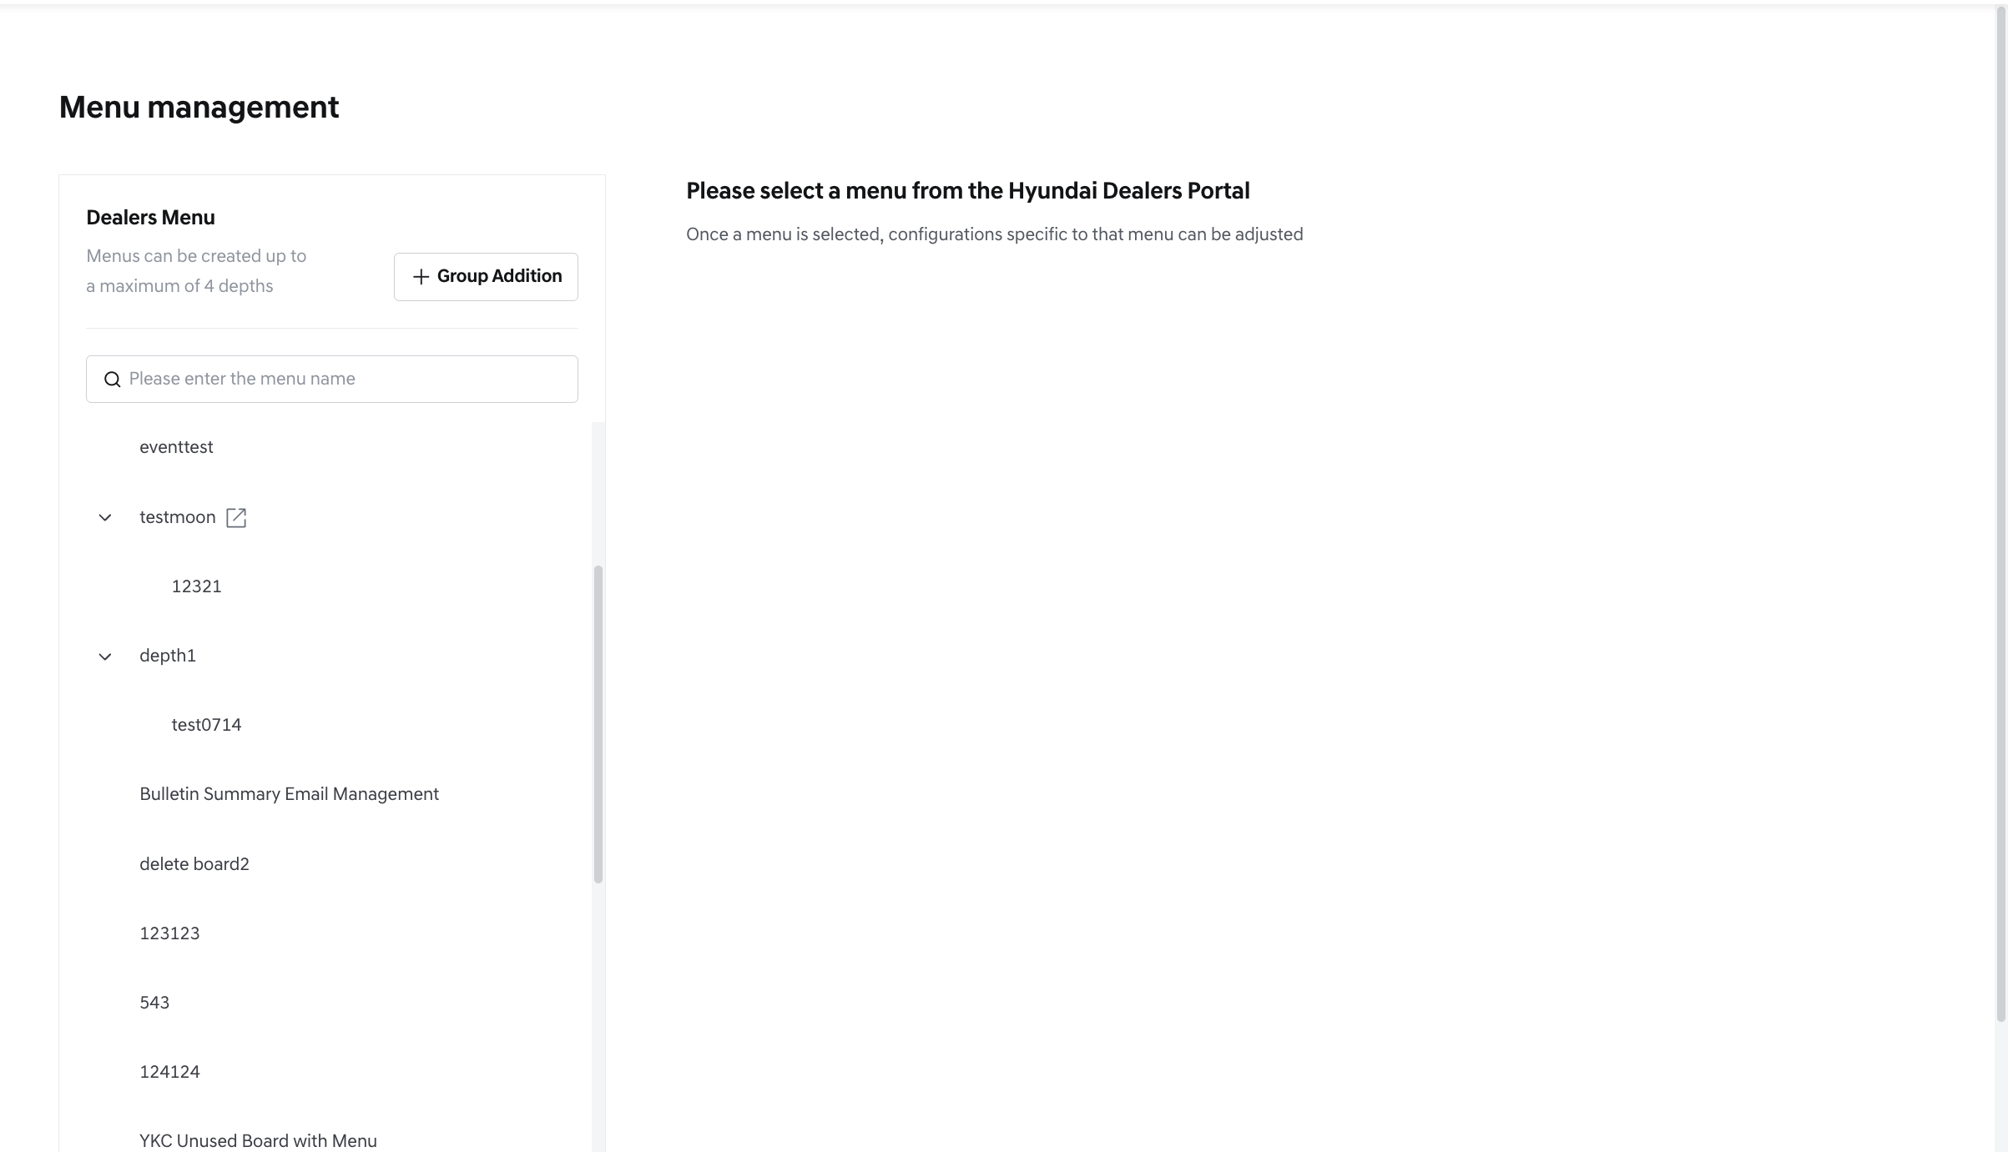
Menu List – initial view
- When hovering over a created menu, you can create sub-menus or delete that menu.
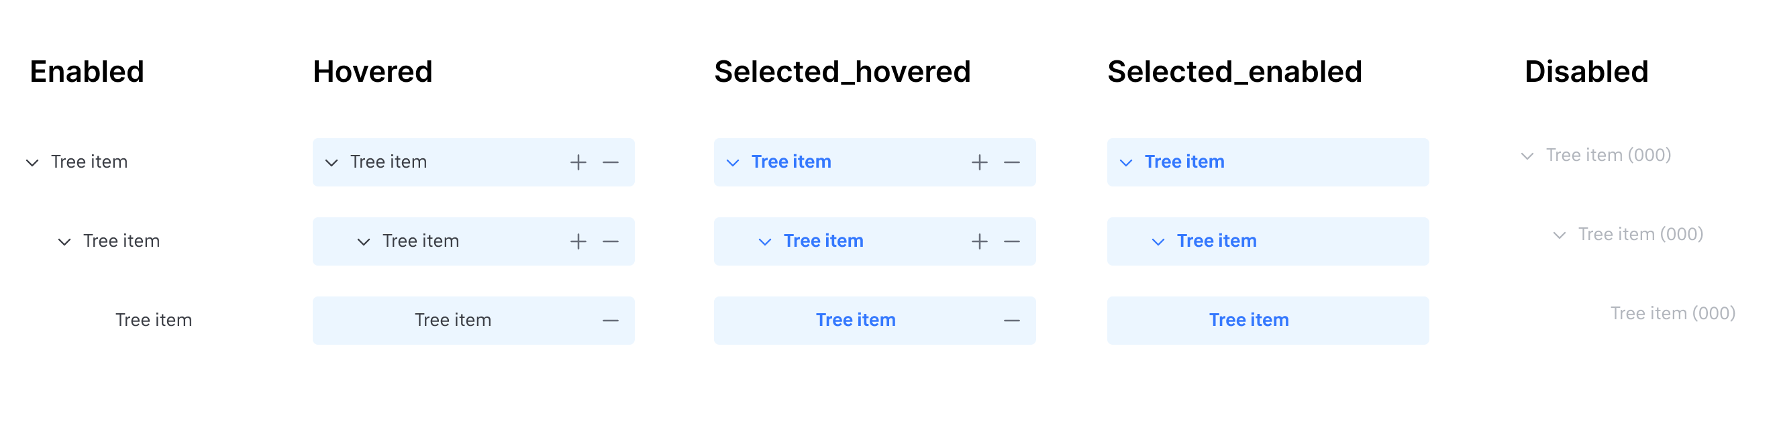
Menu and sub-menu - hovering status
- You can move menus within the same menu level by clicking and holding for 1 second, then drag & drop.
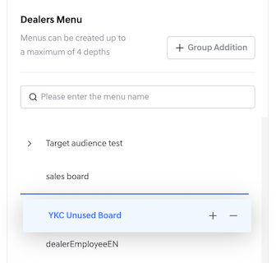
Menu re-ordering
Menu Search & Results
- You can search for Menu names in the menu search box. When you type words in the search box, real-time keyword search (like search) is available.
- Menu search conditions:
  - All hierarchies of menus matching the search criteria are displayed.
  - Keywords matching the search criteria are highlighted with color.
  - Clicking the [x] button on the right after entering search terms deletes all keywords and returns to the initial state.
  - If there are no search results, a "no search results" message is displayed.
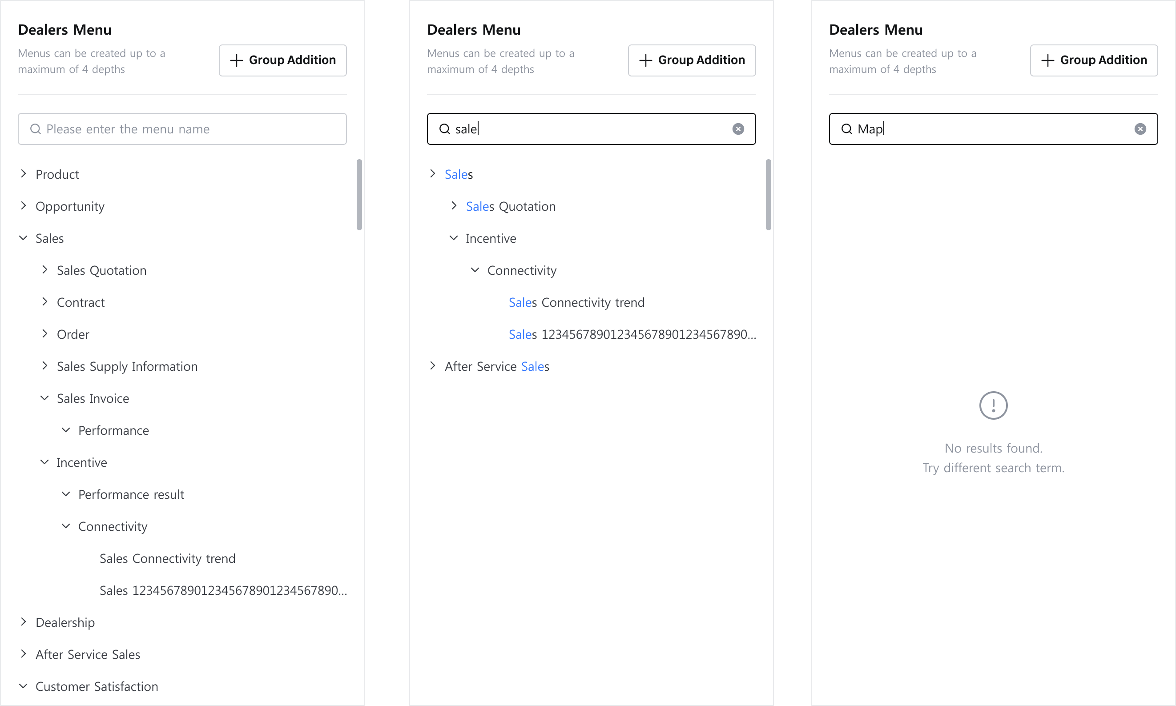
Menu List - Search

Menu Creation
- Menu creation is only available to users with Write permission.
- Users with permissions can create 1-depth menus through the [+ Group Addition] button in the Menu List.
- When hovering over a created menu, you can create sub-menus up to 2-depth through 4-depth.
- When creating a menu, the Menu Detail tab is displayed on the right, where you can enter display properties, Menu Type, basic menu properties, permissions, etc.
- In the Menu Detail screen, you must enter required fields to create a menu.
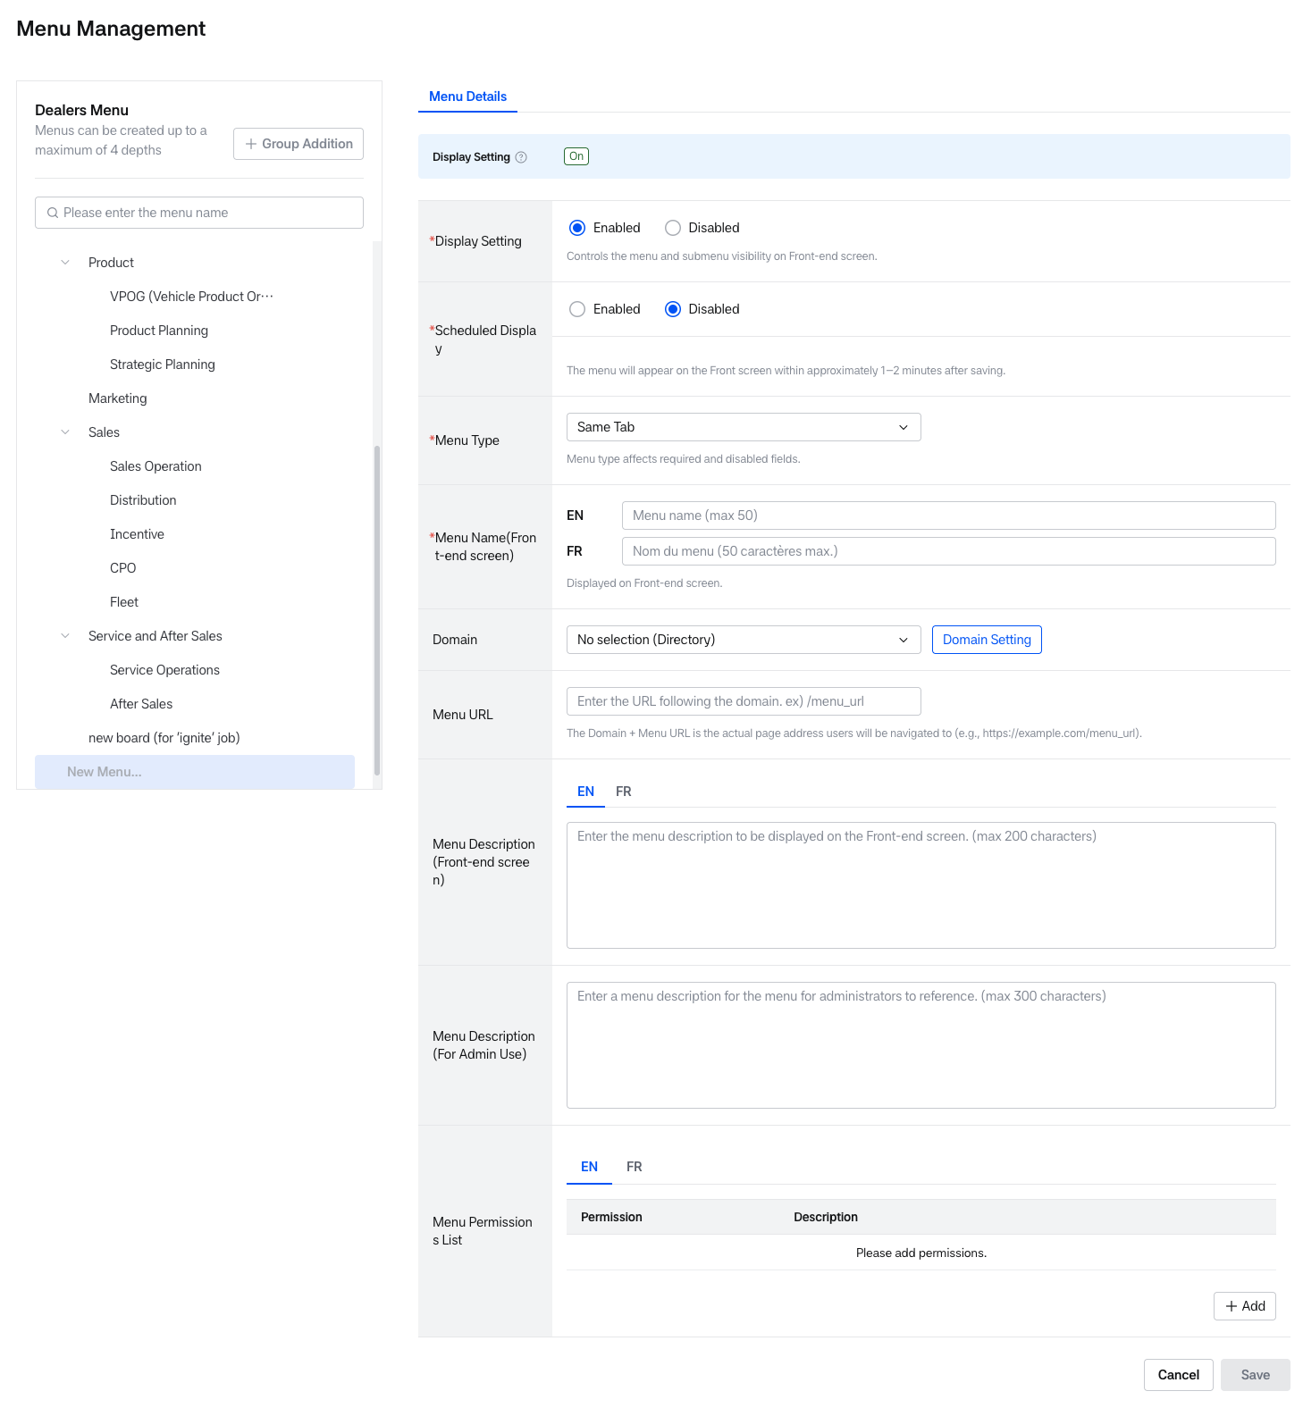
Creating Menu
Menu Display Information
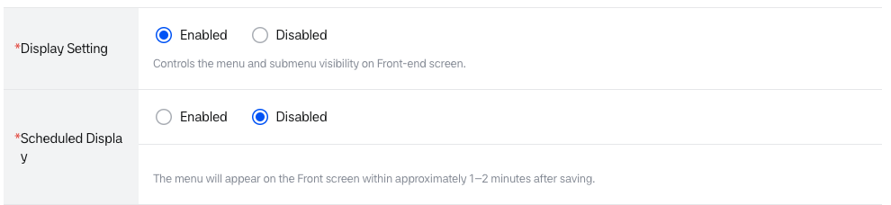
Scheduled Display (Disabled)Default
Creating Menu – Display information
- A status banner at the top of the Menu Detail screen shows the current Display setting (On/Off). If the tenant’s Mobile Web setting (Tenant Management > Basic Information) is enabled, the banner shows separate PC and Mobile statuses; if disabled, only the PC status is shown and the Mobile Display setting field below is not displayed.
- Display setting (Required field): A function to set whether the menu is displayed, allowing you to show or hide the menu in the front menu area.
  - (Default) Enabled: The menu can be displayed on the front screen, and the Scheduled Display function is activated.
  - Disabled: The menu is not displayed on the front screen, and the Scheduled Display function is deactivated. The menu is also shown as disabled in the menu tree.
  - When creating a menu, switching the Display setting takes effect immediately without a confirmation popup.
  - Created Date/Created By: When saving a menu, the date the menu was created and the person who created it are automatically entered.
    - Creation rule: MM DD, YYYY (EST) / ID(employee number)
  - Updated Date/Updated By: The date the menu was modified and the person who modified it are automatically entered.
    - Creation rule: MM DD, YYYY (EST) / ID(employee number)
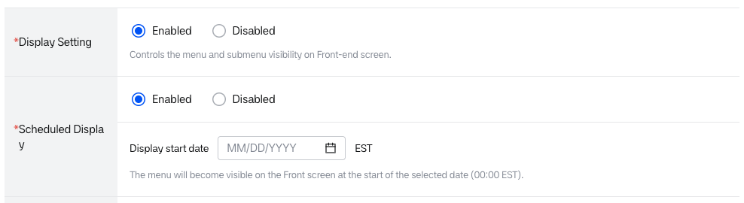
Scheduled Display (Enabled)
- Scheduled Display: A function to plan scheduled menu exposure by setting a specific future display start date, allowing the menu to be displayed on the front screen from that date.
  - Scheduled Display is only available while Display setting is Enabled; when Display setting is Disabled, Scheduled Display is forced to Disabled and cannot be changed.
  - (Default) Disabled: The scheduled menu exposure function is not used. The menu will appear on the Front screen within approximately 1-2 minutes after saving.
  - Enabled: A Display start date field (date only, format MM/DD/YYYY, EST) is displayed. Only dates from the next day onward can be selected; today and past dates are disabled.
  - The menu becomes visible on the Front screen at 00:00 EST of the selected date. Guidance message: “The menu will become visible on the Front screen at the start of the selected date (00:00 EST).”.
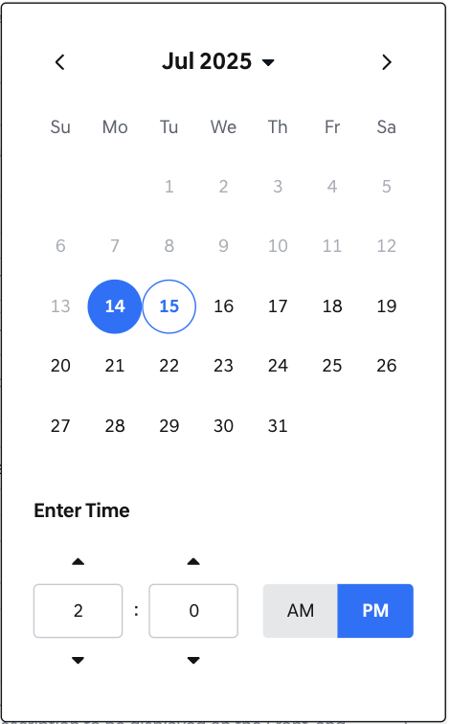
Calendar setting
- If the menu is saved without selecting a date, a validation popup “Please enter required information.” is displayed.
- If the selected date becomes a past date (midnight boundary), a popup “Scheduled Display is set to a past date. Please adjust it to a future date.” is displayed.
- While Scheduled Display is set to Disabled, date validation is skipped.
Menu Basic Information
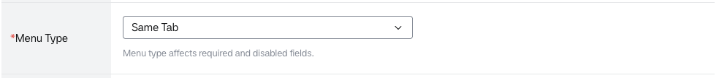
Menu type
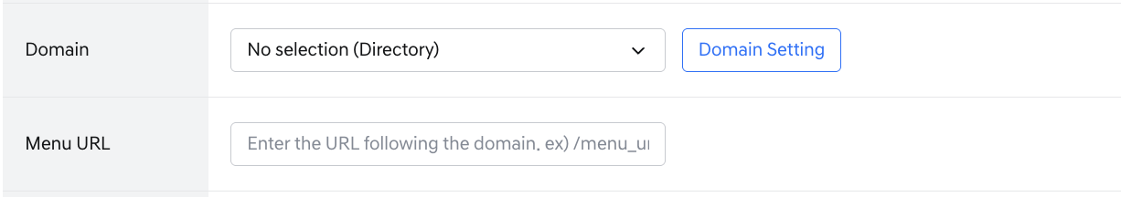
Creating Menu – Basic information
- Menu Type (Required field): A function that determines the type of the menu. There are 3 menu types in total (Same Tab, Bulletin board, New Tab). When changing the menu type, some items will be reset. Menu name, Menu-board mapping, Domain, and Menu URL are reset, while the Menu Permission List is kept as is.
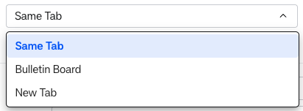
Menu type dropdown
- Domain: A function that specifies which domain the menu operates on. You can select a domain address. The required field input setting for Domain changes according to the Menu type.
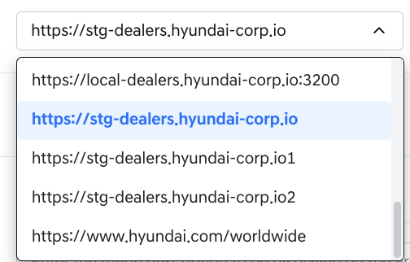
Domain dropdown
- Menu URL: A function to enter the actual page address (URL) that will be connected when a user clicks on the menu. The Domain and Menu URL are combined to complete the link. For menus linked to bulletin boards, the bulletin board ID is automatically entered.
  - Input rules: Up to 240 characters. An empty or null value is automatically set to '/'. If the value does not start with a leading '/', it is automatically corrected to start with '/' at the time of [Save]. Spaces inside the value are allowed. Pasting more than 240 characters shows an immediate inline error “Menu URL Maximum {limit} chars.”.
  - Example:
    - Domain: https://dealers.kia-corp.io
    - Menu URL: /board/5
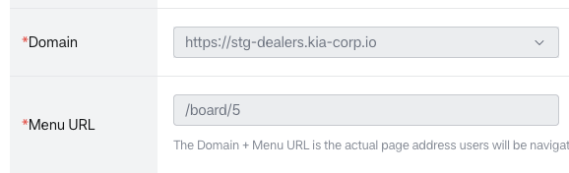
Linking menu-board mapping - Domain and Menu URL
- Is this page implemented with DEALERS’ Frontend Library?: A radio button that marks whether the linked page is built with the DEALERS Frontend Library, so the Front GNB/LNB menu can be highlighted accurately. Displayed below Menu URL only when Menu Type is Same Tab or New Tab and a Domain address (not “No selection (Directory)”) is selected; not displayed for Bulletin Board menus or when Domain is “No selection (Directory)”.
  - YES: The system automatically appends ?menuId={menuId} to the saved Menu URL.
  - (Default) NO: The Menu URL is saved as entered, without the menuId parameter.
- (Default) Same Tab: When selected, Domain has "No selection (Directory)" selected, and Menu name must be entered as required.
  - Purpose: Used as a general menu type, can be used as a Directory menu or Link page navigation menu.
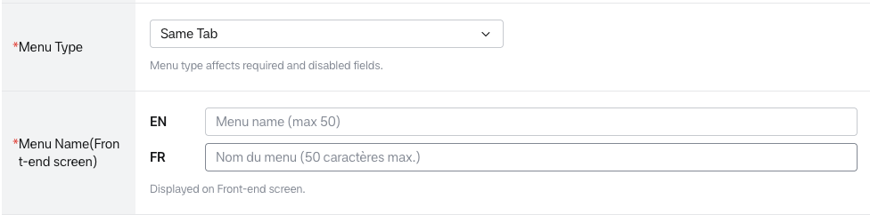
Menu type – Same Tab information 1
- Menus with "No selection (directory)" selected in Domain do not navigate to any screen when clicked. They can be used as directory-purpose menus in a folder open/close format.
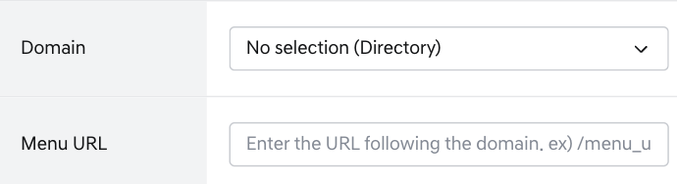
Menu type – Same Tab information 2(Domain: No selection)
- If you select and save a domain address, clicking the menu on the front screen will navigate to that link address.
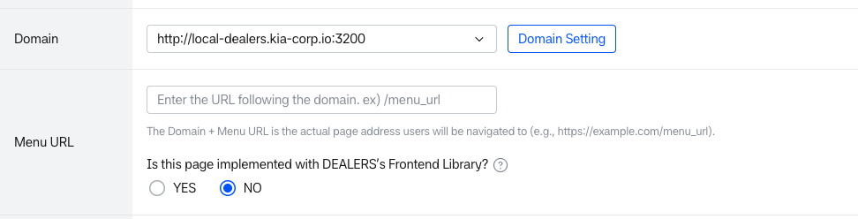
Menu type – Same Tab information3 (Domain: address)
- Bulletin Board: When selected, the 'Menu-Board Mapping' function is exposed, Domain becomes a required field, and Menu name, Domain, Menu URL are set to read-only. (Existing values are removed if any.)
  - Purpose: Can be used as a Bulletin board menu where posts can be published.
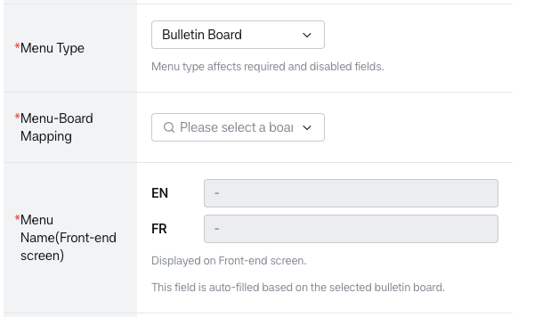
Menu type – Bulletin board information 1
- Menu-Baord Mapping(Required field): When selecting a bulletin board from the dropdown, Menu name, Domain, and Menu URL are automatically entered according to the selected board information.
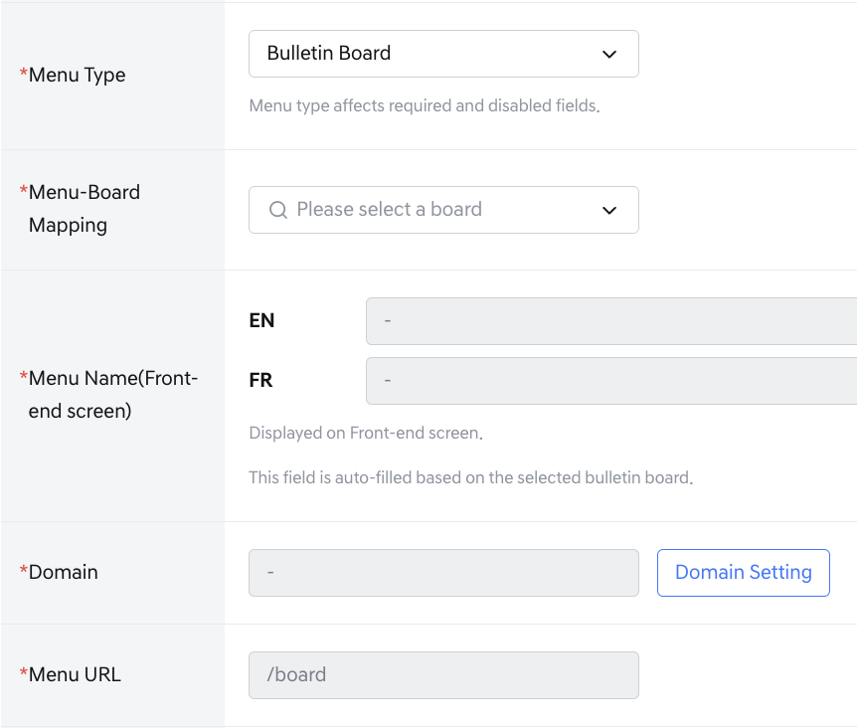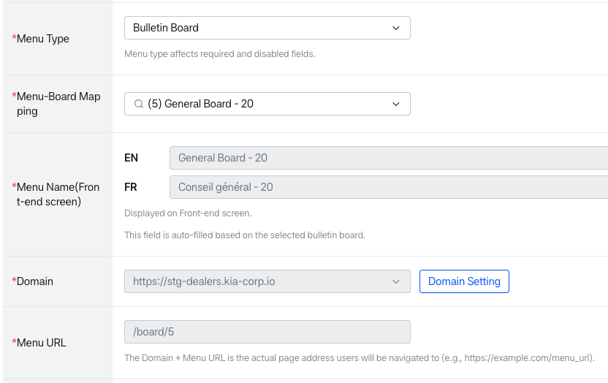
Menu type – Bulletin board information 2
- Menus and bulletin boards can be mapped 1:1, and only mappable bulletin boards are displayed in the dropdown. Bulletin boards already linked to menus are not displayed in the dropdown.
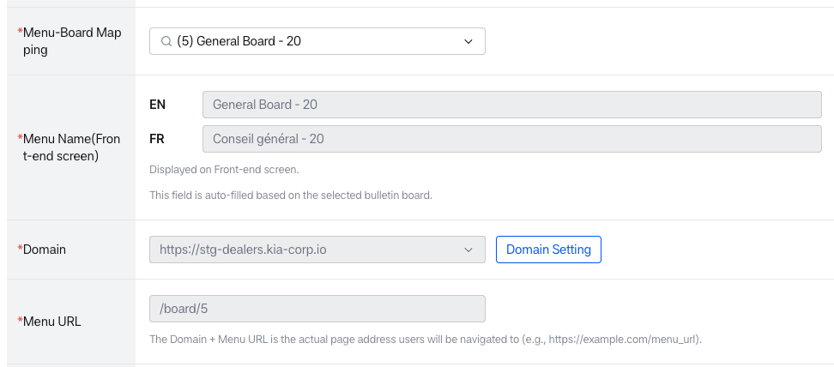
Menu type – Bulletin board information 3
- New Tab: When selected, Menu name and Domain must be entered as required. An New Tab guidance message is displayed under Menu type.
  - Purpose: Can be used as an External Link menu that opens in a new tab to domain addresses other than Dealers page addresses.
  - Domain becomes a required field, and you can create menus that open in new tabs by selecting addresses registered in Domain.
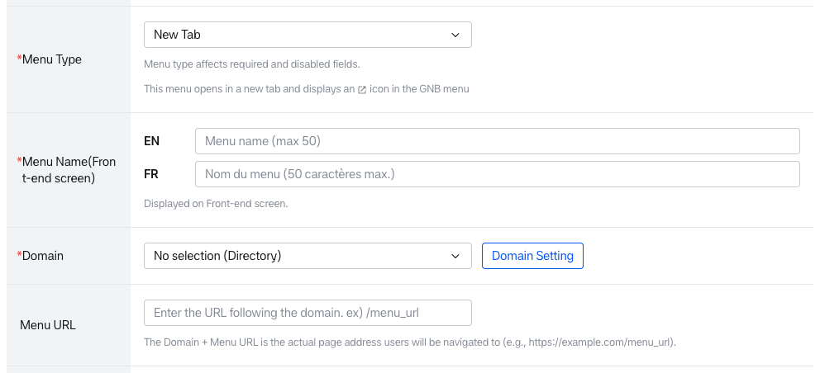
Menu type – New Tab information 1
- Since Domain is a required field, it cannot be saved in "No selection (Directory)" state.
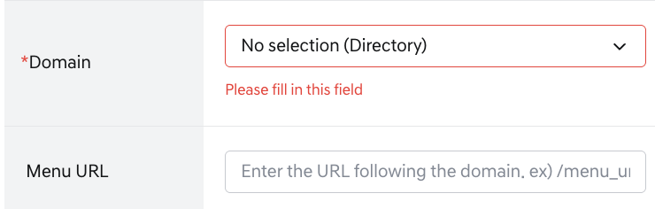
Menu type – New Tab information 2
- If you select and save an external link address in Domain, clicking the menu on the front screen will open a new tab to that address.
Menu type – New Tab information 3
- Domain Setting
Domain Setting
- The [Domain setting] button is only displayed to users with super administrator permissions, allowing them to manage the Domain List.
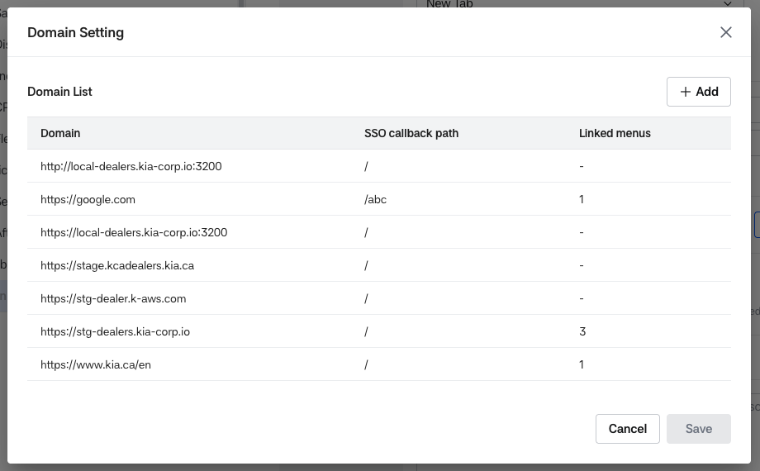
Domain setting list view
- New domains can be added through the [+Add] button, and existing domains can be edited/deleted.
- You can click the domain edit button to enter Domain and SSO callback path.
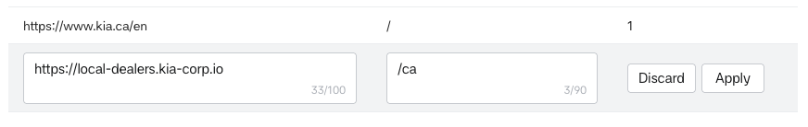
Domain setting add or edit
Editing Domain Setting
- Domain: Placeholder “e.g., https://example.com”, with a character counter (n/100) shown below the input. Validated in order, with an inline error for the first rule that fails:
  - Required (e.g., “Domain is required.”)
  - Maximum 100 characters (e.g., “Domain Maximum 100 chars.”)
  - Must start with a scheme ('http://' or 'https://')
  - Must not end with a trailing '/'
  - Must not contain spaces
  - Must be a valid URL format
  - Must not contain a query string or fragment
  - Must not duplicate an existing domain
- SSO callback path supports SSO that allows movement to all services with just HMG-admin and Dealers system login. Placeholder “e.g., /sso/callback”, with a character counter (n/90) shown below the input.
- SSO callback path input rules: Up to 90 characters can be entered, starting with '/'. Leading/trailing spaces are trimmed automatically. An empty or null value is automatically set to '/'. Absolute URLs are not allowed, and a trailing '/' is not allowed (except when the value is a single '/').
- Clicking [Save] in the Domain Setting popup immediately reflects the change in the Domain List, regardless of whether the menu itself is saved.
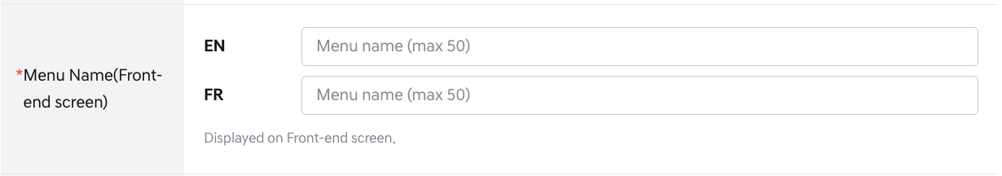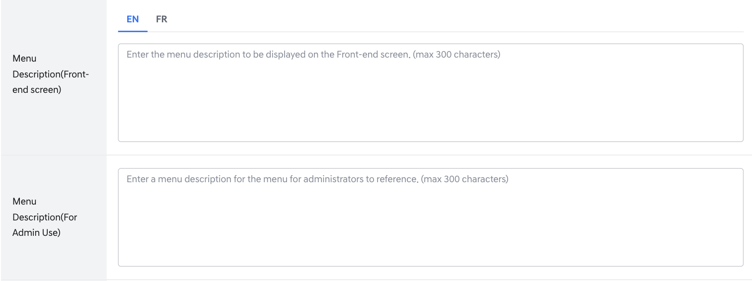
Creating Menu – Basic information 2
- Menu Name (Front-end screen) (Required field): Menu name can be entered up to 50 characters in EN and FR. The languages follow the Primary/Secondary languages set in Tenant Management; for a tenant without a Secondary language, only the Primary language is entered.
- Menu Description (Front-end screen): Menu description displayed on the front screen, can be entered up to 200 characters in EN and FR. All characters, including special characters, are allowed. The languages follow the same Primary/Secondary setting as Menu Name.
- Menu Description (For Admin Use): Menu description entered by operators for internal management purposes, can be entered up to 300 characters.
Menu Display Information 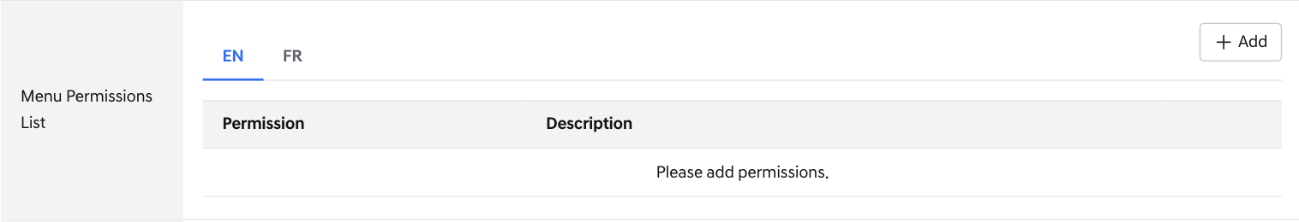
Creating Menu – Permission List information 1
- Menu Permission List: A function to add/delete and manage permissions for the menu.
- Menu permissions must have higher-level permissions added first before lower-level permissions can be added. (Permission hierarchy: Access > Read)
- Menu permissions can be added through the Menu permission [+Add] button, and can be saved when all required fields are entered.
- Menu permissions can be added, edited, and deleted regardless of the Domain setting, including for Same Tab menus whose Domain is “No selection (Directory)”. Permissions added to a parent Directory menu are used when granting Job Title and User permissions to its sub-menus.
- Permission(Required field): Access, Read can be selected, and duplicates are not allowed.
- Permission Description: You can enter a description of the permission. Up to 200 characters can be entered in EN and FR.
- Permission Code: Refers to the permission code automatically issued by the system for each menu upon creation. This field is read-only and cannot be modified by operators.
  - Generation Rule:
    - Format: M{timestamp}_{permission type}
    - Timestamp: Automatically generated by backend logic at the time of menu permission creation. All permissions belonging to the same menu share the same timestamp.
    - Permission Type: Fixed lowercase values — access, read
  - Example:
    - Menu 1: M1232938201_access, M1232938201_read
    - Menu 2: M1232938202_access, M1232938202_read
  - Uniqueness: Duplicate codes are not allowed across the entire system. Uniqueness is guaranteed by the system.
  - Display Policy: The Permission Code field is not displayed on the Create or List screen. It is only visible on the Edit screen after saving, displayed as read-only for reference purposes.
- 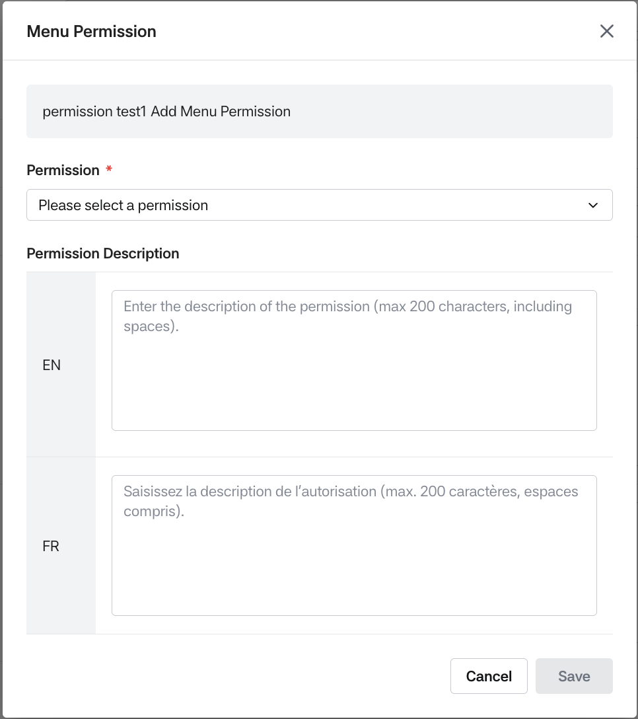
Adding Permission
- You can edit and delete by clicking the Menu permission edit/delete buttons.
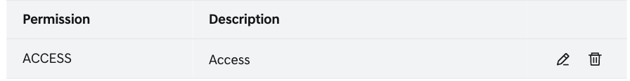
Editing and Deleting Menu permissions
- When deleting, if there are Access permissions in sub-menus, permission removal is not possible.
Menu Save/Cancel
- [Save]: When clicked, if required input values are missing, it cannot be saved and a popup corresponding to validity verification is displayed. When the menu is successfully saved, the menu inquiry screen is displayed.
- [Cancel]: When clicked, if there are changes, an alert is displayed indicating that unsaved changes will be deleted, then the previous screen is displayed.

Menu View
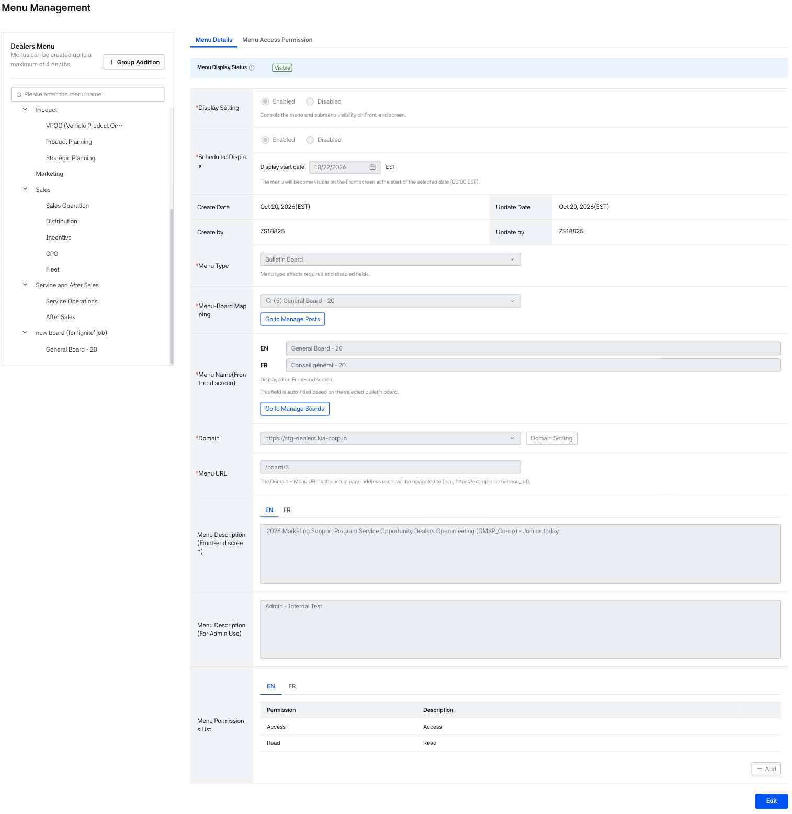
Menu view
Menu Detail
- When a menu is successfully saved or when you click a menu name in the Menu List, you move to the menu detail screen.
- The Menu Detail tab displays saved menu property data, and Menu Access Permission displays job title and user settings that can access the menu.
- Menu Display Status: The banner at the top of the Menu Details tab shows whether the selected menu is currently visible on the Front-end screen.
  - Visible (green dot): The menu is displayed on the Front-end screen.
  - Not Visible (gray dot): The menu is not displayed on the Front-end screen.
  - If the tenant uses Mobile Web, the banner shows both values, for example “PC: Visible Mobile: Not Visible”. If the tenant does not use Mobile Web, the banner shows a single value, for example “Visible”.
  - Hover over the info icon to see how visibility is decided. For a 1st-depth menu, the tooltip reads “This menu’s visibility is based on its own Display Setting & Scheduled Display.” For 2nd- to 4th-depth menus, the tooltip adds “If the parent menu is hidden, this menu will not appear on the Front-end screen, regardless of its own Display Setting.”
  - A menu is visible when Display Setting is Enabled and Scheduled Display is Disabled, or when Scheduled Display is Enabled and the display start date has passed. A menu is not visible when Display Setting is Disabled (including its submenus), or when Scheduled Display is Enabled and the display start date is in the future.
- Scheduled Display: When Scheduled Display is Enabled, Display start date is shown as a date (MM/DD/YYYY) and the menu is displayed from 00:00 on the selected date. When Scheduled Display is Disabled, the Display start date field is hidden.
- Created Date/Created By: When saving a menu, the date the menu was created and the person who created it are automatically entered.
  - Creation rule: MM DD, YYYY (EST) / ID(employee number)
- Updated Date/Updated By: The date the menu was modified and the person who modified it are automatically entered.
  - Creation rule: MM DD, YYYY (EST) / ID(employee number)
- When Menu type is selected as Bulletin board, [Go to manage Board] and [Go to manage Post] buttons are displayed according to permissions.
  - [Go to manage Board]: When clicked, moves to the bulletin board inquiry screen linked to the menu.
  - [Go to manage Post]: When clicked, moves to the post list screen of the bulletin board linked to the menu.

Menu Editing
- You can move to each editing screen by clicking the [Edit] button in Menu Details and Menu access permission.
Display setting and Scheduled Display
- Display setting (PC):
  - When changing the Display setting from Enabled to Disabled on the Menu Edit screen, a confirmation popup is always displayed, regardless of the Scheduled Display status or whether a date has been entered. (The Menu Creation screen has no popup.)
    - Title: “Do you want to hide this menu?”
    - Message: “Turning the Display Setting OFF will hide this menu and its sub-menus, and reset any related scheduled display settings.”
    - [Cancel]: Closes the popup only, and the Display setting stays Enabled.
    - [Confirm]: Changes the Display setting to Disabled, greys out the whole Schedule Display section, and shows Scheduled Display as Disabled. The scheduled display settings are actually reset (date saved as empty) when [Save] is clicked.
  - When changing the Display setting from Disabled to Enabled, Scheduled Display is reset to Disabled even if it was previously Enabled (for example, with a past date), so the menu can be saved immediately without date validation.
- Scheduled Display date:
  - When Scheduled Display is switched from Disabled to Enabled, the date is empty (MM/DD/YYYY) and must be entered directly, as on the Menu Creation screen. A previously saved date is not restored, even if Scheduled Display is switched off and on again after saving.
  - Selectable dates start from the next day. Today and past dates are greyed out.
  - If only the Menu name, Menu type, description, or permissions are edited without changing the date, no validation error occurs even if the existing Display start date is in the past. If the date is changed, the new date validation is applied.
  - If the start date of a menu that is currently visible is changed to a future date, the Change Start Date popup is displayed.
  - If the selected date becomes a past date when saving (midnight boundary), a popup is displayed.
Menu Access Permissions 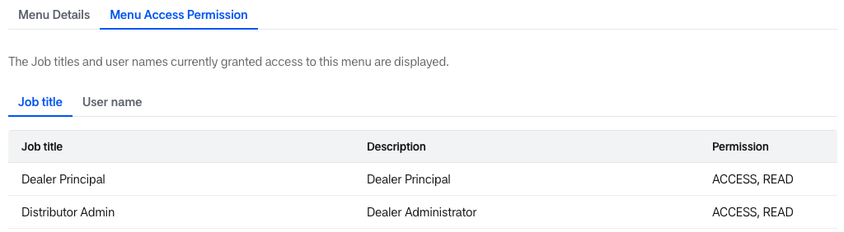
Menu access permissions List

- When clicking the [Edit] button in Menu access permission, the conditions are checked in the following four steps, and a pop-up is displayed according to the first condition that applies. The same steps apply to both the Job title tab and the User name tab, and also to the first access right after a menu is created.
  - Current menu has no menu permission: The Add Menu Permission pop-up is displayed.
    - [Go to Setting]: Moves to the Menu Details tab of the current menu and focuses on the permission area.
    - [Later]: Closes the pop-up only.
  - Parent menu has no menu permission (skipped if there is no parent menu): The Add Parent Menu Permission pop-up is displayed.
    - [Go to Setting]: Moves to the Menu Details tab of the parent menu and focuses on the permission area.
    - [Later]: Closes the pop-up only.
  - Current menu has Job title permissions other than Dealer Principal / Dealer Admin (User name permissions on the User name tab): The Menu Access Permission pop-up is displayed, and you can grant permissions (Access, Read, etc.) to job titles (or user names) that can access the menu. For a 1 Depth menu, the same pop-up is displayed even if there are no such permissions.
  - Parent menu has Job title permissions other than Dealer Principal / Dealer Admin (User name permissions on the User name tab): The Import {target} Permissions pop-up is displayed. If there are none, the Add Parent Menu Access Permission pop-up is displayed. {target} is Job Title or User.
    - Import {target} Permissions: “Would you like to import {target} permissions from the parent menu? The parent menu’s {target} permissions will be automatically applied to this menu.”
      - [Import]: Copies the parent menu permissions to the current menu, closes the pop-up, and shows the copied permissions in the list screen.
      - [Add Manually]: Moves to the Edit screen with no permissions selected.
    - Add Parent Menu Access Permission:
      - [Go to Setting]: Moves to the Menu Access Permissions tab (list screen) of the parent menu.
      - [Later]: Closes the pop-up only.
      - On the User name tab, the pop-up message is “No menu access permissions have been set for the parent menu. Users must be added to the parent menu before they can be assigned to sub-menus.”
- [Import] copies only the permissions that are registered in the Permission List of the current menu and also checked in the parent menu. For example, if the current menu has only Access and the parent menu has Access and Read, only Access is copied. After copying, the list is sorted by the Job title / User sorting rule.
- After clicking [Later], clicking [Edit] again starts again from step 1. If the condition is not resolved, the same pop-up is displayed again.

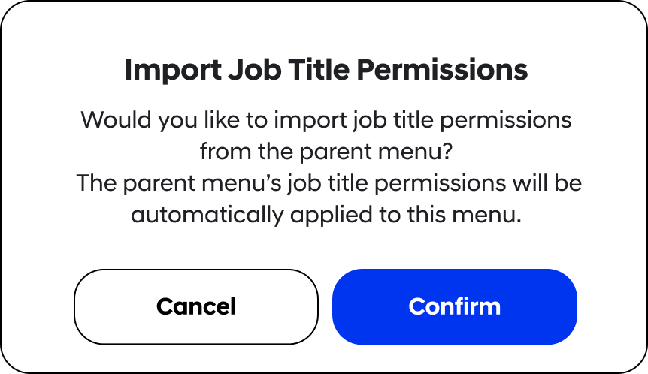
Menu access permissions List – Import Job title pop-up

- In the Menu Access Permission pop-up, the Job title popup shows the Job titles that the User belongs to even if that User has permissions (Job and User permissions can overlap). The User name pop-up does not show Users who are already included in a selected Job title.
- A permission cannot be removed on the Job title tab if a sub-menu has the Job-access permission, and on the User name tab if a sub-menu has the User-access permission.
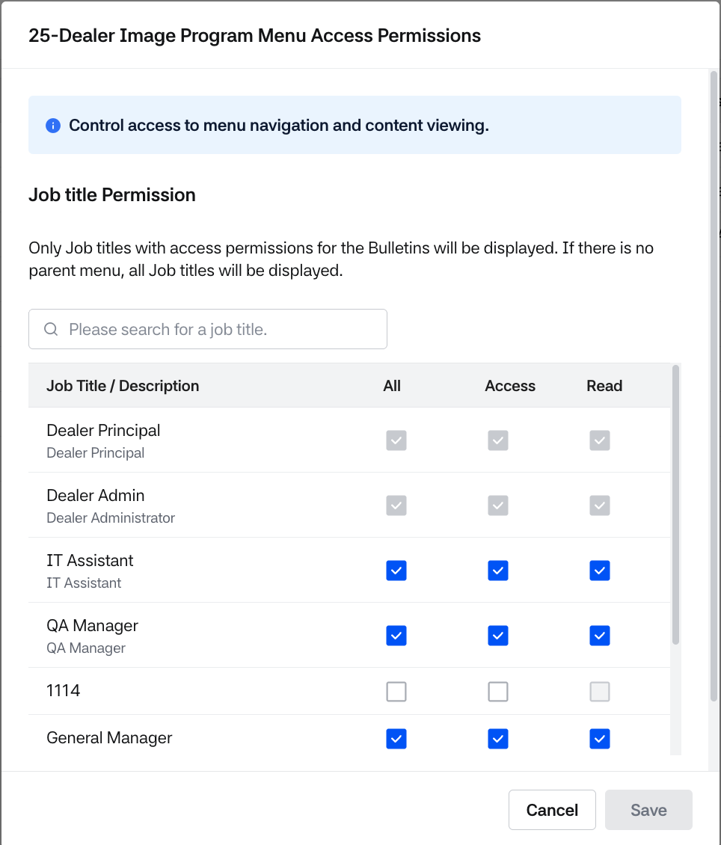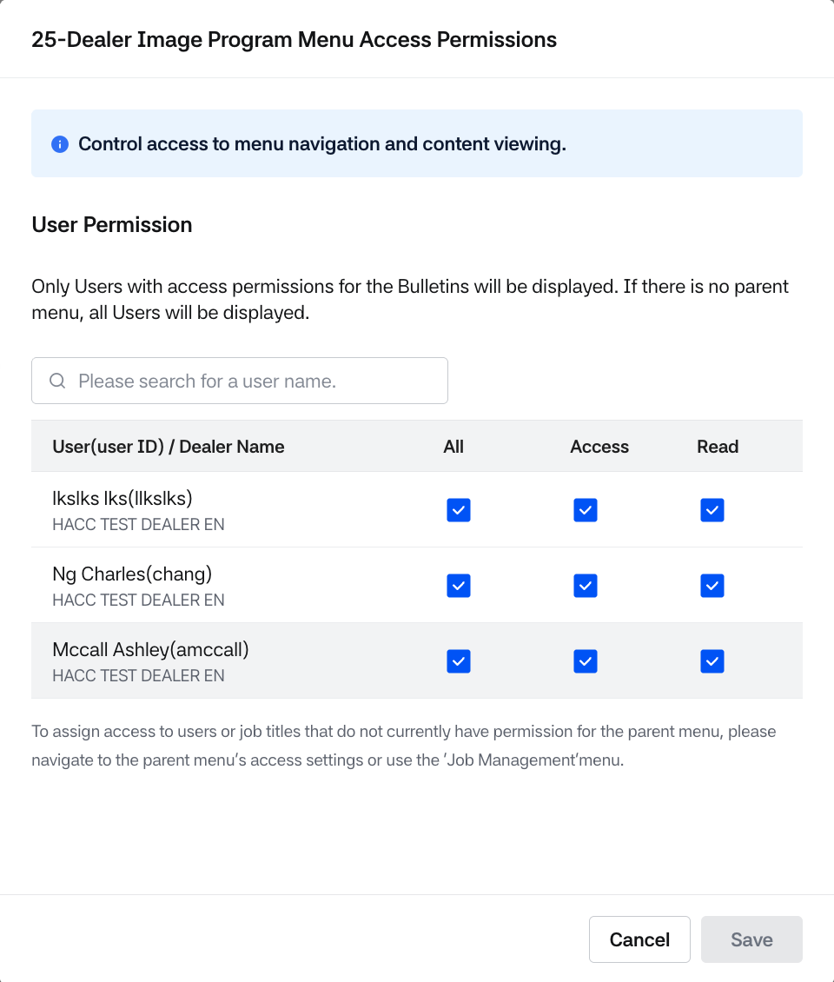
Menu access permissions pop-up detail
- If there are modified permissions, saving is possible, and a permission change notification popup is displayed.

Menu Deletion
- Menu deletion is only available to users with write permissions.
- When a user with permissions selects a menu and hovers over it, the [Delete] button is displayed, and the menu can be deleted through this button.
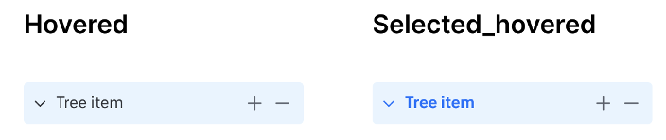
- Menu deletion conditions:
  - When there are no sub-menus
  - When there are no mapped bulletin boards
- When a menu is deleted, permissions created for that menu are also deleted together.
- When deleting a menu with mapped bulletin boards, the Menu-Board mapping is released and only the menu can be deleted.
- 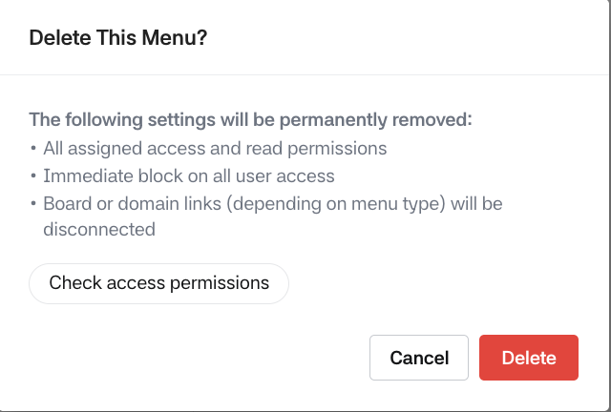

9. Bulletin Board Management
- Bulletin board management is a feature that allows the BO system to create, modify, and delete bulletin boards.
- Each bulletin board is configured according to the purpose of posting information on the site.
- Bulletin board includes attribute conditions for linking with post writing/viewing.

Bulletin Board List
- When accessing the Bulletin Board Management menu, a full page with a search panel and a list of registered bulletin boards opens. The previous board tree panel and inline detail panel are no longer displayed.
- The bulletin board list displays Board ID, Board Name, Menu-Board Mapping, Menu Path, Created By, Updated By, Created Date, and Updated Date.
- When clicking the [+ New Board] button at the top right, you move to the bulletin board creation page.
- When clicking a row in the list, you move to the Board Details page of the bulletin board.
- When a tenant or brand is added, the system automatically creates an Announcement Board, which is a system-fixed bulletin board that cannot be deleted.
  - The Announcement Board is identified by the "System" label displayed in the board list.
  - The Announcement Board has predefined properties that cannot be modified. These items are visible on the view screen but cannot be edited or modified on the edit screen.
    - The following attributes are Enabled (mandatory and always active): Posting Period, Important Notice (top pinning), Notification, and Attachments.
    - The following attributes are Disabled: Post Target and Additional Properties.
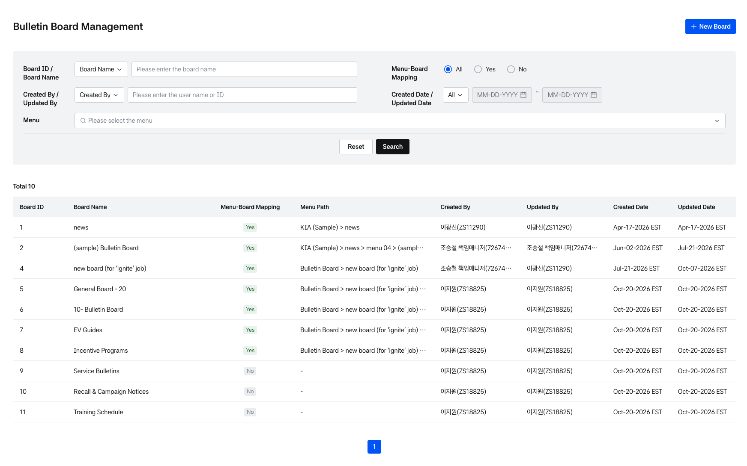
Bulletin board list
Bulletin Board Search & Result
- Search conditions in the search panel:
  - Board ID / Board Name: Select the criteria in the dropdown (default: Board Name) and enter text. The placeholder changes according to the selected criteria (Please enter the board name / Please enter the board ID).
  - Menu-Board Mapping: Select All, Yes, or No (default: All).
  - Created By / Updated By: Select the criteria in the dropdown (default: Created By) and enter a user name or ID (Please enter the user name or ID).
  - Created Date / Updated Date: Select the criteria in the dropdown (default: All), then enter the From ~ To dates (MM-DD-YYYY). The date fields are enabled after you select a criteria other than All.
  - Menu: Select one or more top-level (depth 1) menus in the multi-select dropdown (Please select the menu). Typing in the field filters the options. Selected menus are checked and displayed as chips below the field; clicking the x on a chip removes the chip and clears the check. Boards linked to the sub-menus of the selected menu are also searched.
- Clicking the [Reset] button clears all entered text and chips and returns the dropdowns and radio buttons to their default values.
- When Menu-Board Mapping is set to No, the Menu dropdown is disabled.
- Bulletin board list:
  - Menu-Board Mapping shows whether the board is linked to a menu, and Menu Path shows the menu hierarchy separated by > (for example, Sales > Bulletins > 20-General). If the board is not linked to a menu, - is displayed in Menu Path.
  - Created By / Updated By are displayed in the Name(Employee ID) format.
  - The Announcement Board is displayed at the top of the list, followed by the other boards in ascending order of Board ID.
  - If a value is longer than the column width, it is truncated with ..., and the full text is displayed as a tooltip when you hover over it.
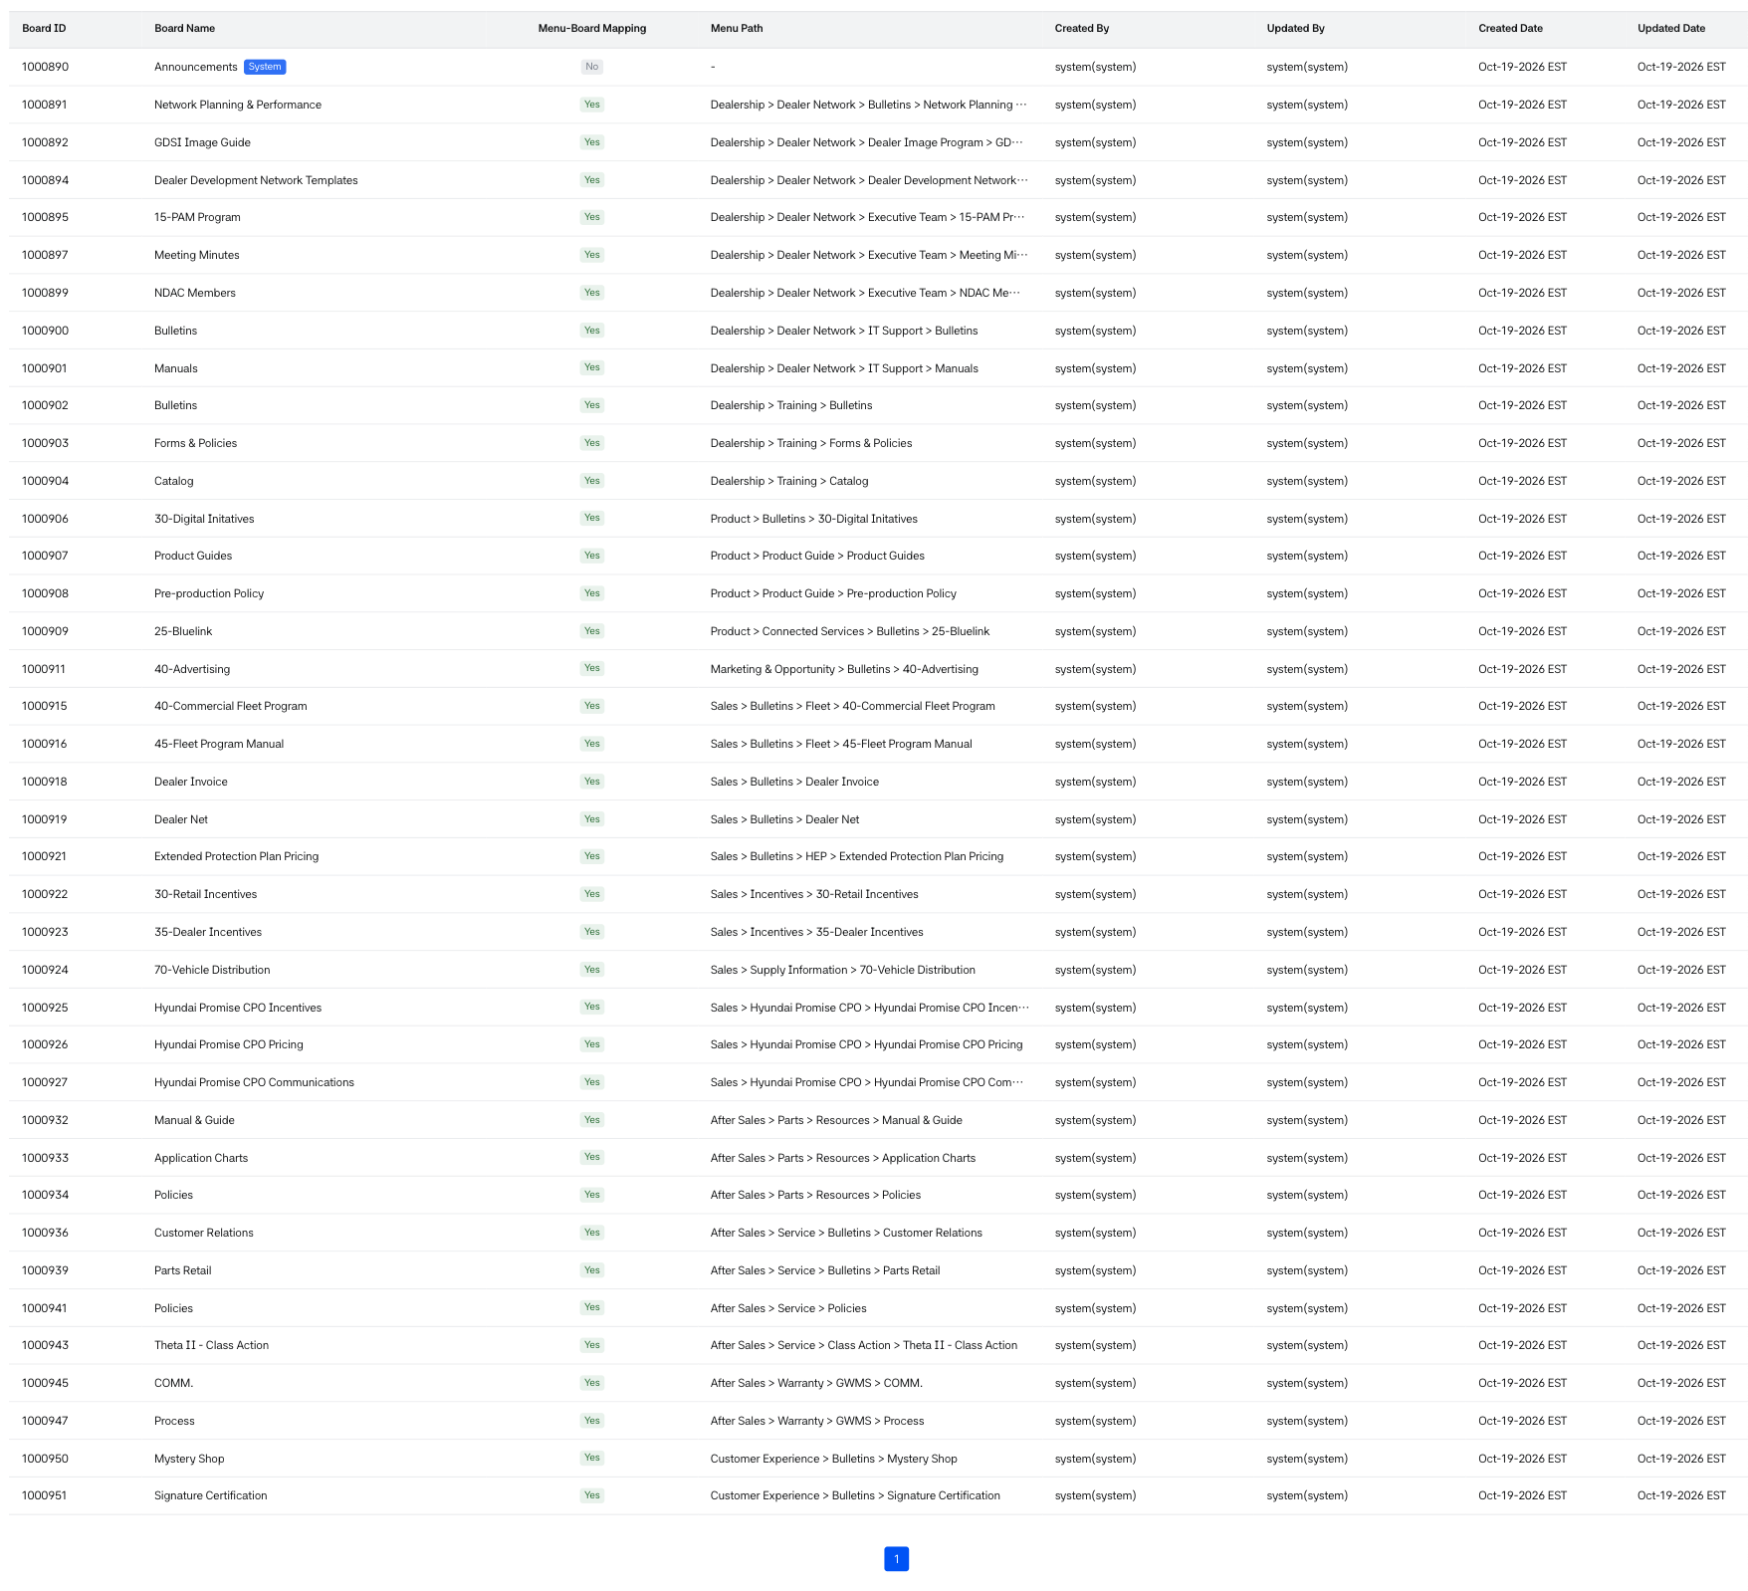
Bulletin board List 1

Bulletin Board Creation
- Bulletin board creation is only possible for users with Write permission.
- Users with permissions see the [New Board] button in the bulletin board list view results, and can create a bulletin board through this button.
- On the bulletin board creation screen, you can enter basic Board information at the top, and at the bottom you can enter Post Attribute Settings that specify the attributes of posts.
- Default values are selected in the Post attribute setting.
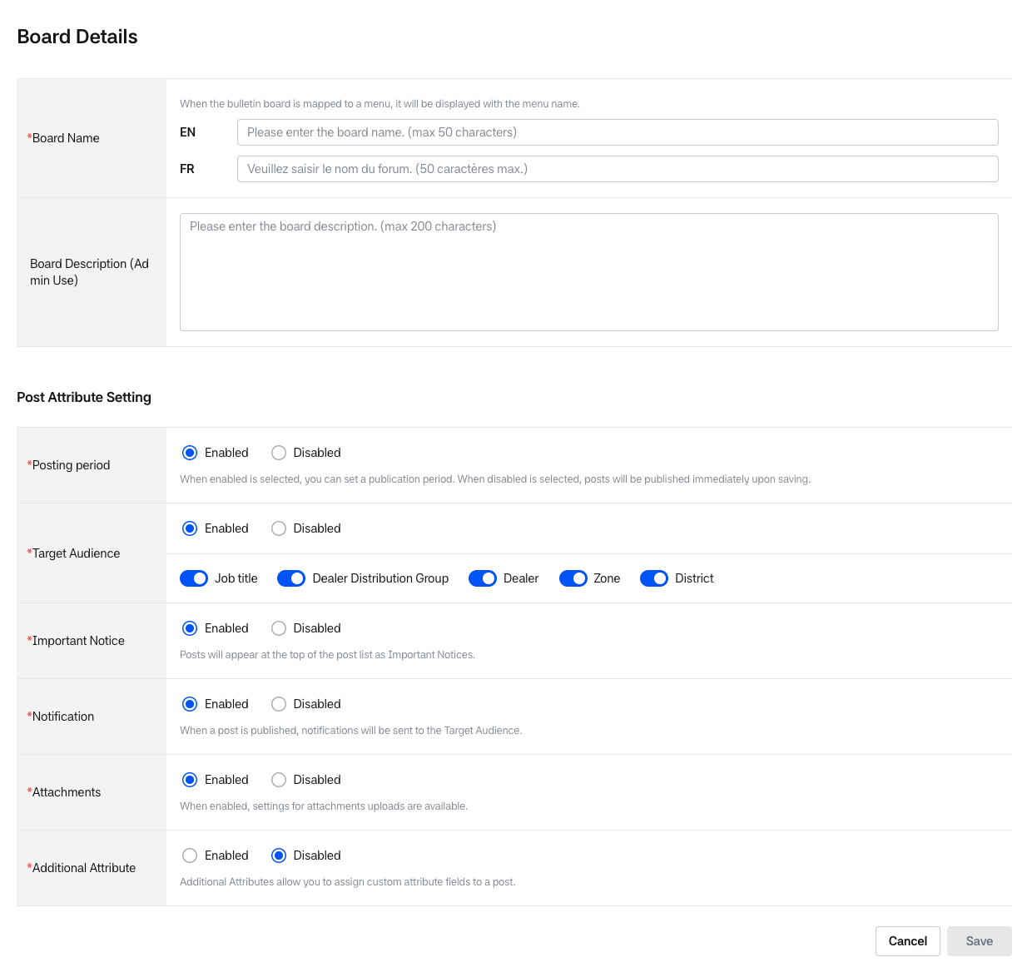
Creating Bulletin board
Board Basic Information
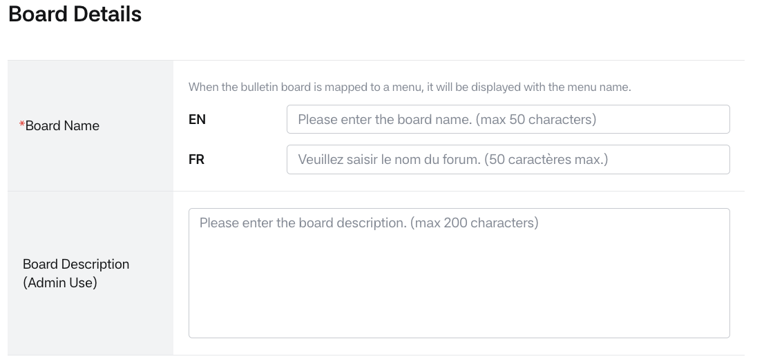
Creating Bulletin board – Basic information
- Board Name (EN, FR Required field): The bulletin board name can be up to 50 characters.
  - Menu name and Board name are mapped 1:1, and when Board name is mapped to a menu, it is used as the menu name.
  - Duplicate board names are allowed; however, if the board is linked to a menu, it follows the duplication policy at the menu level.
  - When entering a board name, if a duplicate name is entered within the linked menu level, saving will not be possible.
- Board Description (Admin Use): The bulletin board description can be up to 200 characters.
Post Attribute Setting Information
- Post Attribute setting is a function that allows you to set the attributes of posts.
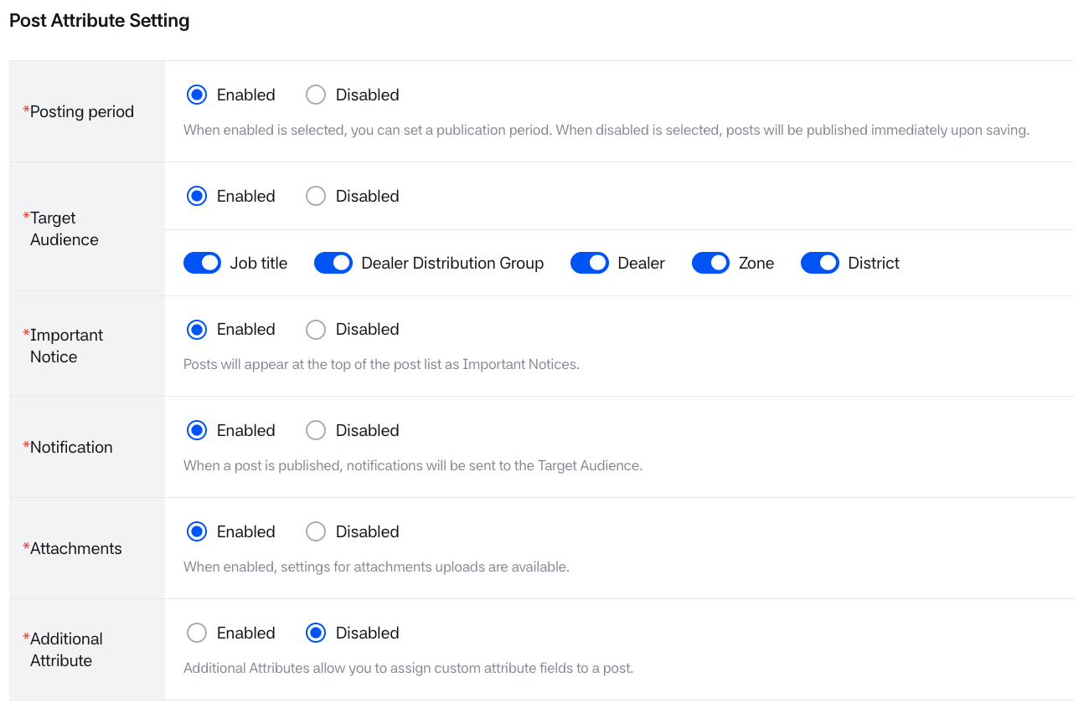
Creating Bulletin board – Post attribute setting information
- The descriptions of each post attribute information are as follows:

Posting Period
Creating Bulletin board – Post attribute setting information1
- Enabled(Default): This is a function that allows you to set the posting period for posts, enabling features like scheduled posting.
- When clicked, you can set the posting period on the post detail page, and the set posting period is displayed in the post list.
- Disabled: When clicked, the posting period cannot be set on the post detail page.
- When a post is saved, it is immediately displayed and the posting period is set to indefinite (9999-12-31).
- The posting period is displayed in the post list.

Target Audience
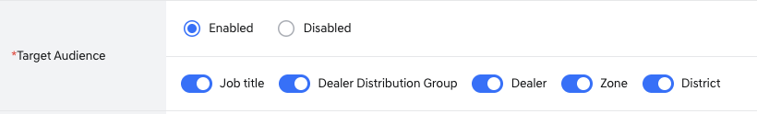
Creating Bulletin board – Post attribute setting information2
- Enabled (Default): This is a function that allows you to post to specific target audiences.
- When clicked, the target audience setting UI and target audience option (Job title ~District) selection UI are displayed in the post details.
- Selection boxes are displayed in the post according to the ON/OFF of the target audience options. If you toggle OFF, you cannot set the target audience.
- Job title: Job role (eg. Sales manager, sales staff etc.)
- Dealer distribution group: Dealer group
- Dealer: Dealership
- Zone: The value entered in the dealer area setting, which is the zone to which the dealership belongs.
- District: The District value to which the dealership belongs, which is entered in the dealer area setting.
- Disabled: You cannot specify a target audience.
- The target audience option UI is not displayed in the post details.
- If the bulletin board is linked to a menu, posts are displayed to all users who can access the menu.

Important Notice
Creating Bulletin board – Post attribute setting information3
- Enabled (Default): This is a function that allows you to set important notices.
- The important notice post and important notice posting period setting UI are displayed in the post details, and when the post is saved, it is fixed at the top of the BO/FO posts for the corresponding period.
- Disabled: You cannot set important notices.
- The important notice post setting UI is not displayed in the post details.
- If there is an important notice post that has already been set and the attribute value is changed, it can be fixed at the top for the set period.

Notification
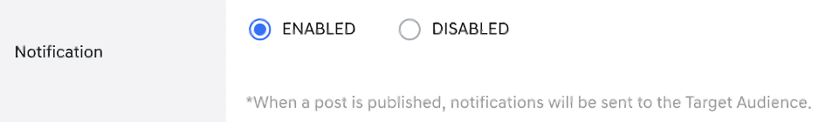
Creating Bulletin board – Post attribute setting information4
- Enabled (Default): This is a function that allows you to set notifications.
- The Notification selection UI is displayed in the post details, and when a post is published with the notification function set, notifications and emails are sent to the target audience through the notification center.
- Disabled: You cannot set notifications.
- The Notification selection UI is not displayed in the post details.
Attachments
Creating Bulletin board – Post attribute setting information5
- Enabled (Default): This is a function that allows you to attach files.
- The attachment UI is displayed in the post details, and the attached file names are displayed in the BO/FO post list.
- Disabled: You cannot attach files.
- The attachment UI is not displayed in the post details. If there are already attached files, they remain displayed in the post list.
Additional Attribute
- The Additional Attribute function is a feature that allows you to add user-defined input fields when posting on a bulletin board, enabling diverse content classification or use as search criteria.
- Operators can freely create attributes on a per-bulletin board basis and set usage status, required status, search status, etc.
- Additional attribute usage limit: Up to 5 can be used per menu (bulletin board)
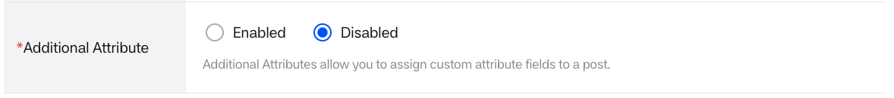
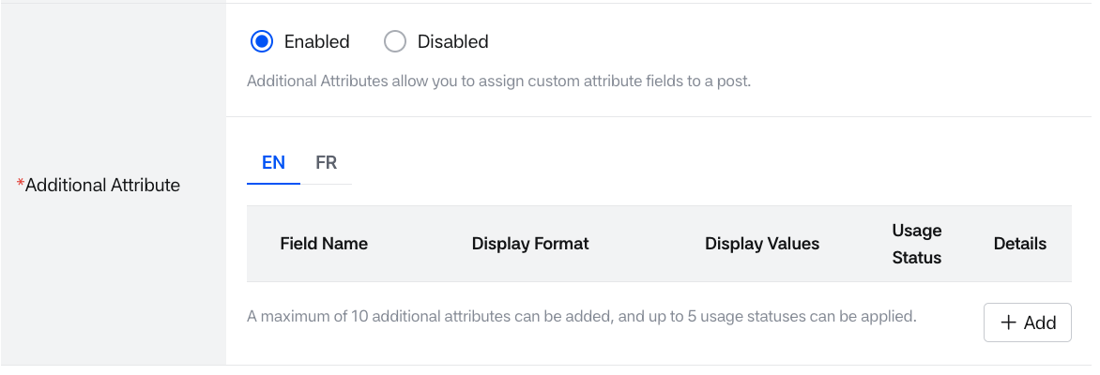
Creating Bulletin board – Post attribute setting information6
- Enabled: You can create multiple attributes using Additional attribute.
  - Up to 10 additional attributes can be created per bulletin board, but only up to 5 can be used.
  - When using the added attribute items, the corresponding attribute item UI is displayed in the post details.
- Disabled (Default): Additional attribute values cannot be used.
  - The additional attribute UI is not displayed in the post details.
  - If there are previously created attributes, their values are maintained.
- When the [Add] button is clicked, the popup below appears, and you can set attributes for creating additional attributes.
- When an Additional attribute is added, the summary information of the added attributes is displayed based on EN/FR as shown below.
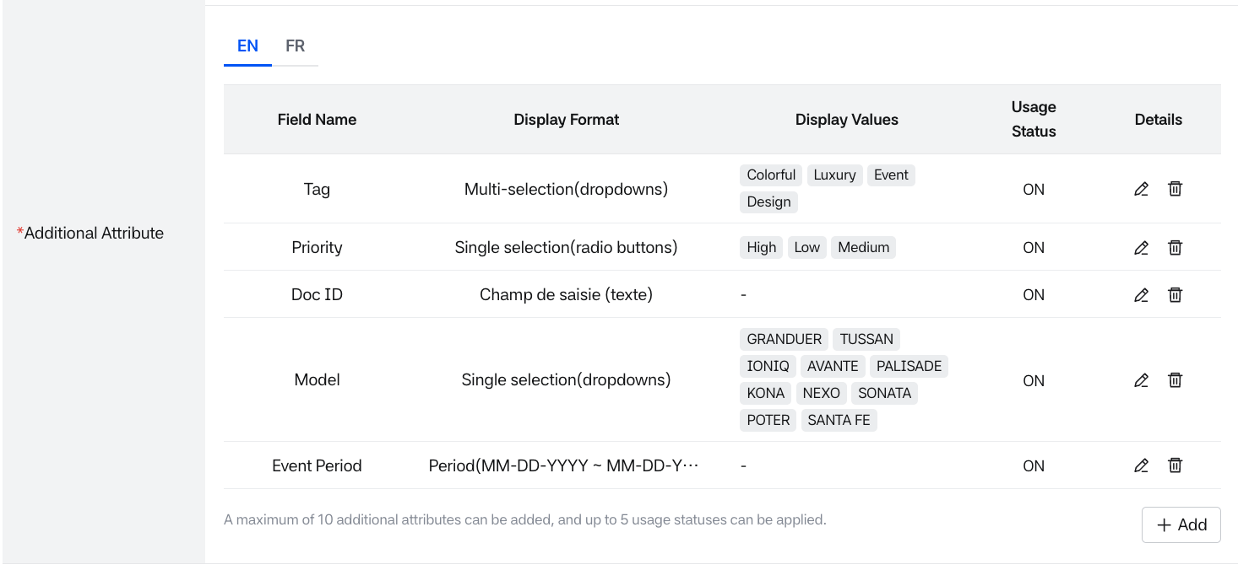
Creating Bulletin board – Additional attribute setting detail
- When you click the language (EN/FR) tab, you can check the attribute items based on each language.
  - Field Name: Field name
  - Display Format: Shows the selected display format
  - Display Values: Shows the entered display values
  - Usage Status: Usage status
  - Detail: Delete, Edit buttons displayed (refer to modification and deletion conditions below)
Additional attribute popup
- The Additional attribute popup title is displayed according to whether the bulletin board name is saved.
- If the bulletin board has been saved and assigned a name, the bulletin board name is displayed.
- When initially created, the Field Name and Display Format are displayed, and additional input fields appear depending on the selected Display Format.
- If the Display Format is changed while values have already been entered in the popup, those values will be reset according to the new Display Format’s input requirements.
- The save button is activated when all required values are entered in the additional attribute popup.
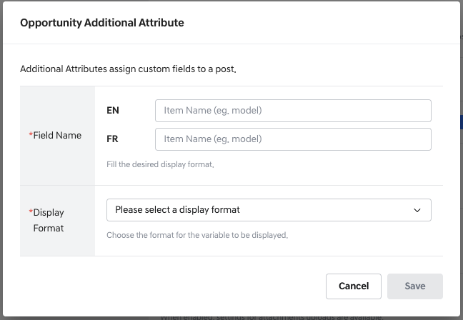
Additional attribute setting pop-up
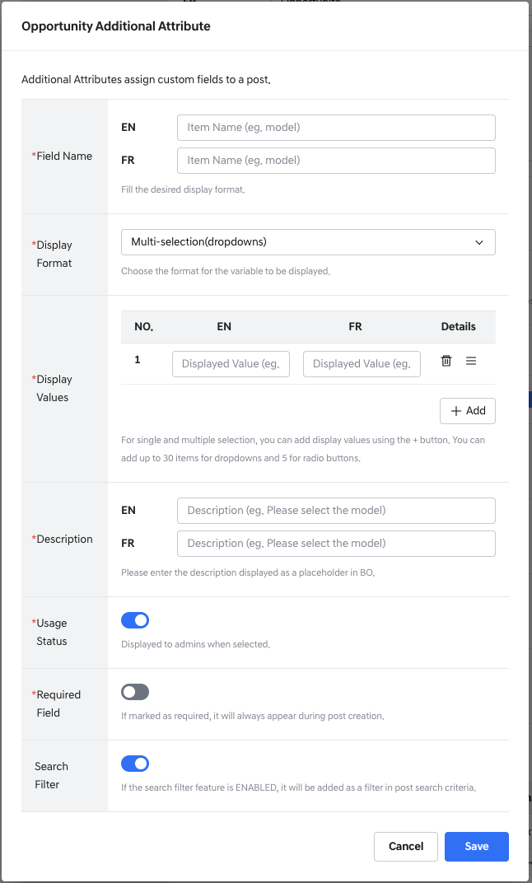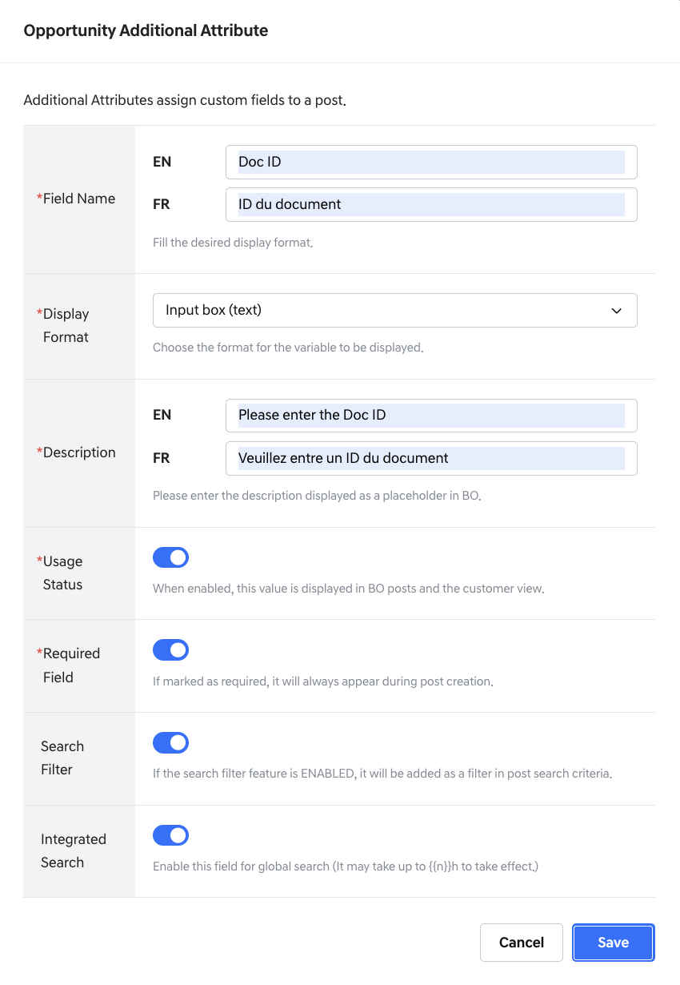
Additional attribute setting pop-up - Display format
Field Name (Required field)
- Operators can specify user-defined input field names. Field names can be up to 50 characters (including English, French, dashes, and numbers) by language (English, French).
- Field name EN/FR language-specific duplicate check: When entering additional attributes within a bulletin board, duplicate field names cannot be used.
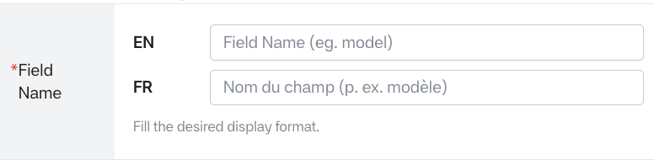
Additional attribute setting pop-up – Field name
Display Format (Required field)
- This is a function that allows you to set the input method. You can select from 6 different display formats, and once you specify and save a display format, you cannot modify the format later.
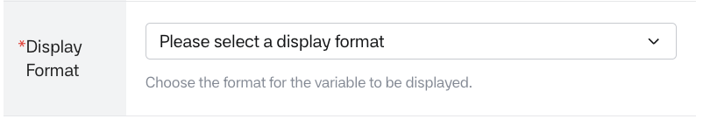
Additional attribute setting pop-up - Display format 1
- Single Selection (dropdowns): Displayed as dropdowns, only one option can be selected
- Single Selection (radio buttons): Displayed as radio buttons, only one option can be selected
- Multi-selection (dropdowns): Displayed as dropdowns, multiple options can be selected
- Period (MM-DD-YYYY ~ MM-DD-YYYY): Displayed as a calendar UI, period selection is possible
- Date (MM-DD-YYYY): Displayed as a calendar UI, date selection is possible
- Input box(text): Displayed as a text input field where users can directly enter text values.
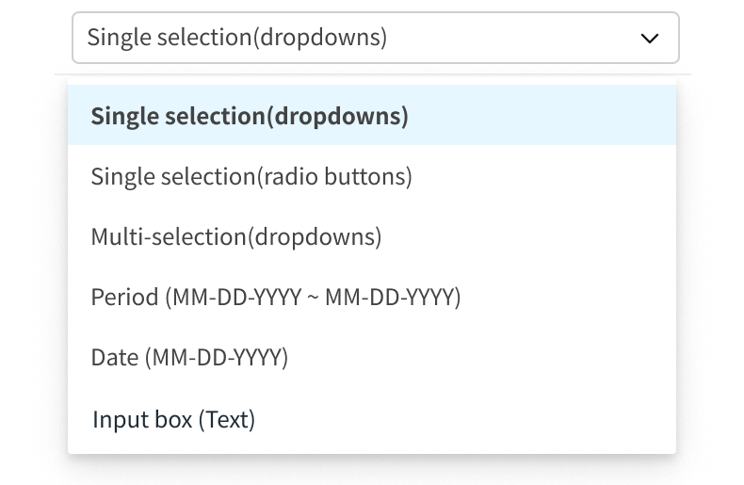
Additional attribute setting pop-up – Display format 2
Display Values (Required field for dropdowns, radio buttons)
- This is a function that registers a list of values that users can select. Display values require multilingual input (EN/FR). Display values appear when single/multiple selection is made in the display format.
- Display value can be up to 50 characters (including English, French, dashes, and numbers) by language (English, French).
- Display values list EN/FR language-specific duplicate check: Prevents the same Display values from being entered more than once.
- For dropdowns, up to 40 entries are possible; for radio buttons, up to 5 entries are possible. The guidance below the Display Values list reads “You can add up to 40 items for dropdowns and 5 for radio buttons.”
- Display Values List
  - NO.: Display Values order
  - En: Display Values English input field displayed
  - Fr: Display Values French input field displayed
  - Detail: Delete, move icons displayed
- Add button displayed in the bottom right
- Scroll: Right scroll is created when there are 5 or more Display Values
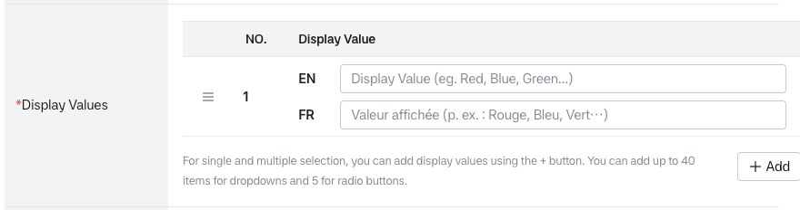
Additional attribute setting pop-up – Display values setting 1
- Example of screen display when there are 5 or more display values (a scroll is created on the right.)
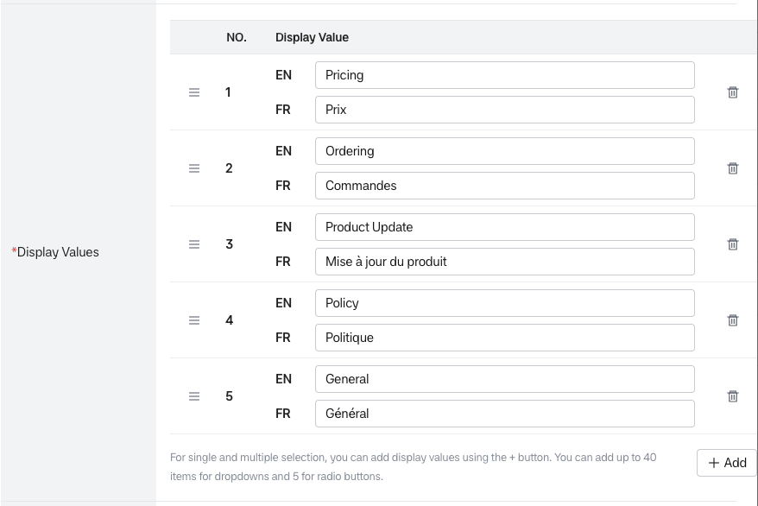
Additional attribute setting pop-up – Display values setting 2
- When the [+Add] button is clicked, EN and FR input field UIs are displayed as a pair at the bottom, and you can add up to 40 for Dropdowns and up to 5 for Radio buttons.
- If a display value is not entered, or if one of the EN or FR values is not entered, an alert message is displayed at the bottom.
- When the delete icon is clicked, deletion is possible without an alert for initial creation.
- However, when modifying a Display value, it cannot affect previously entered values, but you can no longer select pre-modification values in posts, so an alert is displayed.
Description (Required field for dropdowns)
- Used as placeholder text and is the text displayed in the BO post select box when dropdown is selected in the display format. 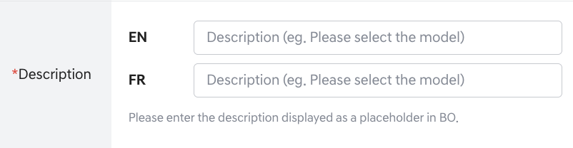
Additional attribute setting pop-up – Description
Usage Status (Required field)
- Usage status can be set On/Off, and a popup appears indicating that selection is not possible when the number of additional attributes in use exceeds 5.
- When On is clicked, the Additional attribute field name selection UI is displayed on the BO post writing screen for operators.
- When Usage status is changed to OFF, both Required field and Search filter are changed to OFF.
- Note: When Usage status is OFF, the Additional attribute cannot be set in BO Post management and is not displayed in the BO Bulletin board > List setting area. The value is also not displayed on the FO screen.
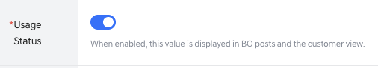
Additional attribute setting pop-up – Usage status
Required Field (Required field)
- Required field (function to check if the additional attribute is a required input value for posts)
- The (Default) value is set to OFF, and ON/OFF settings can be configured.
- Note: When Required field is ON, the Additional attribute value is marked as required (*) in BO Post management and is also displayed as required in the BO Bulletin board > List setting area. When Required field is OFF, it can be used as an optional value.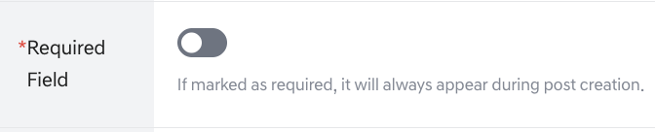
Additional attribute setting pop-up – Required field
Search Filter
- Search filter (function to set the additional attribute as a search filter in the front search area)
- Note: If ON, it is automatically displayed in the front post list, added to the search area, and set as required in the list settings. (Always ON, Read only). When the Search filter for additional attributes is turned OFF, the corresponding additional attribute search filter is not displayed on the front end.
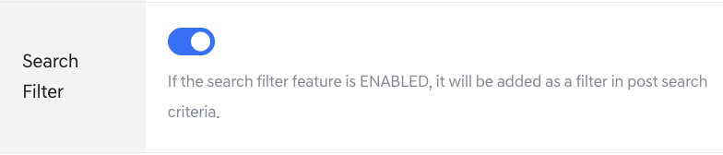
Additional attribute setting pop-up – Search filter
- Additional attribute popup save and modification policy
- The save button is activated when required values are entered.
Integrated Search Filter
- Integrated Search filter (function to set the additional attribute as a search filter in the front integrated search area)
- Note:
  - When set to ON, the field is included in the front-end global search and can be searched.
  - When set to OFF, the field is excluded from the front-end global search.
  - After saving or editing, it may take up to 2 hours for the field to be indexed or excluded from the global search results.
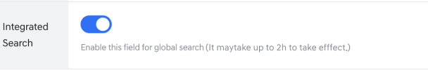
Additional attribute setting pop-up – Integrated Search filter
Additional Attribute View
- You can view, edit, and delete additional attribute items created in Post Attribute Setting > Additional Attribute.
- Created additional attributes are displayed when writing posts in the corresponding bulletin board.
- When a post with additional attributes is saved, you can check the additional attributes in the front post list and post details.
- The main information of the created additional attribute items is displayed in the post attribute setting > Additional Attribute list.
- When the language (EN/FR) tab is clicked, each language standard can be checked
  - Field Name: Field name (Display entered values)
  - Display Format: Shows the selected display format
  - Display Values: Shows the entered display values
  - Usage Status: Usage status
  - Detail: Delete, Edit buttons displayed (refer to modification and deletion conditions below)
  - Example screen when EN tab is clicked
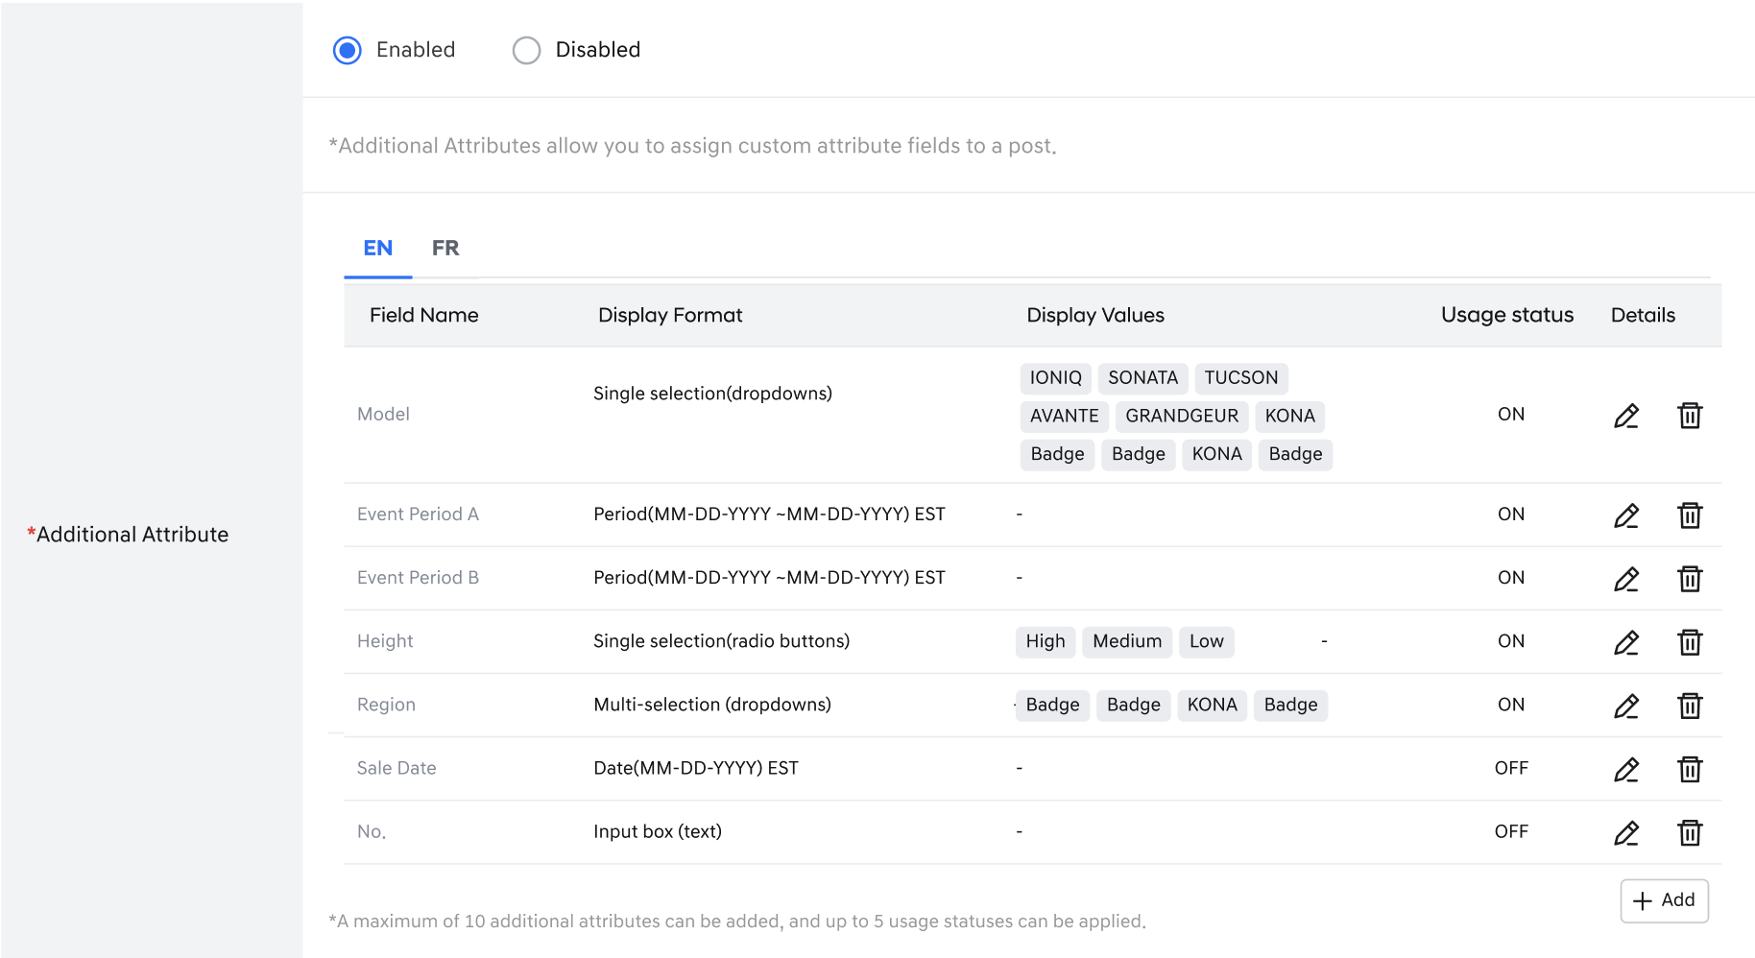
Additional attribute detail (English tab)
- Example screen when FR tab is clicked
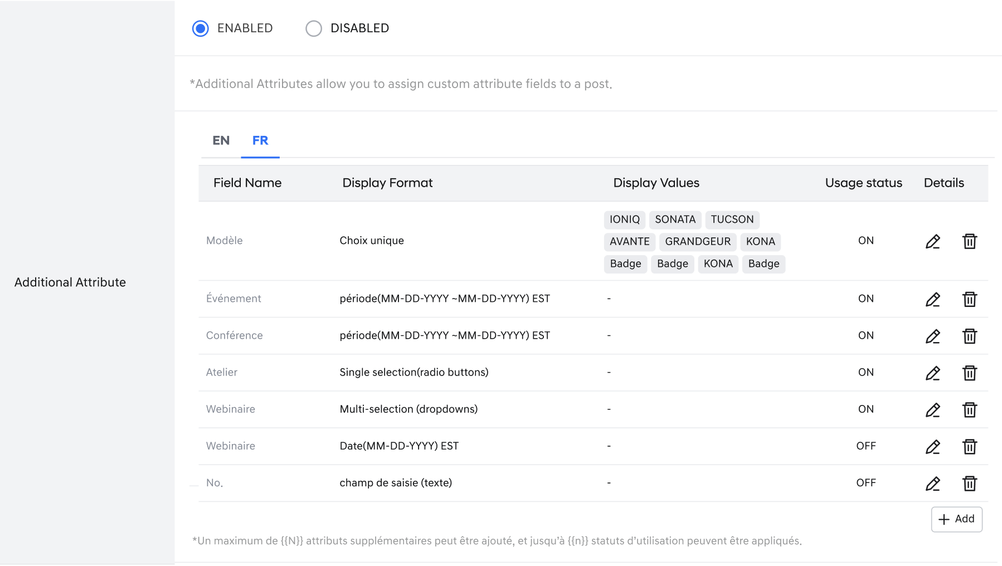
Additional attribute detail (France tab)
- [Edit]: When clicked, the additional attribute popup is displayed and non-modifiable items are deactivated (see detailed description below)
- [Delete]: Cannot be deleted if Usage Status=ON, additional attribute values that have been used in posts cannot be deleted.

Additional Attribute Modification and Deletion
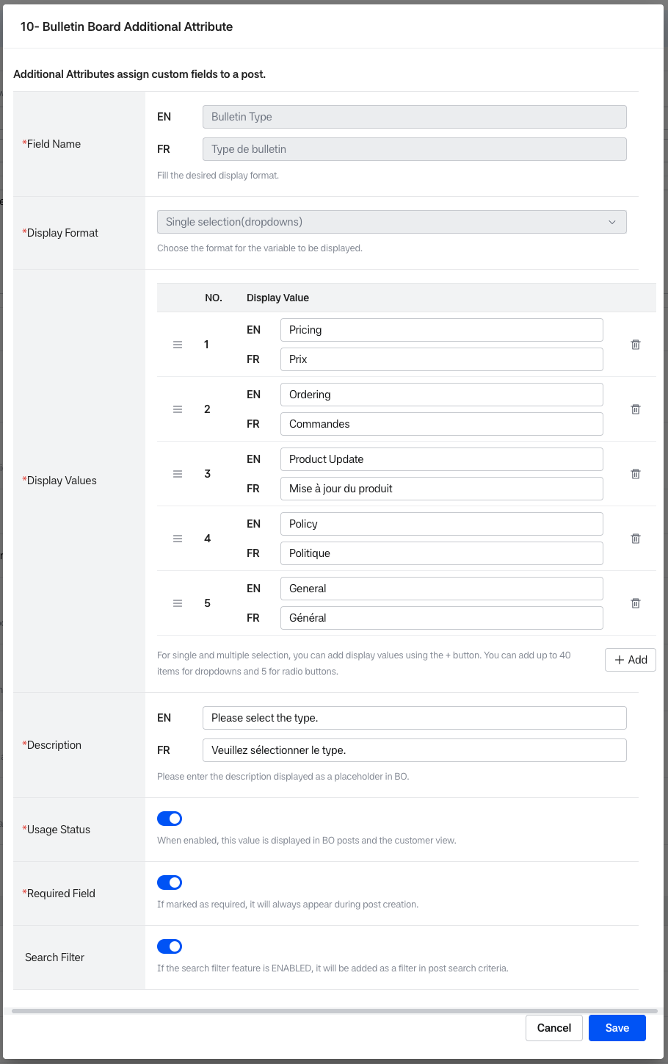
Editing Additional attribute setting
- Usage status toggle: When ON is clicked, if the number of uses exceeds 5, a popup indicating it is unavailable is displayed
  - [Edit]: When clicked, the additional attribute popup is displayed and non-modifiable items are deactivated
  - Display Values, Description, Usage Status, Required Field, Search Filter can be modified
  - Display value: When modifying, it cannot affect previously entered values, but pre-modification values can no longer be selected in posts.
  - Post impact: When modifying/deleting Display value, Display values entered in existing posts remain unchanged, but Display values that can be selected when entering BO posts are modified/deleted.
Bulletin Board Save/Cancel
- [Save]: When clicked, if required input values are missing, saving is not possible, and a popup corresponding to validity verification is displayed after validity verification.
- [Cancel]: When clicked, if there are changes, an alert is displayed indicating that unsaved changes will be deleted, then the previous screen is displayed

Bulletin Board View
- When you click a rowin the bulletin board list, you move to theBoard Details full-page screen.
- You can access through the view button in the Board Name or Details column within the bulletin board list view results.
- Basic board data such as Board ID, Name, Description are displayed at the top. The Post Attribute Setting that specifies the attributes of posts connected to the bulletin board is displayed at the bottom.
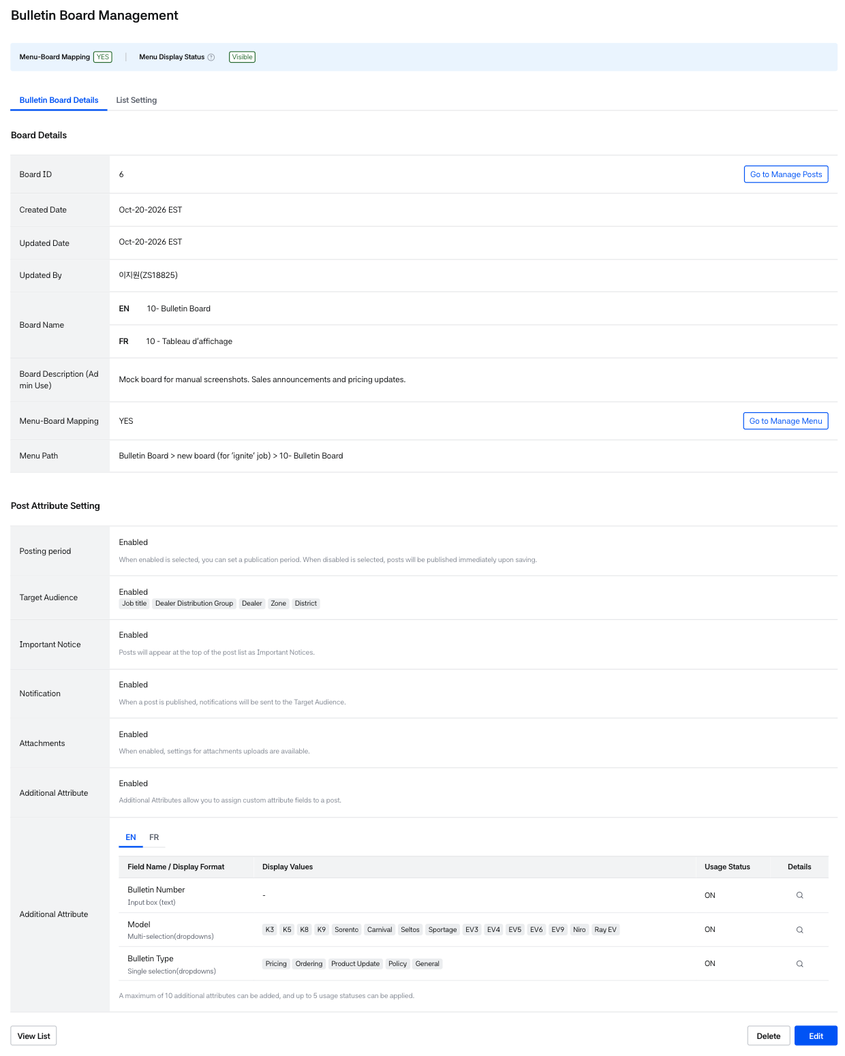
Bulletin board view
Bulletin board detail
- Board Name (EN, FR Required field): For Announcement Boards, which are automatically created during tenant setup, the board name (EN/FR) and description can be modified. (e.g., EN Default: Announcement, FR Default: Annonce)
- Board Description (Admin Use): For Announcement Boards, which are automatically created during tenant setup, the board name and description can be modified
- When viewing an Announcement Board, a banner with the following information is displayed at the top of the screen.
- For Announcement Boards, the Edit button is enabled, but the Delete button is not displayed.
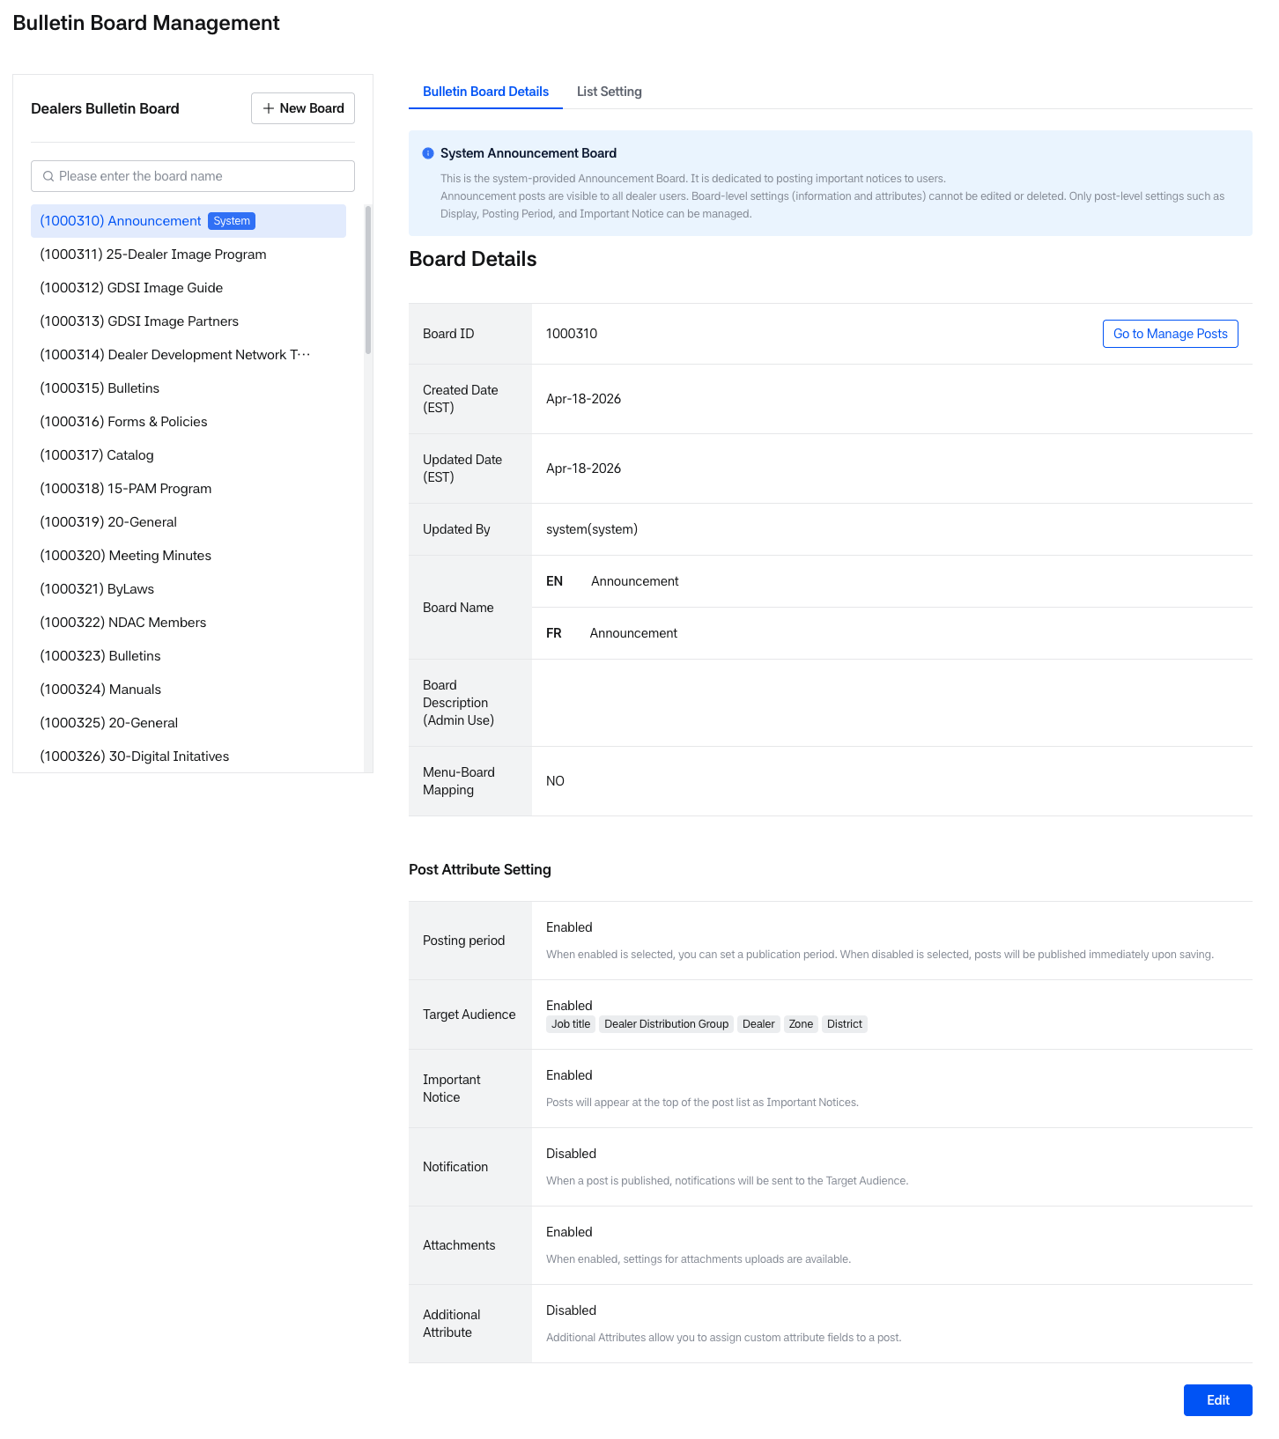
Bulletin board- Announcement
- Board Basic Information
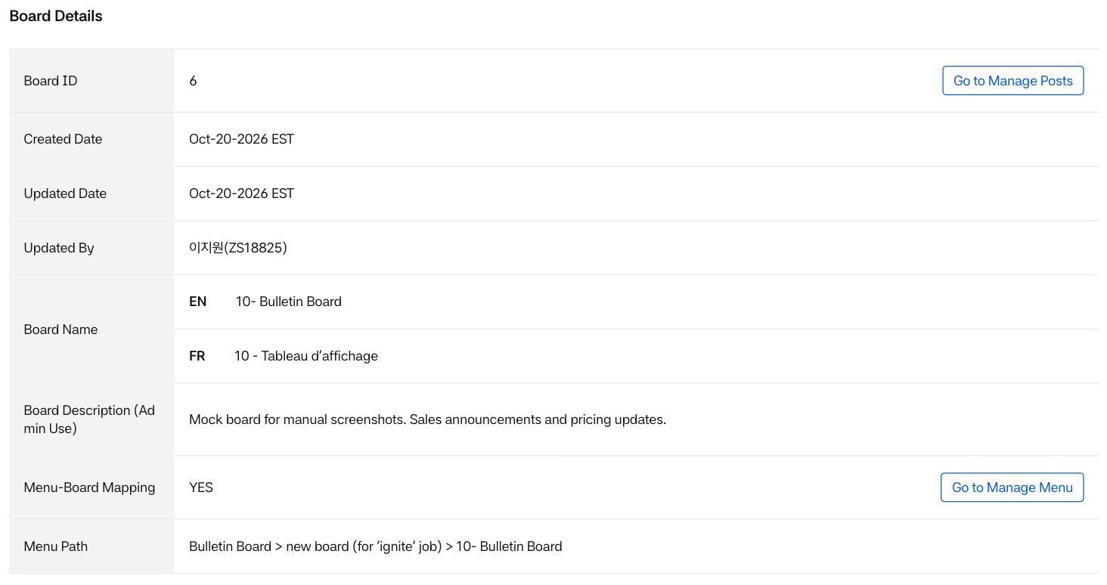
Bulletin board detail – Basic information
- When the bulletin board is linked to a menu, a Menu Display Status banner is displayed at the top of the screen. It appears the same way on the view and edit screens.
- Menu-Board Mapping: YES (green dot) or NO (gray dot).
- Menu Display Status: Shows whether the linked menu is displayed, based on the menu's own Display Setting & Scheduled Display. What is shown depends on whether Mobile Web is enabled for the tenant.
- The same banner change applies to the Menu Management and Post Management screens.
- The banner is not displayed for Announcement Boards because they are not linked to a menu.
- Basic information related to the bulletin board is displayed.
- Board ID: Automatically assigned when creating a bulletin board. When entering this Board ID in the menu URL in menu management, menu and bulletin board mapping is possible
- Board Name: The bulletin board name, and when mapped to a menu, the bulletin board name is displayed on the front screen.
- Menu Path: Displayed directly below Menu-Board Mapping. When the bulletin board is mapped to a menu, the full menu path (1 to 4 levels, all menu names shown, line breaks allowed) is displayed in the format Sales > Bulletins > 20-General. If Menu-Board Mapping is NO, or for an Announcement Board, - is displayed.
- Once the Bulletin Board is saved, the [Go to Manage Post] button will be displayed based on the user's permissions.
- If the Bulletin Board is linked to a Menu, the [Go to Manage Board] button will also be displayed based on permissions.
  - [Go to Manage Menu]: Navigates to the Menu Details screen linked to the bulletin board.
  - [Go to Manage Post]: Navigates to the Post List screen associated with the bulletin board.
- Post Attribute Setting Information
  - The Post Attribute setting information set during bulletin board creation/modification at the top is viewed.
  - For detailed explanation, refer to the 'Post Creation > Post Attribute setting information' section above
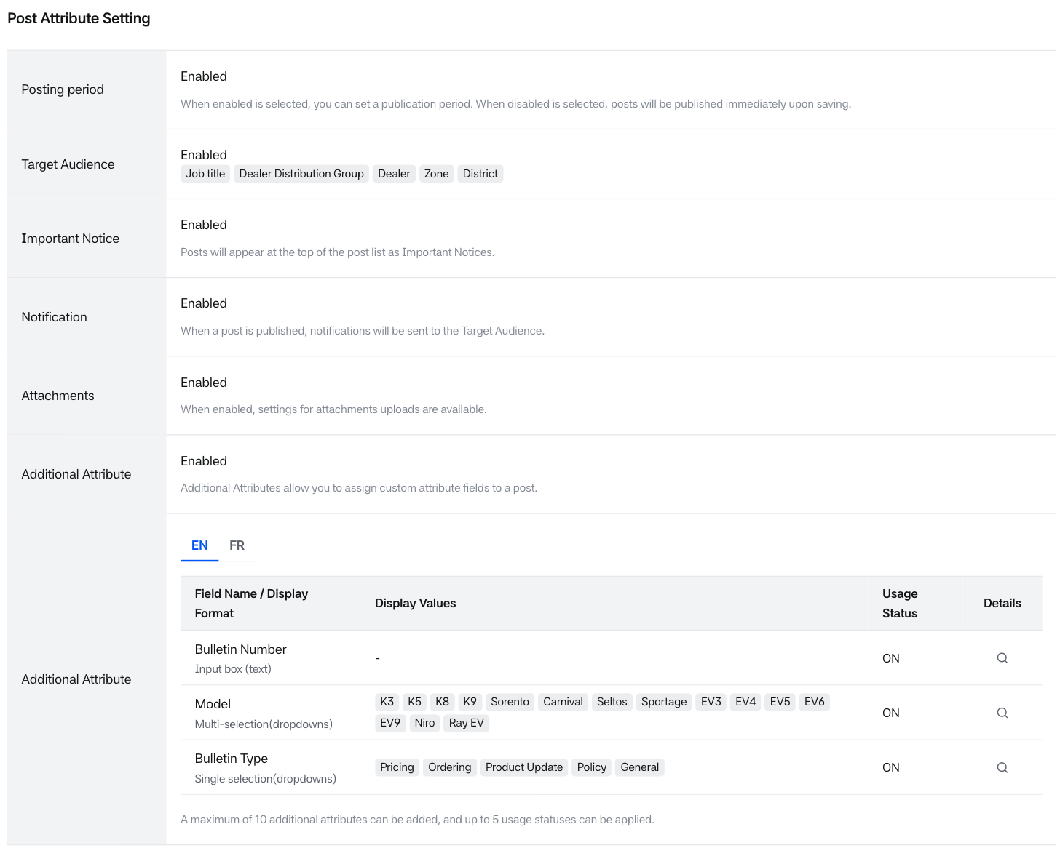
Bulletin board detail – Post Attribute setting
- Values entered during post creation are displayed on the post inquiry screen
- Posting Period 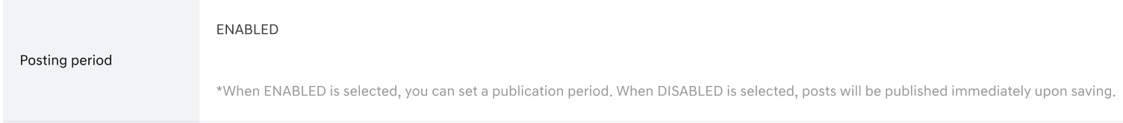
Bulletin board detail – Post Attribute setting1
- Target Audience (Job title, Dealer Distribution Group, Zone, District, Dealer)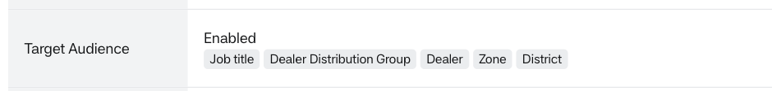
Bulletin board detail – Post Attribute setting2
- Important Notice 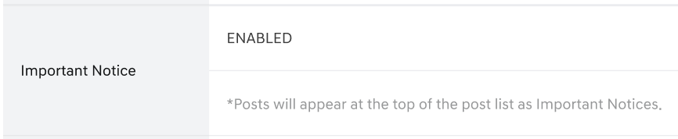
Bulletin board detail – Post Attribute setting3
- Notification 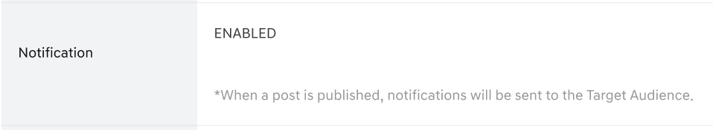
Bulletin board detail – Post Attribute setting4
- Attachments 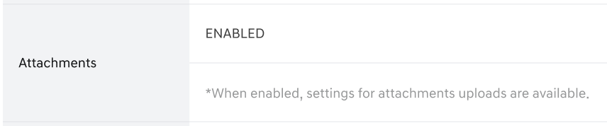
Bulletin board detail – Post Attribute setting5
- Additional Attribute
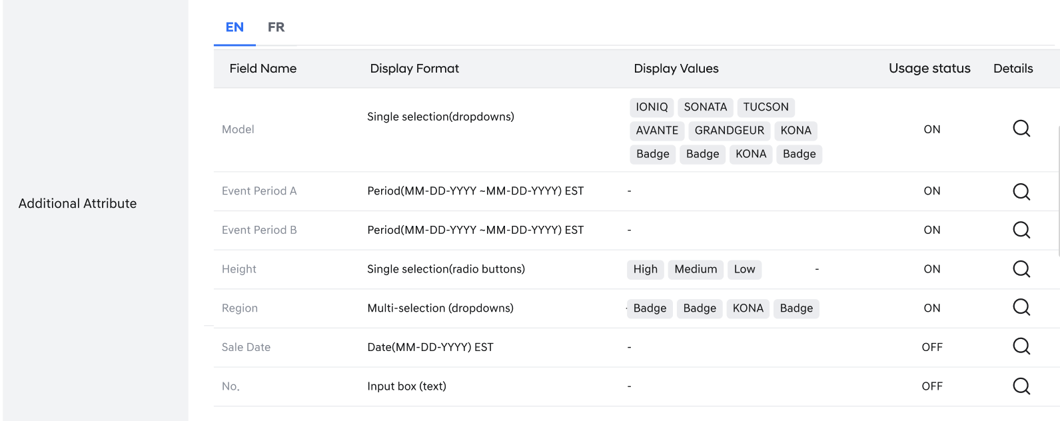
Bulletin board detail – Post Attribute setting6
Bulletin Board Editing
- Necessary actions are possible through the bottom buttons when viewing a bulletin board
  - [Delete]: Clicking the [Delete] button will trigger a validation check before the bulletin board can be deleted.
  - Deletion Not Allowed If:
    - The bulletin board is mapped to a menu.
    - The bulletin board contains existing posts.
    - In these cases, an alert pop-up will be displayed, and deletion will be blocked.
  - [Edit]: Clicking allows you to move to the bulletin board modification screen
- [View List]: Displayed at the bottom left. Clicking it returns you to the bulletin board list.
- Bulletin board attribute values can be freely changed, but they are reflected in the post management screen according to the bulletin board attribute modification policy below.
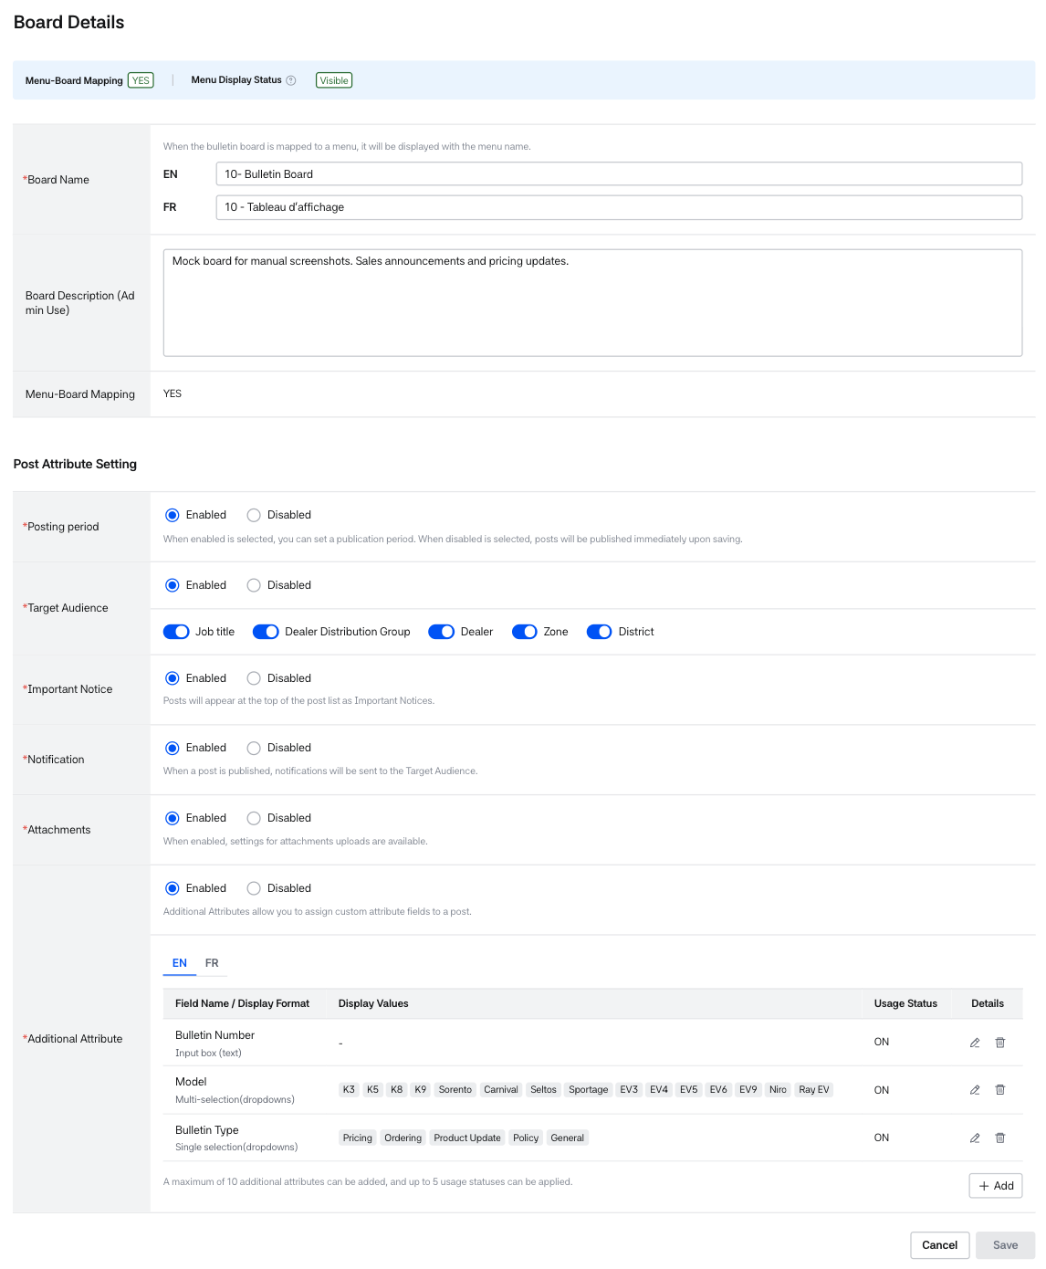
Editing Bulletin Board
- The bulletin board/post display policy according to bulletin board attribute modification is as follows:
  - If the bulletin board attribute setting is changed from Enabled → Disabled, the input UI is not displayed on the Post creation/modification screen.
- For posts that already have data, the data is maintained.
  - If there is already entered data, the entered data is maintained on the inquiry screen (BO Bulletin Board List, BO Post View, FO Board List, FO Post View).
- For posts that do not have existing data, no data is displayed.
  - If the bulletin board attribute setting is changed from Enabled → Disabled → Enabled, the input UI is displayed on the Post creation/modification screen.
- For posts that already have data, the data is maintained.
  - If there is already entered data, all entered data is displayed on the inquiry screen (BO Bulletin Board List, BO Post View, FO Board List, FO Post View).
- For posts written in a previously Disabled state, default values are set because there are no entered values.
  - Posting period: unlimited posting
  - Target audience: all settings

List Setting View
- The List Setting function allows you to manage the fields and their display order on the front-end bulletin board.
- The Order, Field Name, and Display Setting shown in the List Setting are based on the attributes configured in the Bulletin Board Details tab.
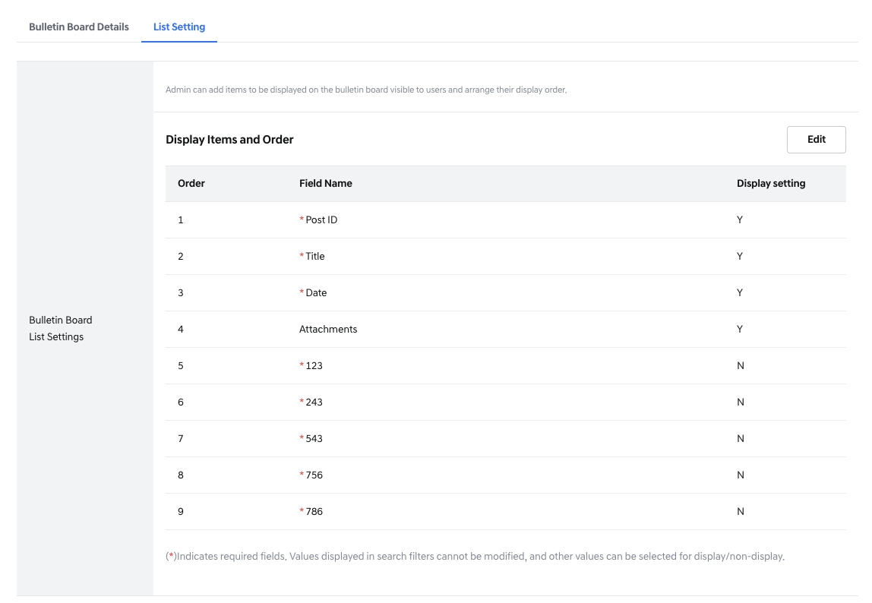
Bulletin Board – List setting tab
- Order: Indicates the display order of each Field Name in the front-end bulletin board list.
- Field Name: The name displayed in the front-end list. This is composed of:
- Default fields (e.g., Post ID, Title, Date)
  - Additional attributes where Usage Status = ON
If the field is marked as required, an asterisk (*) will be shown next to the field name. A field is considered required under the following conditions:
  - It is a default field (Post ID, Title, Date
  - The Required Field option is set to ON in the Additional Attributes.
  - Display Setting: Indicates whether the field is visible in the front-end list.
    - Y: The field is visible
    - N: The field is hidden
- [Edit]: Clicking this button opens the List Setting Edit screen.

List Setting Editing
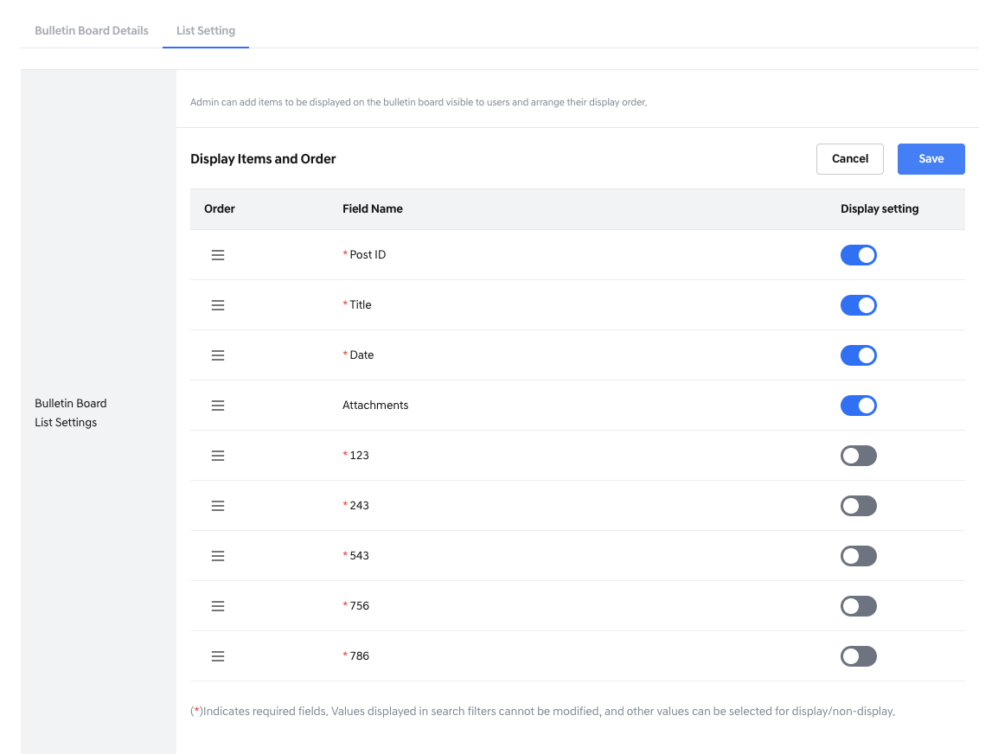
Editing List setting
- Order: You can rearrange the order of Field Names by pressing and holding the icon for more than 1 second, then using drag & drop to reorder the fields.
- Field Name: When entering edit mode, default fields (e.g., Post ID, Title, Date) appear at the top, and additional attributes are shown below.
The display order for both types can be rearranged.
- Display Setting:
  - A toggle switch is shown for each field, allowing you to set whether it will be displayed on the front-end bulletin board.
The toggle follows these rules:
    - For default fields (Post ID, Title, Date): Toggle is always ON and read-only.
    - For additional attributes with Search Filter = ON: Toggle is always ON and read-only.
    - For additional attributes with Required Field = ON: Toggle is ON and editable.
    - For additional attributes with Required Field = OFF: Toggle is OFF and editable.
Action Buttons
- [Cancel]: Clicking this button will show a warning message if there are unsaved changes.
Proceeding will discard all unsaved edits.
- [Save]: Saves the list settings according to the configured order and toggle display status.
After Saving
- Fields with the toggle set to ON will move to the top of the list.
- The Order will be displayed as sequential numbers (1, 2, 3, ...).
- The saved list settings will define the column headers shown in the front-end bulletin board list, as in the example below:
(The screen below is an example of the actual front-end view based on the List Setting configuration.)
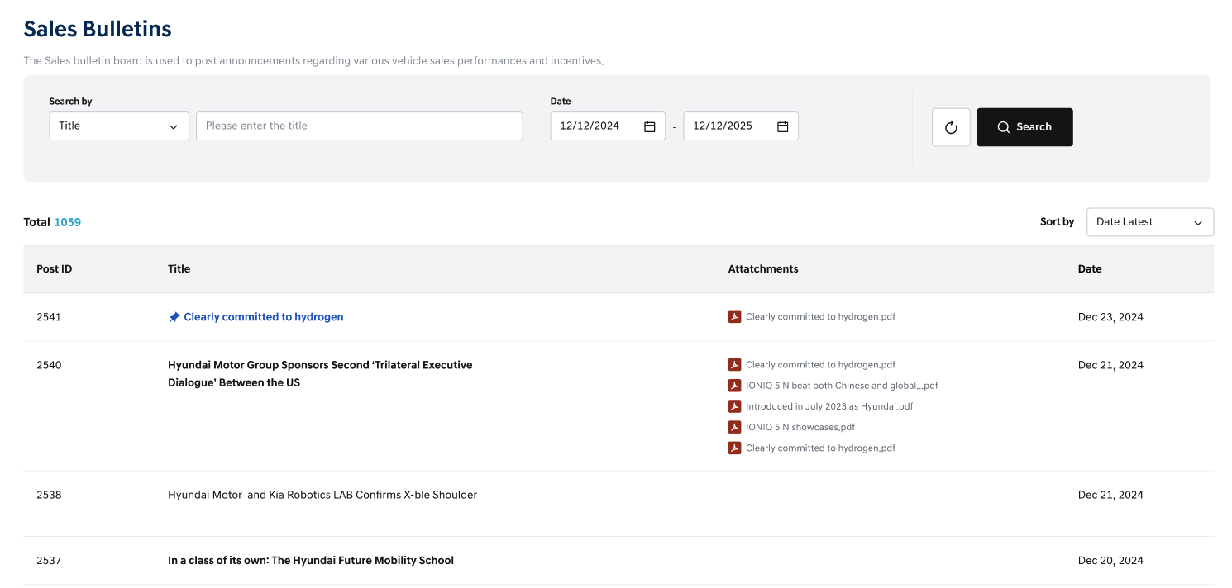
Listing setting detail – Post List Example

10. Post Management
- The Post Management page in the BO allows users to create, edit, and delete posts under each bulletin board.
- When you select a Bulletin Board, you can check whether it is linked to a menu.
The attributes of each post are determined based on the Post Attribute Settings of the selected bulletin board.
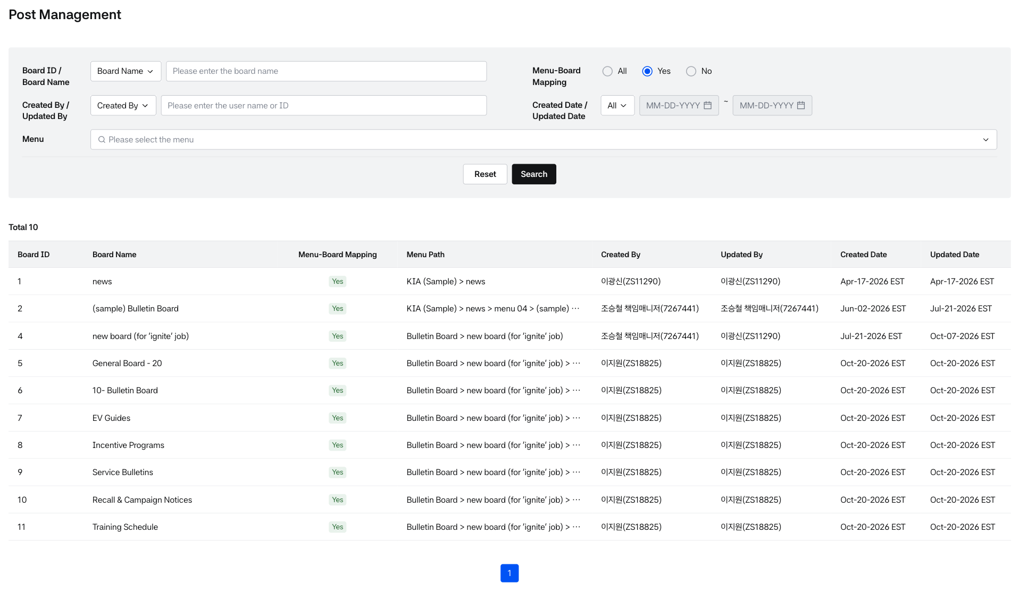
Bulletin List – Initial View
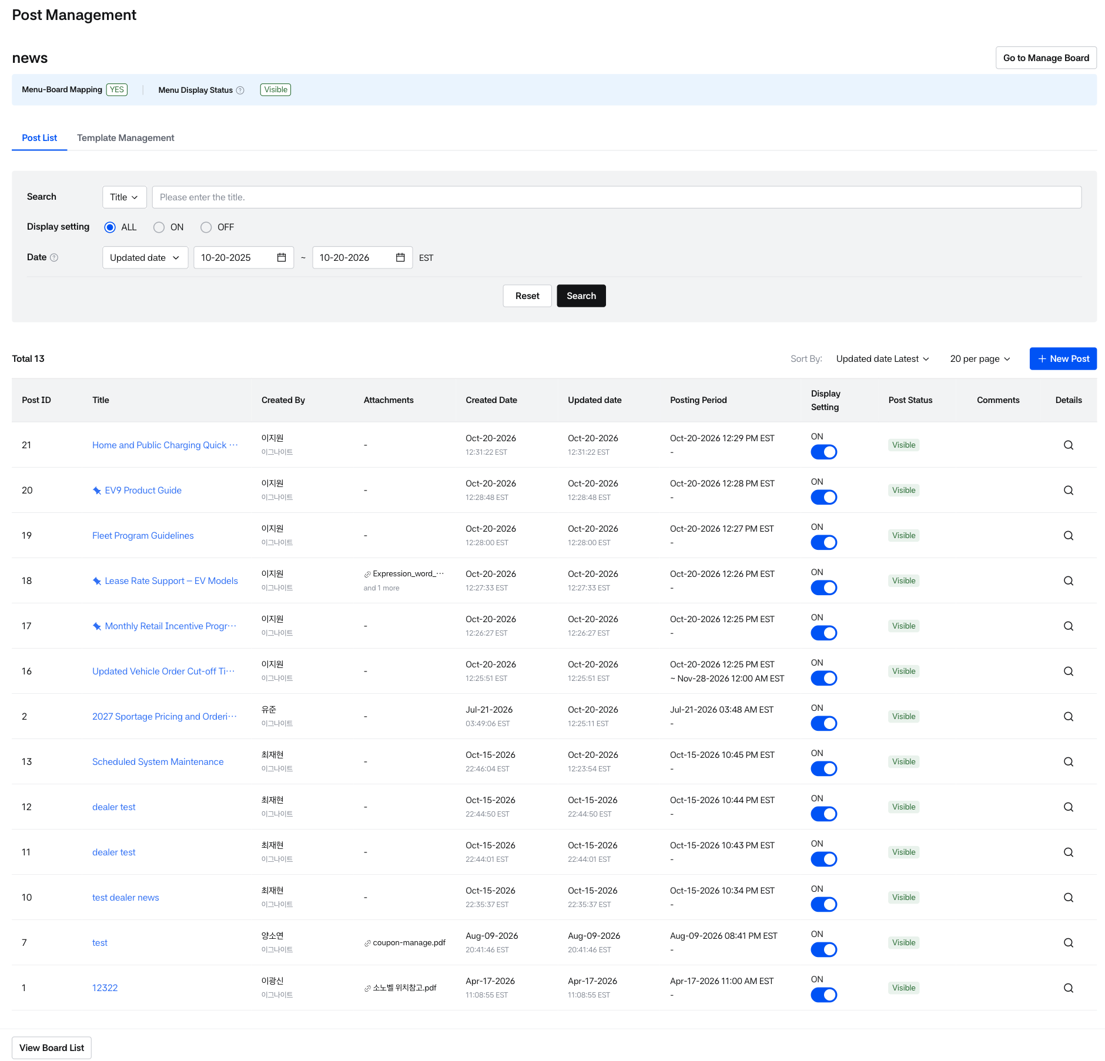
Post List
Post List – Selecting board
- When you access the Post Management menu, the board selection screen opens as a full page with a table of bulletin boards. Click a bulletin board row to open its post list.
- The post list opens as a full page. To return to the board selection screen, click [View Board List] at the bottom left of the post list.
- Above the post list, two tabs are available.
  - Post List: The default tab.
  - Template Management: Visible only to users with Write permission.
- The Menu Display Status banner is shown at the top of the post list. Its content depends on whether Mobile Web is enabled for the tenant.
  - If Mobile Web is ON, both values are shown: “PC: Visible/Not Visible Mobile: Visible/Not Visible”.
  - If Mobile Web is OFF, only a single value (Visible/Not Visible) is shown.
  - Visible is marked with a green dot, and Not Visible with a gray dot.
  - Hover over the ⓘ icon to see a tooltip: “This menu’s visibility is based on its own Display Setting & Scheduled Display. If the parent menu is hidden, this menu will not appear on the Front-end screen, regardless of its own Display Setting.”

Bulletin Board Search & Result
- Use the search panel to find a bulletin board, then click its row in the list to view the posts of that bulletin board.
This screen is only for selecting a bulletin board. You cannot create, edit, or delete bulletin boards here.
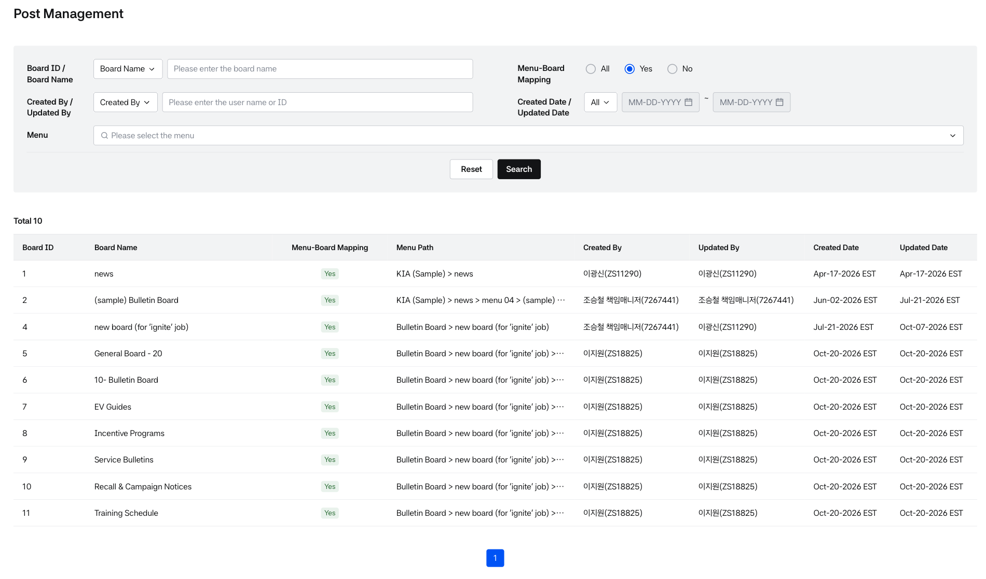
Bulletin board List in Post management
Search Panel
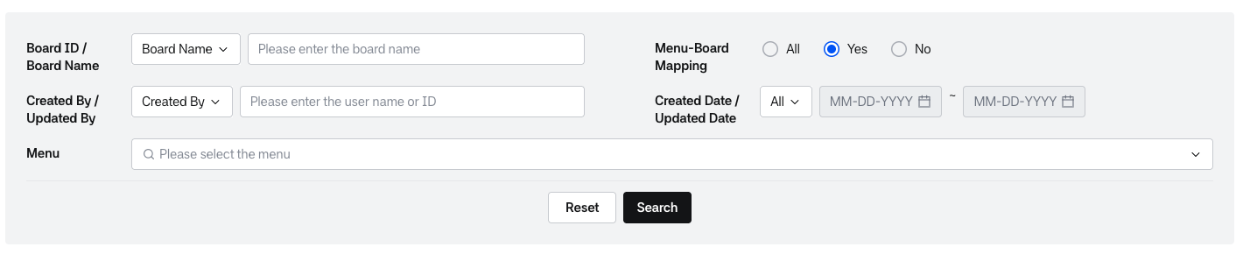
Search panel
- Board ID / Board Name: Select the search criterion, then enter the keyword.
  - The default criterion is Board Name.
  - The placeholder is “Please enter the board name” or “Please enter the board ID” depending on the selected criterion.
- Menu-Board Mapping: Filter by whether the bulletin board is mapped to a menu (All / Yes / No).
  - The default is Yes.
  - If you select No, the Menu drop-down is disabled.
- Created By / Updated By: Select the search criterion, then enter the user name or ID.
  - The default criterion is Created By.
  - The placeholder is “Please enter the user name or ID”.
- Created Date / Updated Date: Select the search criterion, then enter the period (From ~ To).
  - The default is All (the entire period). The date fields are enabled after you select a criterion.
  - No limit is applied to the search period.
- Menu: Select one or more 1-depth menus.
  - Use the multi-select drop-down (placeholder “Please select the menu”). You can search for a menu in the drop-down.
  - The selected menus are displayed below as chips (for example, Sales ×). Clicking × on a chip also clears its check in the drop-down.
- Click [Reset] to clear the inputs and chips and return to the default values (for example, Menu-Board Mapping = Yes).
- Click [Search] to search with the entered conditions.
Bulletin Board List
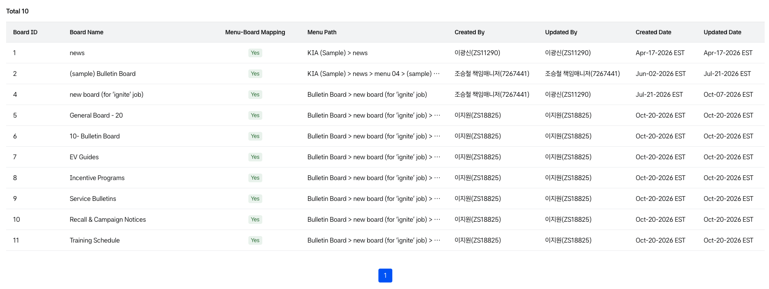
List
- Board ID: The ID of the bulletin board.
- Board Name: The name of the bulletin board, displayed according to the language setting.
- Menu-Board Mapping: Whether the bulletin board is mapped to a menu.
- Menu Path: The path of the menu the bulletin board belongs to (for example, Sales > Bulletins > 20-General).
  - Bulletin boards with the same name in different menus are distinguished by Menu Path.
- Created By: The user who created the bulletin board.
- Updated By: The user who last updated the bulletin board.
- Created Date: The date the bulletin board was created.
- Updated Date: The date the bulletin board was last updated.
- If Board Name or Menu Path is too long, it is shortened with an ellipsis (…). Hover over it to see the full text in a tooltip.
- Click a row to go to the post list of that bulletin board.
- If the list fails to load, an error message and a [Retry] button are displayed.
- The bulletin board name and description are displayed at the top.
- A search area and post list for viewing posts belonging to that bulletin board are displayed

Post List View
- The selected Bulletin Board Name is displayed at the top.
Alongside, the system shows whether the board is mapped to a menu, and displays the description of the board.
Status Bar
- Board-to-Menu Mapping Status
- If Board-Menu Mapping = Yes:
  - A [Go to Manage Board] button will appear on the right, depending on the user's permissions.
  - Clicking this button navigates to the BO Bulletin Board Detail screen (full page).
  - The Menu Path of the mapped menu (all levels, up to 4 depths) is displayed in the header. For the Announcement board, "-" is displayed.
- If Board-Menu Mapping = No:
  - This indicates that the bulletin board is not mapped to any menu.
  - You can view posts according to specific conditions.
- Menu Display Status: A banner in the header shows whether the menu is visible on the Front-end screen. The Announcement board is not mapped to a menu, so the banner is not displayed.
  - If the tenant has Mobile Web enabled, PC and Mobile are each shown as Visible or Not Visible.
  - If Mobile Web is disabled, only a single value (Visible or Not Visible) is shown.
  - Visible is marked with a green dot and Not Visible with a gray dot.
  - Hovering over the info icon shows a tooltip.
- [View Board List]: Located at the bottom left. Clicking it returns to the board selection screen.
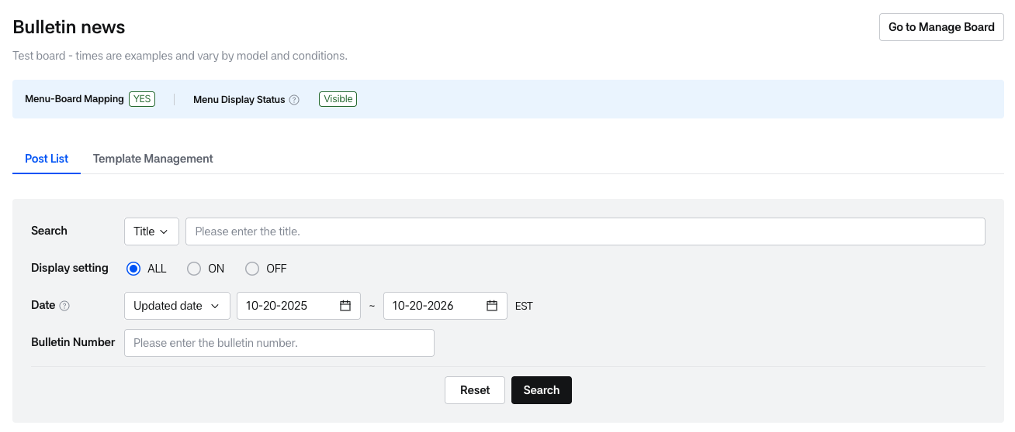
Post List – Selecting board(Board-menu mapping= yes)
- Template Management tab: Users with Write permission see a [Template Management] tab next to the Post List tab. Templates help you quickly fill in the title and content when creating a post.
- Title allows up to 300 characters and Summary up to 50,000 characters. The number of characters entered is displayed.
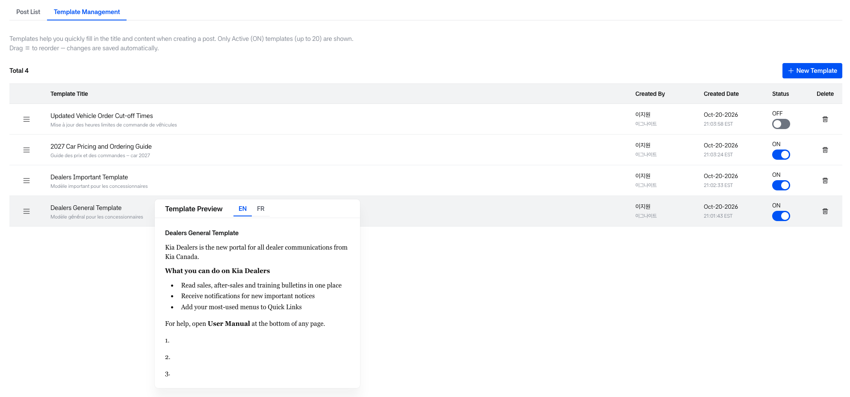
Post Template Tab
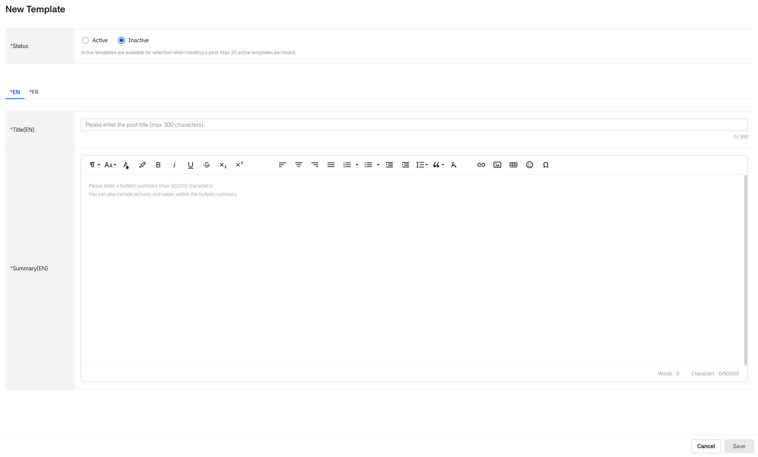
Template creation
- The list shows Template Title (truncated after 2 lines), Created By, Created Date (EST), Status (ON/OFF toggle) and [Delete].
- Drag the handle to reorder templates. Changes are saved automatically and a toast message is displayed.
- Hovering over a template title shows a preview popover with EN and FR tabs.
- Up to 50 templates can be created. When the limit is reached, [New Template] is disabled. Up to 20 templates can be in use (Active) at the same time.
- Templates cannot be edited.
- When [Delete] is clicked, a confirmation message is displayed: "Are you sure you want to delete this template? This action cannot be undone."
- You can search for posts based on keywords in Title, Author, Post ID.
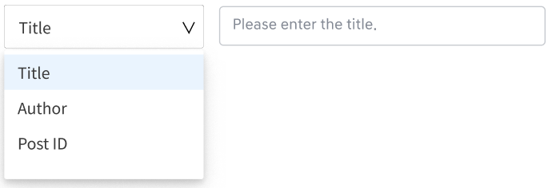
Post List – Search filter 1
You can search for posts based on Created Date, Updated Date, Posting period.
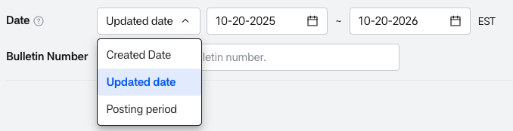
Post List – Search filter 2 Post List – Search filter 3
- Date search period: By default, the last 1 year from today is set, and the period can be up to 1 year.
  - Start Date: There is no limit on past dates. When Start Date is selected again, End Date is automatically adjusted to fall within 1 year of the new Start Date.
  - End Date: Only dates from Start Date up to Start Date + 1 year can be selected. Changing End Date does not change Start Date.
  - The date restrictions are explained in a tooltip.
- Created Date: You can search for posts in order of most recent creation date.
- Updated Date: You can search for posts in order of most recent modification date.
- Posting Period: All posts included within the posting period are displayed, sorted by the most recent posting start date. (If the posting start date is the same, those with the most recent posting end date are displayed at the top.)
- If a Search Filter is added to an additional attribute, it becomes searchable.
- As shown in the example below for the Input box (text) type Search Filter, users can directly enter keywords to perform a search.
- [Reset]: When clicked, filter conditions are initialized and search results are also reset.
- [Search]: When clicked, it displays search results for posts that match the set conditions.
Post List: The list of posts matching the applied search criteria is displayed. You can change the sorting and display options as follows:
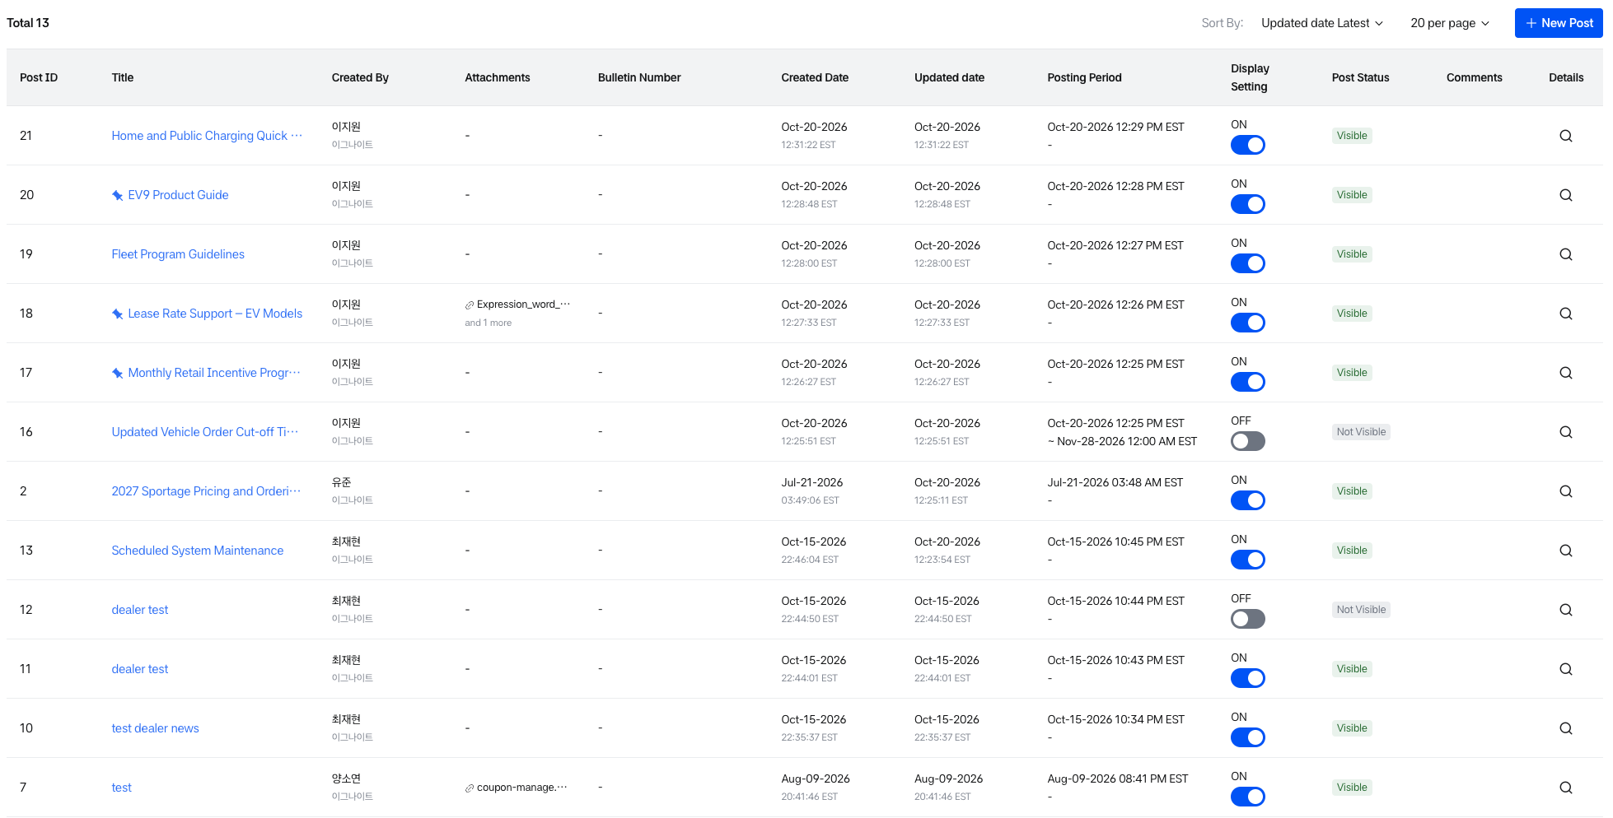
Post List - Detail
- Sorting options are available to organize posts by Date (latest to oldest) or Title (alphabetical ascending or descending).
- By default, 20 posts are displayed, and you can select up to 50 posts to display from the bottom left.
- The post list includes a pagination feature that allows you to navigate between page groups using the < and > buttons, move to the first page using <<, and move to the last page using >>.
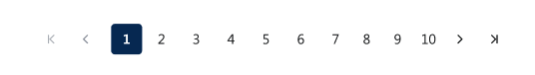
- When [New Post] is selected in the viewed bulletin board, the post writing screen is displayed. [New Post] is visible only to users with Write permission, and it can always be used regardless of the menu's Mobile Display setting.
- Post Creation
  - Users with permission can write new posts.
  - The post writing screen allows input of title, content, attachments, etc.
  - Additional input attributes may be displayed differently depending on the bulletin board attribute settings.
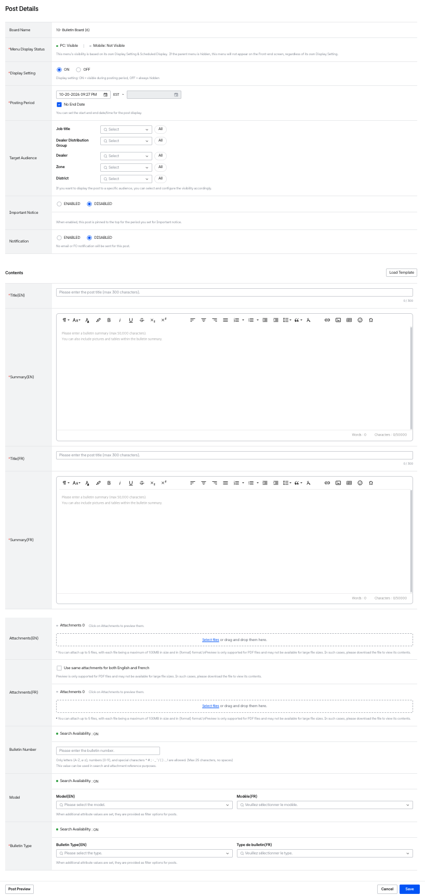
Creating Post
There are required and optional values for post creation.
- Board Name: The name(board id) of the bulletin board to which the post belongs is displayed. (Automatically generated value)
Creating Post – Board name
- Display Setting (Required Field): This setting determines whether the post will be displayed or not.
- (Default) ON: The post will be displayed once the posting period begins.
- OFF: The post will not be displayed, regardless of the posting period.
  - When Display setting = OFF, the following fields become read-only (values are retained):
  - Posting period, Important Notice, Notification
  - The help text is replaced with the Display OFF guidance message.
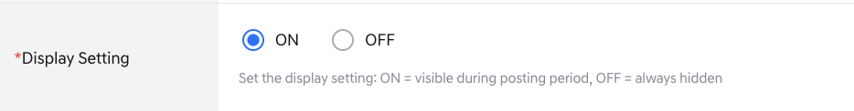
Creating Post – Display setting
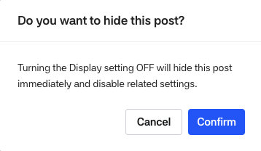
Creating Post – Display setting modal
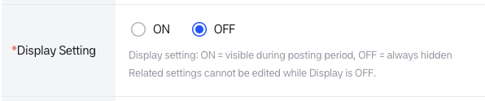
Creating Post – Display setting
- Posting period(Required field): This is a function to set the period during which the post is published.
- (Default)As an initial setting, the posting start date is entered based on the time the post was created, and 'Unlimited Posting' is set for the posting end date to have no deadline
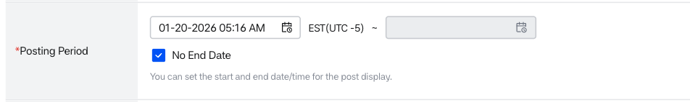
Creating Post – Posting period
- When clicking on the calendar UI input field, you can select date and time.
- When Unlimited posting is unchecked, you can select the posting end date to schedule the end of the post.
- The posting start time setting cannot exceed the posting end date, and the posting end time cannot be set before the posting start date and time.
- 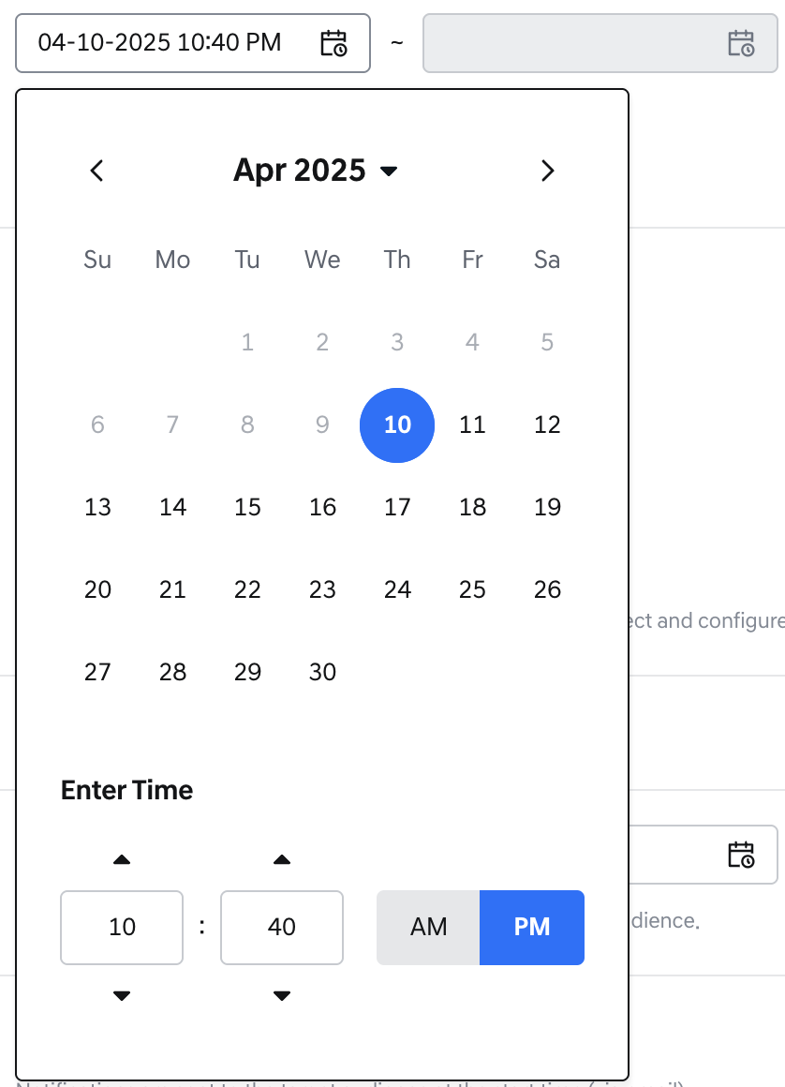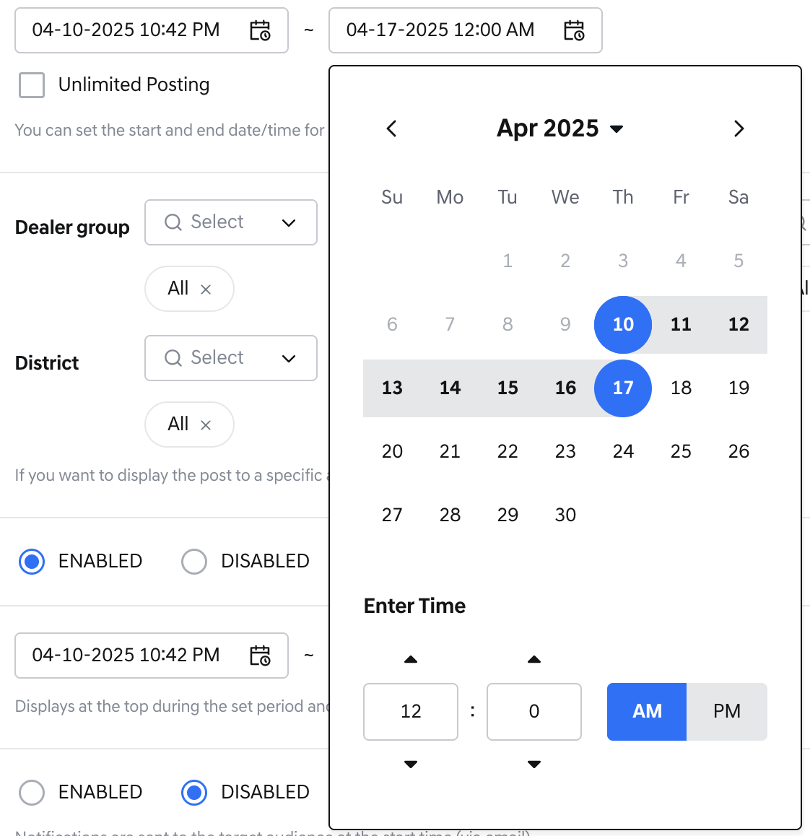
Calendar setting feature
- Target Audience: Selected publishing targets are published under AND conditions.
  - Selected values are displayed as chip filters.
  - (Default)Initial settings are displayed with all publishing targets selected, and the post is targeted at dealers belonging to the current publishing target group.
- Job title: Job title (information entered in Job Management)
  - Job title Display conditions
    - Such bulletin board must be linked to a menu
    - The linked menu should have at least one permission applied (access/read)
    - The Job Title should have saved at least one permission(access/read) of the linked menu.
    - The Job Title status must be 'Active' in DEALERS BO Job Management screen
- Dealer Distribution Group: Dealer group (information entered in Dealer Group Management)
- Dealer: Dealership (information entered in Dealer Management)
- Zone: Location information (information entered in Dealer Zone/District Management)
- District: Location information (information entered in Dealer Zone/District Management), regional information under Zone (when Zone is clicked, Districts belonging under Zone are displayed)
- 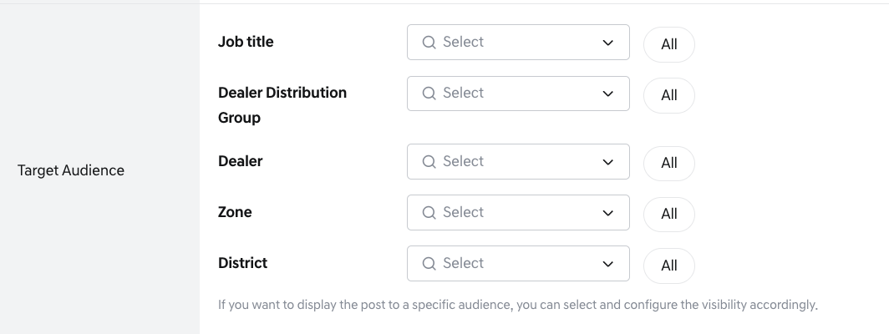
Creating Post – Target Audience
- When each publishing target input field is clicked, option values are displayed, and option values can be searched in the input field. (Like search)
- You can select publishing targets with checkboxes, and when the cursor moves, the selected publishing target option values are displayed in chip filter form below the input box. You can remove the publishing target option by pressing the X button on the chip filter.
- Specific job titles(Dealer Principal, Dealer Admin) in the Job Title field are automatically displayed as fixed by the system and cannot be deselected by operators.
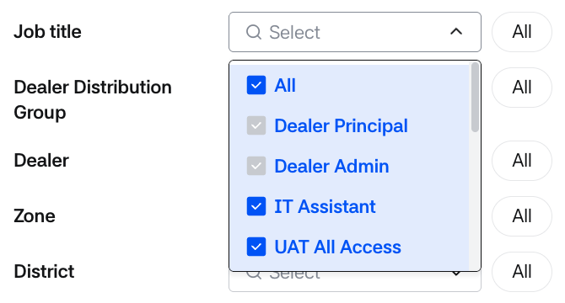
Target Audience – dropdown setting
- Important Notice: This is a value for setting important notices.
  - When Enabled is selected, you can select the period to post as an important notice, and it is fixed at the top of the post list during the set period.
  - (Default) Disabled is selected as the initial setting.
- Note) The Bulletin Highlight on the home screen shows a collection of important notice posts set in each bulletin board.
  - When the Important Notice period ends, only the pinned/important effect ends. Post visibility still follows Display setting and Posting period rules.
  - Notification is automatically synced with Important Notice changes.
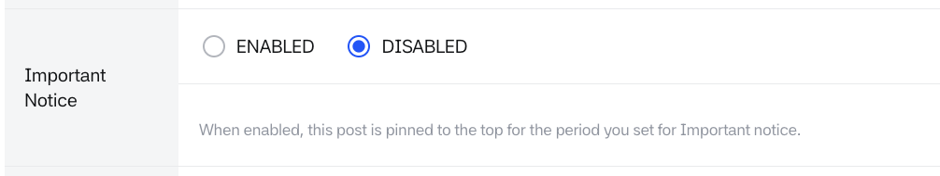
Creating Post- Important notice 1
- Enabled selection screen
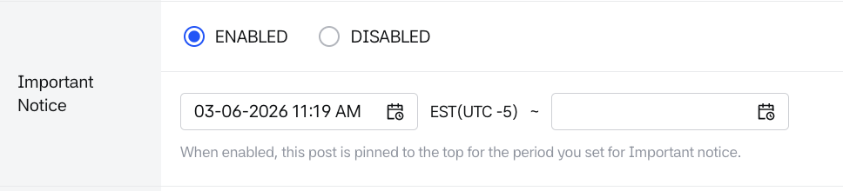
Creating Post- Important notice 2
- You can set the important notice posting period. When you click on the calendar input field, you can select the important notice posting period (date and time).
- The important notice posting period setting follows the policy below. The date selection UI is deactivated according to the policy, and if there is a policy conflict, an alert popup is displayed upon saving.
- Important notice policy
  - The important notice start time setting cannot exceed the important notice end date
  - The important notice end time cannot be set before the important notice start date and time
  - Important notices cannot be set before the posting start time
  - Important notices cannot be set after the posting end time
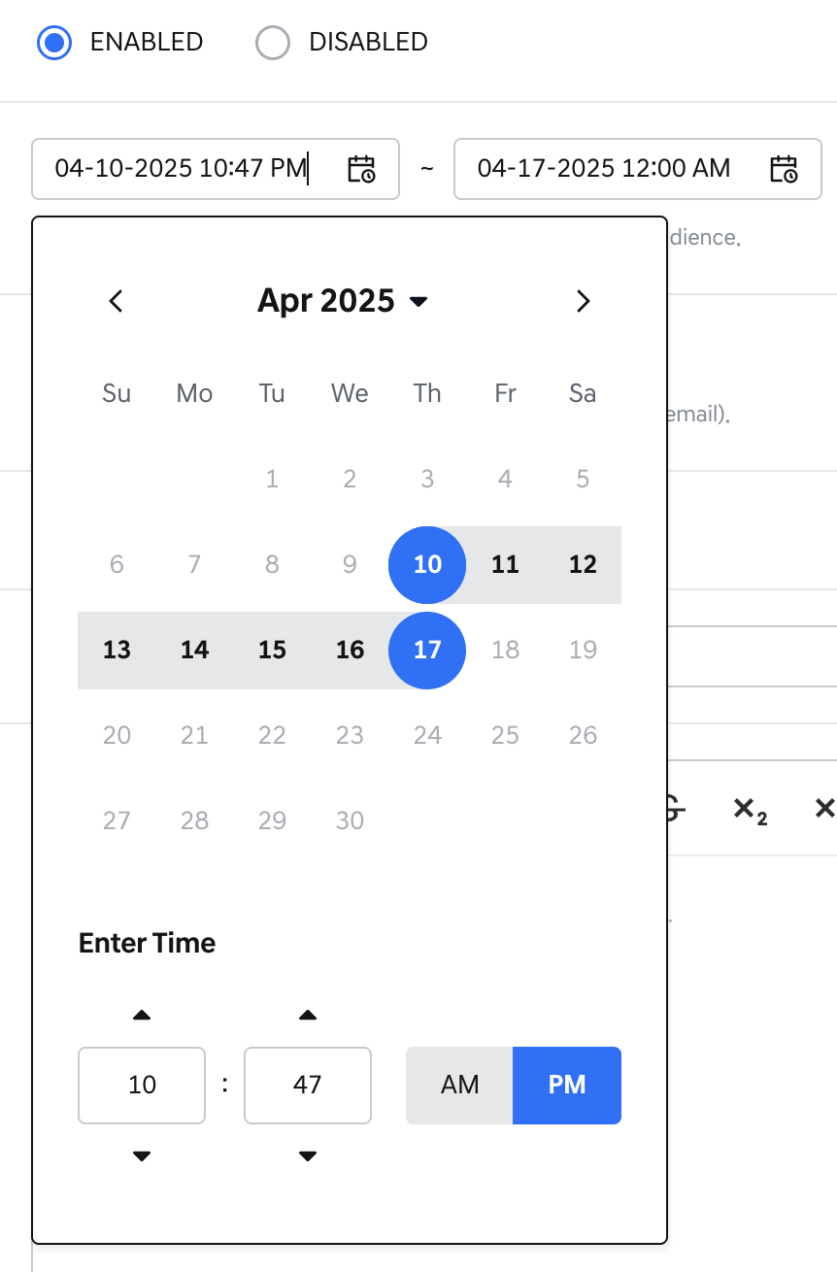
Important notice – Calendar Setting
- Notification: This is a value for setting notifications and is optional.
  - The initial setting is set to Disabled.
  - When Important Notice is turned ON, the Notification setting is automatically switched to ON, and one-time email/FO notification is sent at the posting start time.
  - When Important Notice is turned OFF, the Notification setting is also automatically turned OFF.
  - After the notification has been sent once, the Notification value remains but the control becomes read-only and can no longer be changed.
- Initial setting (Disabled)
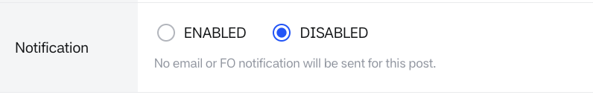
Creating Post – Notification 1
- When Enabled is set, notifications (including email) can be sent to the target audience.
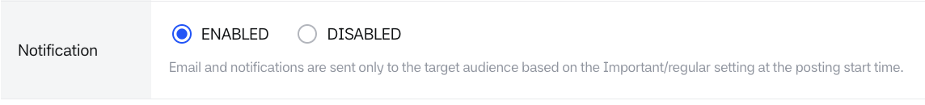
Creating Post – Notification 2
- Title/Content (Required field): You can write the title and content of the post in English/French.
- These are required input values. The initial setting displays the EN tab.
  - Title: The title is limited to 200 characters.
  - Content: The content is limited to 50,000 characters.
  - If the character limit is exceeded, input is not possible.
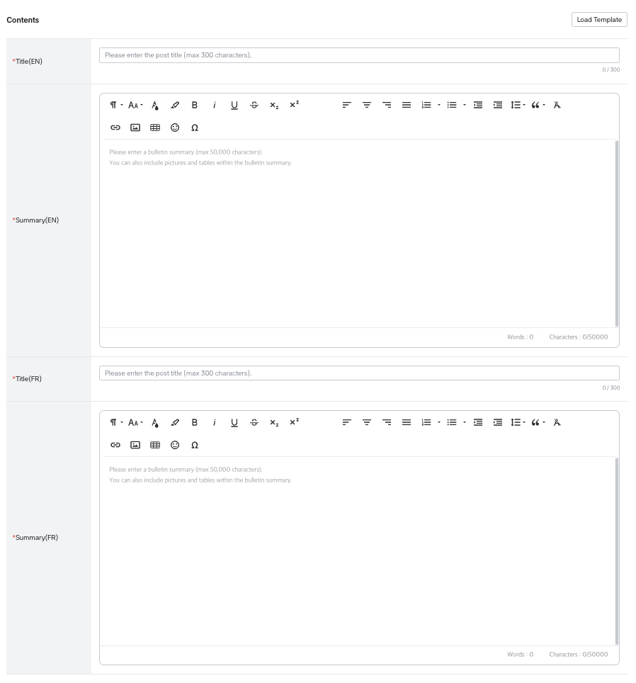
Creating Post – Title/Contents1
- You can click [Template] and select the template you want to use.
- The template’s title and content are filled in automatically in both English and French.
- If you have already entered a title or content, a confirmation pop-up asks whether to overwrite it.
- You can edit the title and content after applying a template. Changes to the post do not affect the saved template.

  - In the “Select a Template” popup, select one template with the radio button. Only templates whose Status is ON are listed.
- The Preview area on the right shows “Select a template to preview.” until a template is selected.
- Select [Apply] to apply the template, or [Cancel] (or the close icon) to close the popup. When applied, the message “The template has been successfully applied.” is displayed.
- After applying, you can freely edit the content. Settings other than Title and Summary are not changed.
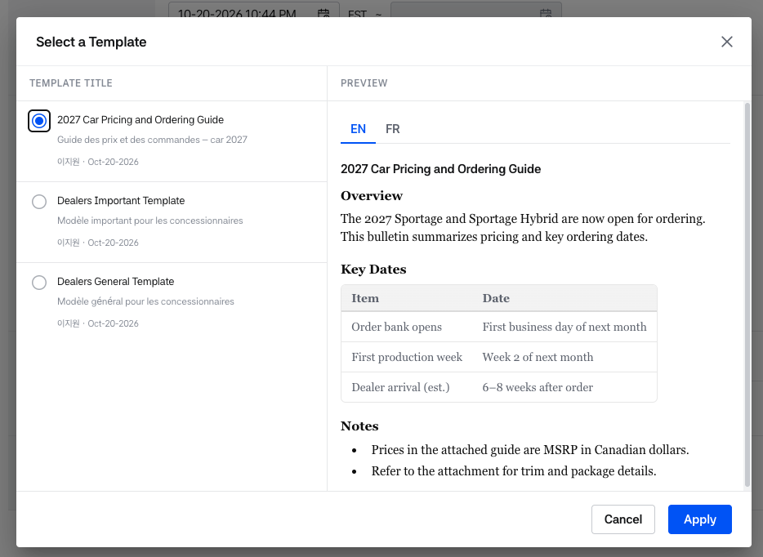
Creating Post –Contents Template
- You can use the editing tools provided by the editor tool.
Creating Post – Title/Contents2
- When writing text content, character count is possible.
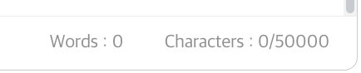
Creating Post – Title/Contents3
- Attachments: You can attach files in English/French versions.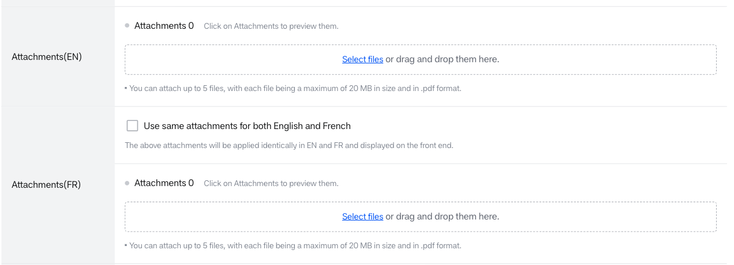
Creating Post – Attachments 1
- When Select File is clicked, a file upload window appears, and PDF format files can be attached.
- When "The same attachments (EN) will be applied" is clicked in the FR version attachment, the attachments registered in the English attachment are applied identically in the French version.
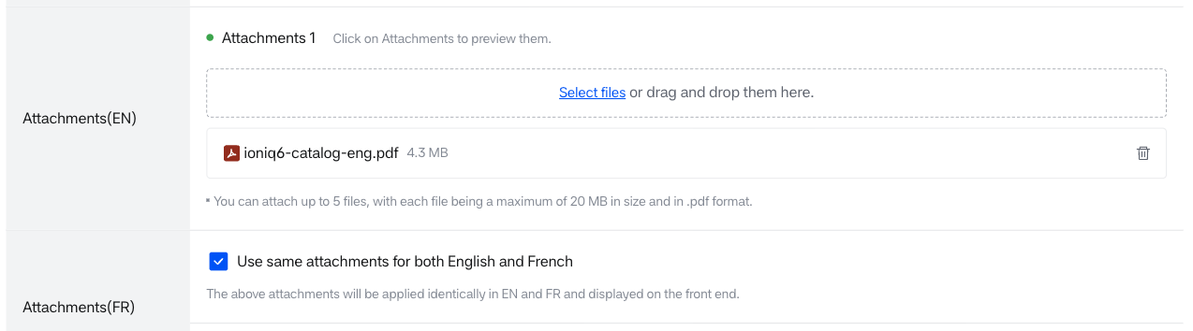
Creating Post – Attachments 2
- If a file is attached, the number of attached files is displayed at the top.
- When the file icon is clicked, preview is possible.
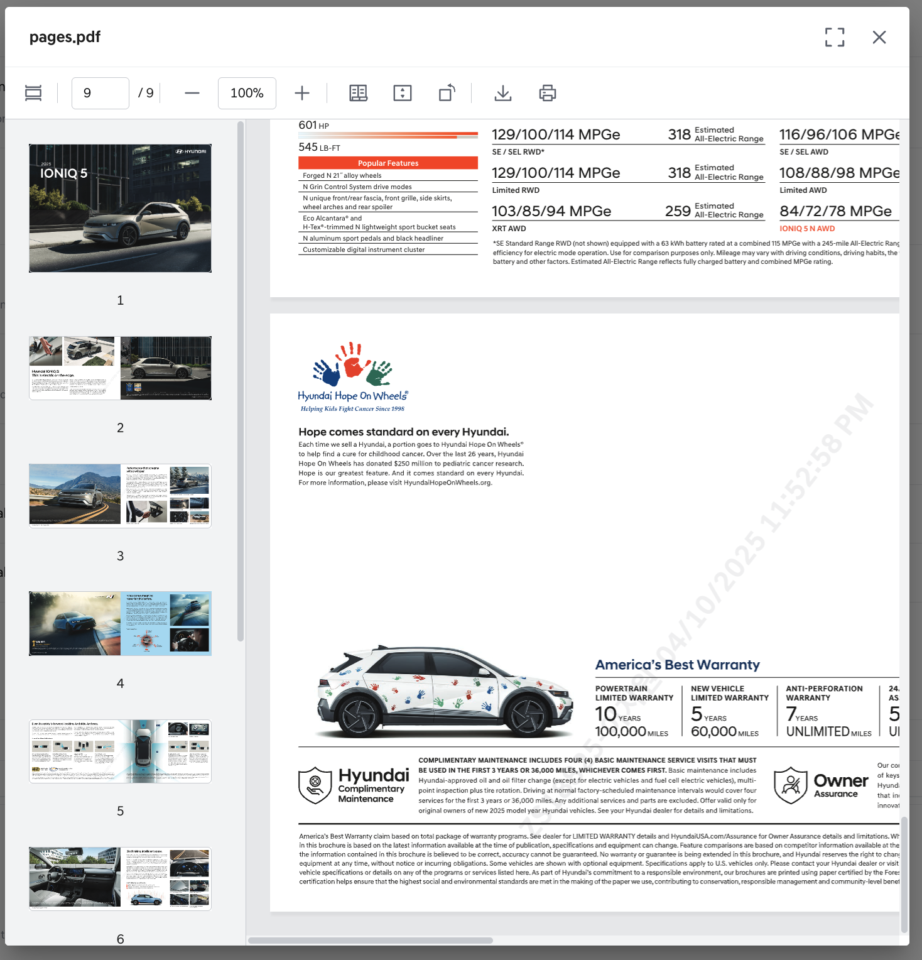
Creating Post – Attachments 2(PDF)
- Additional Attribute: If additional attribute values have been added in the bulletin board management menu, the additional attribute field name is displayed.
- The display values, Search Availability (whether searchable), and whether required values are displayed according to the display format of the additional attribute selected in the bulletin board attributes.
- There are a total of 5 display formats for additional attributes, which can be set as follows:
- Period (MM-DD-YYYY ~ MM-DD-YYYY): This display format allows period selection.
- The initial setting displays a UI for selecting period dates and is displayed with no dates entered.
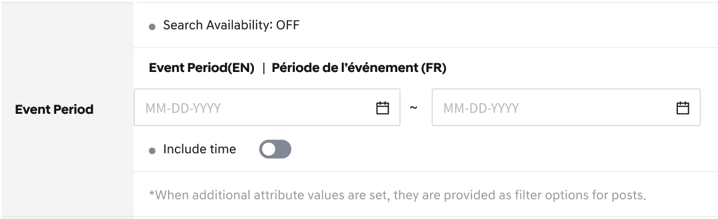
Creating Post – Additional attribute example 1-1
- When the Include time toggle is selected, you can select the period date and time.
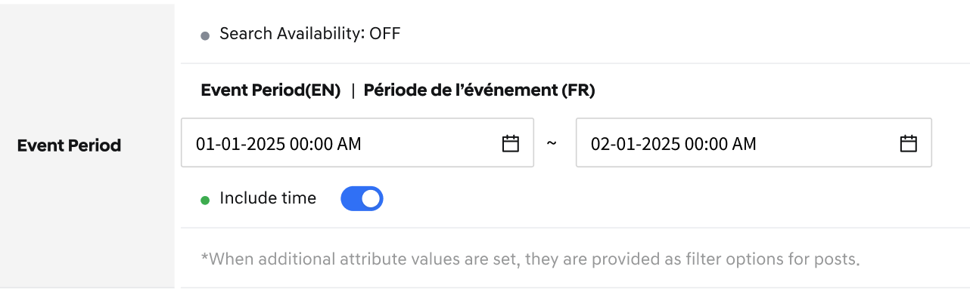
Creating Post – Additional attribute example 1-2
- Date (MM-DD-YYYY): This display format allows date selection.
  - The initial setting displays a UI for selecting period dates and is displayed with no dates entered.
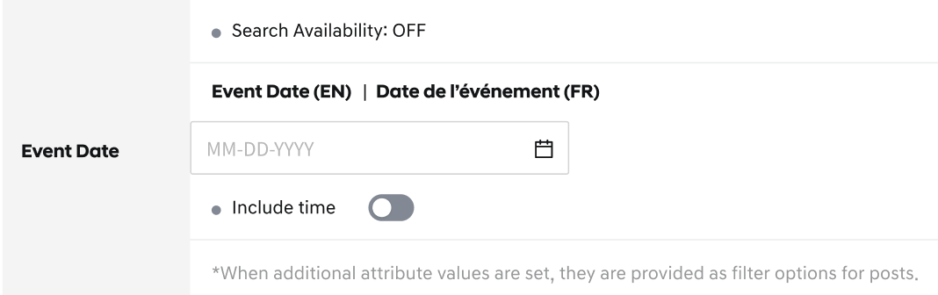
Creating Post – Additional attribute example 2-1
- When the Include time toggle is selected, you can select the date and time.
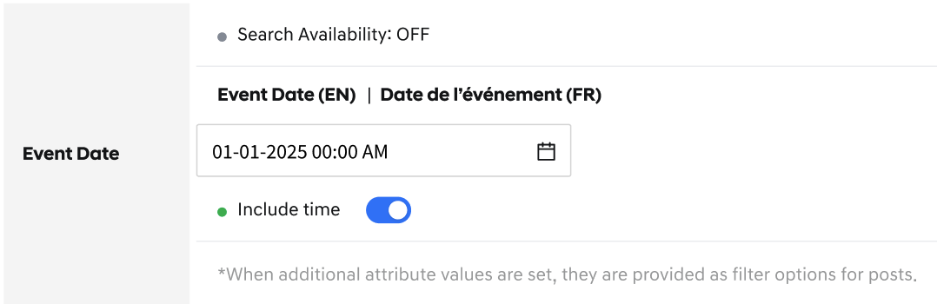
Creating Post – Additional attribute example 2-2
- Single Selection (dropdowns): A dropdown box is created.
- The display values entered in the bulletin board additional attributes are displayed in the dropdown.
- Display value search is possible, and only one value can be selected.
- When a field is marked as Required in Bulletin Board > Additional Attributes, an asterisk (*) is displayed in front of the Field Name.
- For required fields, a value must be selected in order to save the post.
- 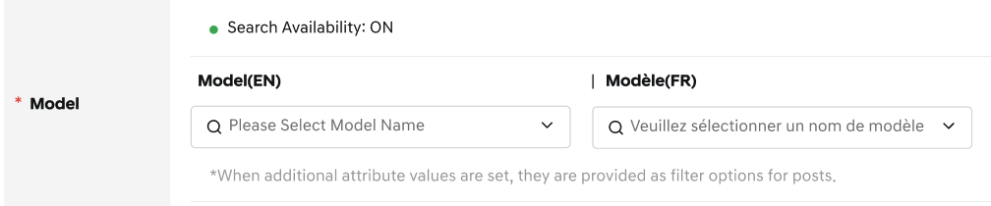
Creating Post – Additional attribute example 3-1
- Since EN items and FR items form a pair, if you select one display value, the display value of the other language is also selected simultaneously. When changing, EN corresponds.
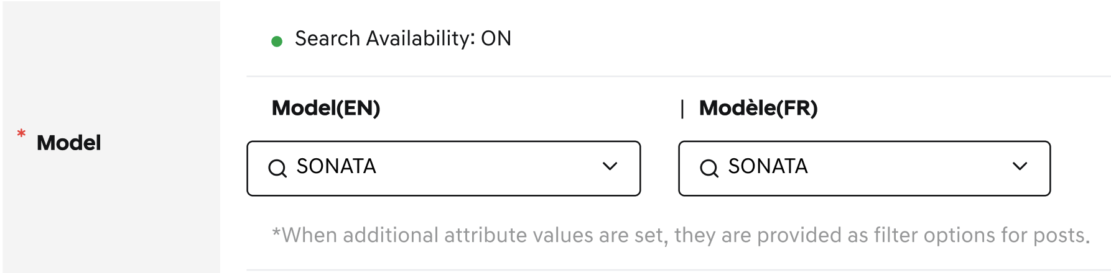
Creating Post – Additional attribute example 3-2
- Multi Selection (dropdowns): A dropdown box is displayed, showing the values entered in the bulletin board additional attributes. Detailed content search is possible, and multiple values can be selected.
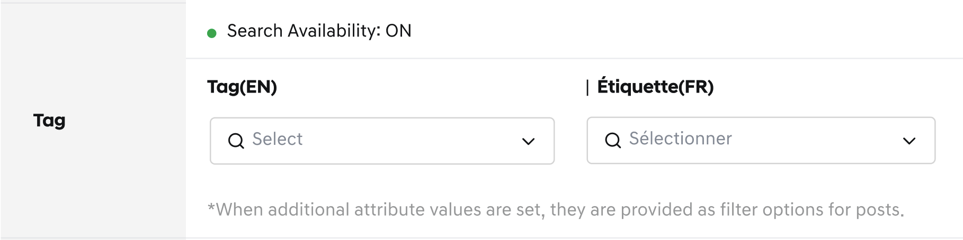
Creating Post – Additional attribute example 4-1
- When multiple display values are selected, the selected display values are displayed as chip filters, and they can be deleted by clicking the X button on the chip filter.
- Since EN and FR items form a pair, when clicking on the EN display value, the corresponding EN display value is automatically selected.
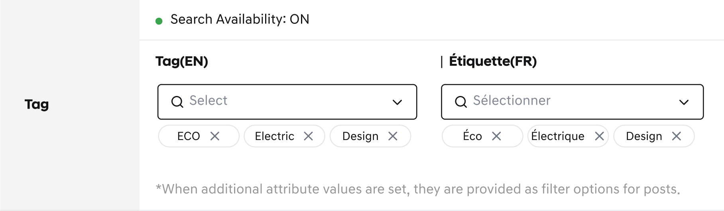
Creating Post – Additional attribute example 4-2
- Single Selection (Radio button): The display values entered in the bulletin board additional attributes are displayed in radio buttons.
  - For radio buttons, if it's an optional value, a 'None' option is additionally provided.
  - If a required value is selected, at least one option value must be selected to be saved.
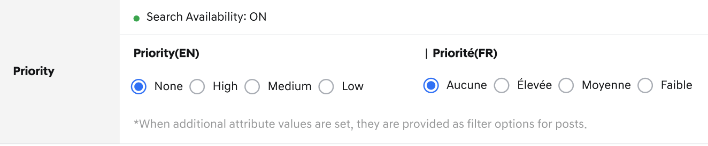
Creating Post – Additional attribute example 5-1
- Input box (text): An input box is displayed, allowing users to manually enter text. This feature is primarily used to manage official document numbers linked to attachments or to track document IDs within posts.
  - If a required value is selected, at least one option value must be entered to be saved.
  - Input character limitations:
Up to 25 characters can be entered according to the following rules:
    - Text: English and French letters (uppercase/lowercase) are allowed
    - Spaces: Not allowed
    - Numbers: 0–9
    - Special characters: Only * # ; - _ ' / ( ) . , ! are allowed
  - Duplicate input rules:
Duplicate values for the same Field Name within the same board are not allowed. However, the same value can be entered if either the Field Name or the Board is different.
When a duplicate occurs, an alert message is displayed and saving is not allowed.
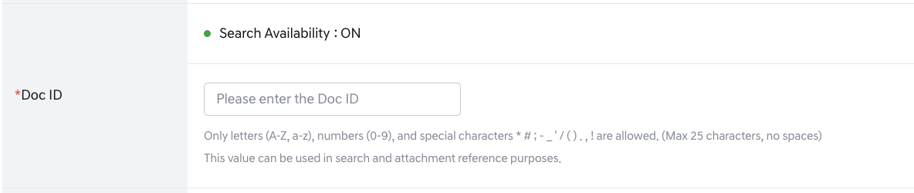
Creating Post – Additional attribute example 6-1
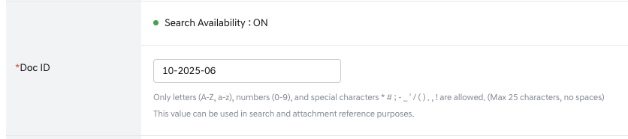
Figure 184 Creating Post – Additional attribute example 6-2
- Duplicate examples:
  - Same board + same Field Name + same value → Not allowed (e.g. (Board A) doc id = 10-10-2025 already exists → entering the same value again is not allowed.)
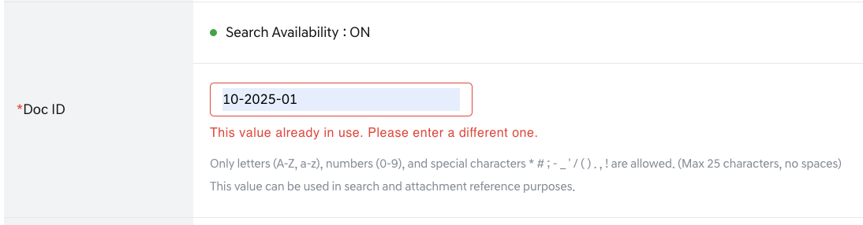
  - Same board + different Field Name → Allowed (e.g. Within the same post: doc id = 10-10-2025, no = 10-10-2025 → allowed.)
  - Different boards + same Field Name → Allowed (e.g. (Board A) doc id = 10-10-2025, (Board B) doc id = 10-10-2025 → allowed.)
- Bottom action buttons are provided
  - [Post Preview]: When clicking on post preview, a post preview screen similar to the front screen is displayed, and you can check both EN and FR versions.
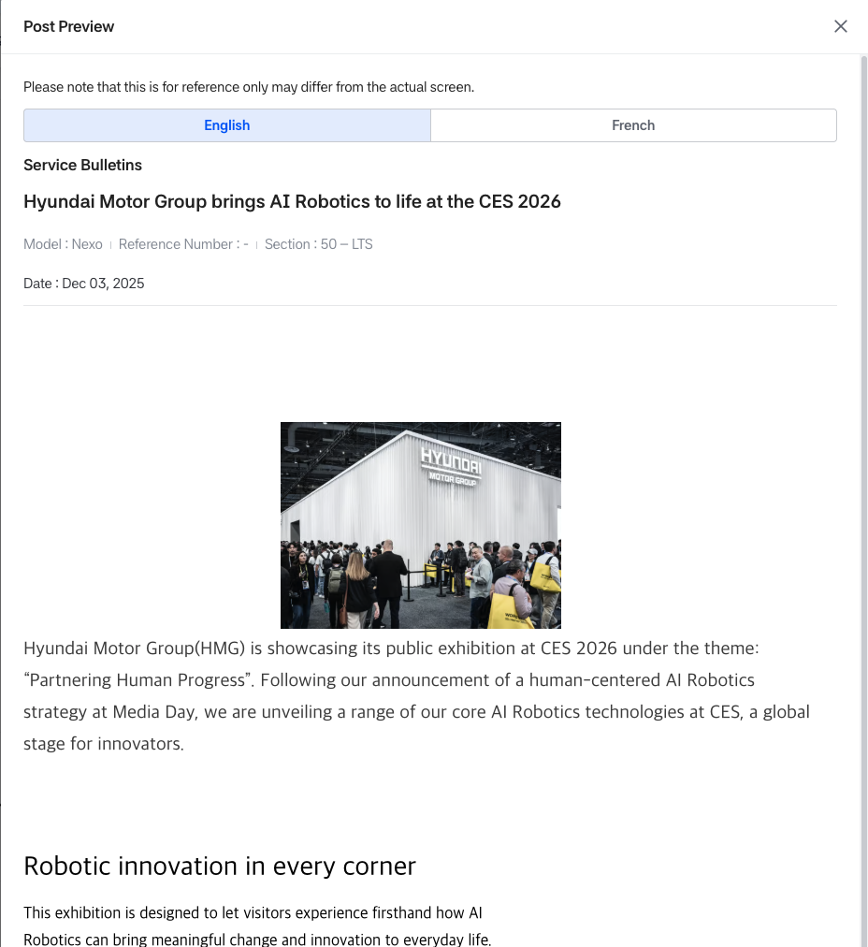
Creating Post – Post preview 1
- [Cancel]: When clicking on exit without saving the post, an alert popup is displayed.
- [Save]: When clicking on save post, it verifies validity and displays popups according to the conditions below.
- If required values are not entered, the post cannot be saved.
- If all required values are entered, the post can be saved, but guidance popups are displayed according to the attribute values of the post.
- If the important notice period is incorrectly entered, a guidance popup appears to adjust the period. The important notice period must be entered within the posting period.
- If there is no target audience, the post can be saved, but a guidance popup appears indicating that there is no target audience.
- If the posting period is set to the current time, a guidance message appears indicating that the post will be published immediately, and it is published immediately.

Post Editing
• You can edit the content of existing posts or change posting conditions.
Editing Post – post attribute information 1
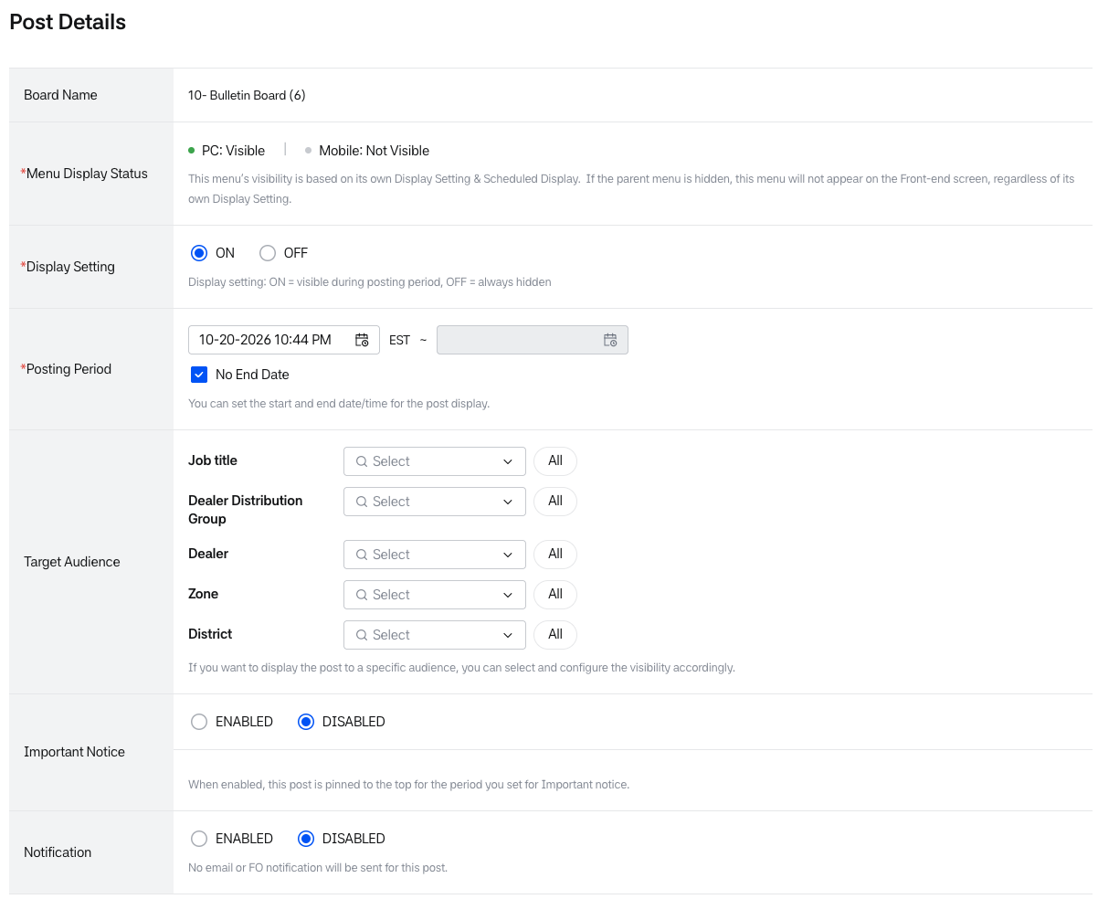
Editing Post - Basic
Editing Post - Contents
Editing Post – post attribute information 2
Editing Post – post attribute information 1
Editing Post – post attribute information3
- Menu Display Status: Shows whether the menu linked to the board is visible on the front-end screen.
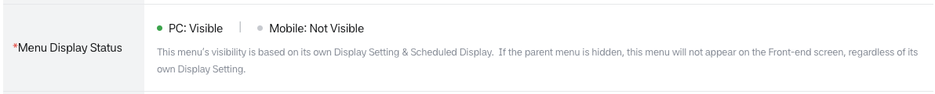
- When the tenant’s mobile web is ON, both values are shown (for example, “PC: Visible | Mobile: Not Visible”). When it is OFF, only one value (Visible / Not Visible) is shown.
• When modifying the posting period, the following policy applies: 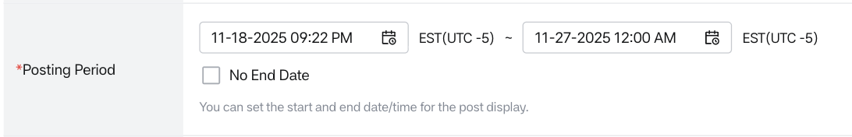
Editing Post – Posting period 1
- When the posting period is modified, it changes to the modified posting period.
- The posting start date and time cannot be modified to a past time from the current point.
- When modifying the posting period of an important notice post, the following policy applies:
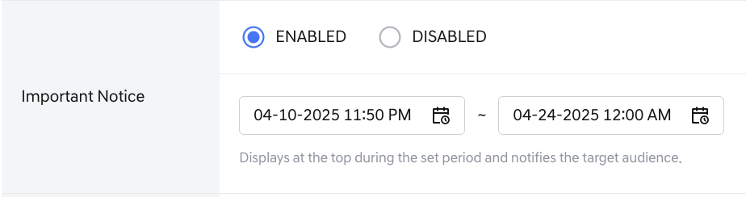
Editing Post – Important Notice 1
- When the important notice posting period is modified, it changes to the modified posting period.
- Important notice posts must be entered within the posting period. If not entered within the posting period, the important notice period cannot be saved.
- An important notice appears in the mobile home Bulletin Highlight only when the Mobile Display of its menu is Enabled. The Important Notice setting on this screen works the same way as before.
- When changing the target audience, the following policy applies:
Editing Post – Target Audience 1
- Values selected in the target audience are published under AND conditions based on the currently selected target audience.
  - Dealer distribution group: The post is targeted at dealers belonging to the current Dealer distribution group.
  - Dealer: The post is targeted at the currently selected Dealer.
  - Zone: The post is targeted at Dealers belonging to the current Zone.
  - District: The post is targeted at Dealers belonging to the District under the current Zone.
- Post attribute information is displayed
- The entered values for Title/Content (EN/FR) are displayed.
Editing Post – Contents 1
- [Load Template]: Fills the Title and Summary (EN/FR) with a saved template.
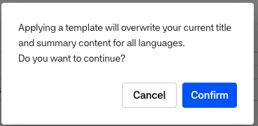
Template overwrite pop-up
- On the edit screen, a confirmation popup always appears first. Select [Confirm] to continue or [Cancel] to stop. (On the Post Details screen for a new post, this popup appears only when something has already been entered.)
- Translation banner: A banner is displayed at the top of the FR area. It contains the [EN → FR Translate] button and the notice “Clicking the left button will translate the English text entered above and display the French translation in the field below.” Only EN to FR translation is supported. The banner is displayed only to users with Write permission for creating and editing posts (it is hidden for Read-only users), and it is currently available only for tenants with two languages (EN, FR).
  - [Translate] is enabled when the Title or Summary in the EN area has any content. If both are empty, it is disabled.
  - While translating, a spinner is displayed on the button, the button is disabled, and the Title and Summary fields are read-only. They are released as soon as the translation completes or fails.
  - Title and Summary are translated together. When the translation completes, the FR area is focused automatically and the fields are replaced with the translation result. Review and edit the translated content before saving.
  - If the FR Title or Body already has content, the popup “Overwrite existing content?” is displayed with the message “The existing content will be replaced. Do you want to continue?” Select [Confirm] to overwrite the content and move the focus to the translated area, or [Cancel] to stop.
  - If only some items fail, only the successfully translated items are entered, and the toast “Partial Translation Failure” is displayed with the message “Some items failed to translate. Please check which fields are missing and try again if needed.”
  - After a failure, [Translate] is enabled again and the existing input is kept.
  - If the translated result exceeds the maximum length, it is not truncated and is entered in full. The inline warning “Translated title exceeds the maximum length (300 characters). Please edit before saving.” or “Translated summary exceeds the maximum length (50,000 characters). Please edit before saving.” is displayed below the field.
  - [Save] stays enabled when the limit is exceeded. Selecting it displays the popup “Character Limit Exceeded” with the message “The title cannot exceed 300 characters. Please check the length of the translated title and edit it.” or “The summary cannot exceed 50,000 characters. Please check the length of the translated summary and edit it.” The inline warning remains displayed.
  - If only the Title is entered in EN and the Body is empty, only the Title is translated. The existing required-field validation for the summary applies when saving.
- When attaching an image in the editor, only png, jpg, and jpeg files are allowed. For other formats, the popup “Unsupported file format. Accepted formats: png, jpg, jpeg” is displayed; select [Confirm] to return to the editing screen.
- Attachments (EN/FR):
- Attached files are displayed, and file preview and download are possible.
- When viewing, downloading, or printing a file, watermarks are included on each page
Editing Post – Attachments
- Additional Attribute displays the entered additional attribute values.
  - For required values, all are entered.
  - For optional values, they may not be entered.
  - If not entered, they are not displayed in the front post list and detail screen.
Editing Post – Additional attributes 1
- Bottom action buttons are provided.
  - [Post preview] (same as above)
  - [Cancel] (same as above)
  - [Save] (same as above)

Post View
- You can view saved posts.
- Menu Display Status: A banner at the top of the screen shows whether the menu linked to the bulletin board is visible on the Front-end screen. The Announcement board is not mapped to a menu, so the banner is not displayed.
  - If the tenant has Mobile Web enabled, PC and Mobile are each shown as Visible or Not Visible.
  - If Mobile Web is disabled, only a single value (Visible or Not Visible) is shown.
  - Visible is marked with a green dot, and Not Visible with a gray dot.
  - The fixed notice below the banner reads: “This menu’s visibility is based on its own Display Setting & Scheduled Display. If the parent menu is hidden, this menu will not appear on the Front-end screen, regardless of its own Display Setting.”
- Posts of a menu whose Mobile Display is Disabled do not appear in the Mobile Home Bulletin Highlight or the Mobile integrated search. The post view screen has no separate mobile setting.
Post Detail
- Post Status Information
Post Detail – Post status information
- Board Name: The bulletin board name (bulletin board ID) to which the post belongs is displayed.
- Post ID: When the post is saved, the post ID is displayed.
- [Copy Front-end URL]: When clicked, the Front-end URL of the post is copied to the clipboard.
  - This feature allows administrators to easily copy and share the Front-end access URL of a post.
  - The button becomes visible after the post has been saved (i.e., when the post ID is generated) and you access the post detail view.
- Post status: The posting status is displayed according to the posting period of the post.
  - Visible: Currently posted (when the current time is within the posting period), if it's currently being posted, the dot color in front of the posting status changes to green.
  - Not visible: The post is currently not visible. Awaiting posting (when the posting start date has not arrived) or Posting ended (when the current time is after the posting end date) -** Display setting**: The display setting for the post is shown.
- Post Attribute Information
Post Detail – Post Attribute information
- Posting Period: The set posting period is shown.
  - If the posting period is set to indefinite, the posting start date and time is specified and Unlimited Posting is checked.
  - If the posting end date is specified, the posting start date and time ~ posting end date and time are displayed.
- Target Audience: The target audience items are shown, and the post is published to targets that meet the AND conditions of the selected target audience. The selected option values are displayed as chip filters below.
  - If saved with the default settings, all target audience options are shown as All values.
- Important Notice: The set important notice value is displayed.
  - If the important notice setting is selected as Enabled:
    - The dot color is shown as green
    - The post has an important notice setting (icon) on the front and is displayed at the top of the post.
    - Posting periods are displayed at the top of the post with the most recent at the top.
  - If the important notice setting is selected as Disabled:
    - The dot color is shown as gray.
    - Posts without important notice settings are displayed the same as regular posts and are sorted by the most recent posting period.
- Notification: The set notification value is displayed.
  - If the notification setting is selected as Enabled:
    - The dot color is shown as green.
    - At the time the post is published, a summary email about the post is sent to the target audience.
  - If the notification setting is selected as Disabled:
    - The dot color is shown as gray.
    - No notifications or emails related to the post are sent.
- Title/Content(EN/FR): The title and content of the post entered in English/French are displayed.
  - EN/FR tabs are provided in the upper left.
  - By default, EN is displayed, showing the title and content entered in English.
  - Clicking the FR tab shows the title and content entered in French.
Post Detail – title/content
- You can attach posts and images together.
- Attachments (EN/FR): Attached PDF files are displayed, and when the attached file icon or file name is clicked, file preview is possible.
Post Detail – Attachments 1
- The total number of attached files is displayed in the upper left of the file, and the file size and download button are displayed to the right of the attached file.
Post Detail – Attachments 2
- When the file icon and file name are clicked, a file preview popup is displayed, and watermarks are displayed on each page of the PDF file.
Post Detail – Attachments preview pop-up
- The file name and extension are displayed in the upper left of the popup window, and the full-screen view button and close button can be clicked in the upper right.
Post Detail – Attachments preview pop-up1
- Clicking on icons from the left operates as follows:
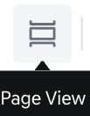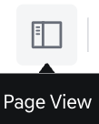
Post Detail – Attachments preview pop-up2 - View settings: Thumbnail preview view setting/Normal page view setting
- View current page number/total page number, possible to view page by entering desired page number
- File ratio input and -/+ button click to zoom in and out of file (minimum 50%, maximum 150%)
- Two-page view/One-page view setting possible
- Page height fit/Page width fit view setting possible

- Page rotation: 90 degrees rotation to the left
- When the download button is clicked, it moves to the PDF file download page, and the file with watermark can be downloaded
  - When the print button is clicked, the print settings page is displayed, and the file with watermark can be printed
  - Additional Attribute: You can view the entered additional attribute values.
  - The right column displays the additional attribute field names according to the user's language settings.
  - You can check whether each additional attribute item is searchable.
  - If the Search Availability value is ON, the Dot is displayed in green. The search filter for that additional attribute is displayed in the front post list search area.
  - If the Search Availability value is OFF, the Dot is displayed in gray and the search filter is not displayed.
Post Detail – Attachments preview pop-up
- If the additional attribute value is period or date selection, the selected period and date are shown.
- If the additional attribute value is single selection, one display value each for EN and FR is shown.
- If the additional attribute value is multiple selection, the selected display values are shown separately for EN and FR.
- Change History: The post change history is shown.
  - All modifications due to changes in status values and attribute values within the post are recorded in the change history.
  - Status value and attribute value change records:
- Posting status information: Awaiting posting, Currently posted, Posting ended
- Posting attribute information: Target audience, Posting period, Important notice setting, Notification sending setting, Title (EN, FR), Content (EN, FR)
- Attachments: EN, FR
- Additional attributes
- If there are 5 or more records, right scroll is displayed
- Table columns
  - Change Date: Updated date
  - Change Info: Area and item name where the change information occurred
  - Change Details: Displays detailed content of values before/after change
  - User ID: Displays the name and User ID (employee number) of the user who performed the action
    - Auto Status Update: If automatically changed by the system due to set time or trigger, it is marked as 'Auto Status Update'
Post Detail – Change history
- Comments: Comments on the post are viewed.
Post Detail – Comments 1
- Name, employee number, and author display are shown, and when you write a comment and click the Save button, the comment is registered.
- When a comment is registered, the total number of comments is displayed to the right of the Comments title.
- For comments you wrote yourself, a more options display appears on the right, and when clicked, you can edit and delete the comment.
- Bottom action buttons are provided.
- [View List]: Move to list
- [Delete]: The delete button is only displayed for posts that have never been published, and when the button is clicked, permissions are verified and deletion is only possible if you have permission to write posts.
  - Deletion is only possible if you have permission
- [Edit]: After checking if you have permission to modify the post at the time of clicking, if you have permission, you enter the modification screen.

11. Weekly Bulletin Summary Email Management
Bulletin Summary Email Management
- This feature allows you to generate post summaries for each bulletin created in the BO system and send them via email.
- Bulletin summaries can be created either on a weekly basis or for a specific date range.
- Users with Write permission can generate bulletin summaries.
- Users with Read permission can view the generated summaries.
Weekly Bulletin Summary Email List

Bulletin Summary Settings
- This feature allows you to configure settings for both Auto Summary and Manual Summary.
- The Manual Summary section is only visible to users with the appropriate permissions.
Weekly Bulletin Summary Email List - Settings
- Auto Summary (Weekly):
This feature automatically sends a weekly bulletin summary email to designated recipients.
When you click [Set Schedule], a Set Schedule pop-up will appear, allowing you to modify the Auto Summary schedule and Email address.
Weekly Bulletin Summary Email List – Auto summary
- By default, the Weekly Bulletin Summary is generated every Monday at 8:00 AM.
Each summary includes posts from the previous Monday at 00:00 to Sunday at 11:59 PM.
- If the delivery day is changed in the Set Schedule pop-up, the updated schedule will take effect starting the following day (i.e., the new schedule becomes active from the next day).
- New Scheduled Date: Displays the next scheduled summary date based on the updated setting.
- To Email address: You can enter one or more recipient email addresses.
Based on the entered addresses, the bulletin summary email is automatically sent on a weekly basis.
  - When entering multiple email addresses, use a semicolon (;) to separate each address.
  - The email address must include **@** and follow a valid format.
If any address is invalid, sending will be blocked and an error alert will be shown.
  - A maximum of 10 email addresses can be entered.
Once 10 addresses have been entered, further semicolon inputs will be disabled.
Weekly Bulletin Summary Email List – Auto summary Set schedule 1
- The currently selected schedule day is displayed, and the delivery schedule can be changed to any day from Monday to Sunday.
Weekly Bulletin Summary Email List – Auto summary Set schedule 2
- Manual Summary: You can generate a Bulletin Summary by selecting a date range of up to 7 days.
  - After selecting the period and clicking [Generate], the Bulletin Summary Email pop-up will appear if the selected range passes validation.
  - When selecting the start and end dates, the total number of posts within the selected period will be displayed.
  - If the selected range does not meet the validation criteria, the summary cannot be generated.
- (Default): The start and end dates are automatically set to a 3-day range, ending one day before today (Start Date = today - 4 days, End Date = yesterday).
- The Start Date and End Date can be selected independently of each other.
  - When you change the Start Date, the End Date is automatically set to Start Date + 3 days. If that date is today or later, the End Date is set to yesterday.
  - When you change the End Date, the Start Date does not change.
The End Date cannot be earlier than the Start Date, and it must be within 7 days of the Start Date and before today (up to Start Date + 6 days).
  - If the Start Date is yesterday, the End Date is fixed to yesterday (only 1 day can be selected).
  - If you try to select a range that exceeds 7 days, a pop-up is displayed. When you click [Confirm], the dates are reset to the default.
Date Range Conditions:
- Today’s date cannot be selected — only past dates are allowed. Today and future dates are disabled in the calendar, so the latest selectable End Date is yesterday.
- You can select a range of up to 7 days in the past.
- Future dates are not allowed, including today, to prevent exceptions.
Weekly Bulletin Summary Email List – Manual summary Data range 1
[Generate] Button Activation Conditions
- If the total number of posts within the selected date range is 100 or more, or zero, an alert message will be displayed and the [Generate] button will be disabled.
Weekly Bulletin Summary Email List – Manual summary Data range 2
- Email Send Settings: Only users with Write permission can send emails.
Email Input Rules
- When entering multiple email addresses, use a semicolon (;) to separate each address.
- The email address must include **@** and follow a valid format.
If any address is invalid, sending will be blocked and an error alert will be shown.
- A maximum of 10 email addresses can be entered.
Once 10 addresses have been entered, further semicolon inputs will be disabled.
Weekly Bulletin Summary Email List – Email send setting 1
- For users with Read permission, only the Bulletin Summary content area is displayed.
Weekly Bulletin Summary Email List – Email send setting 2

Bulletin Summary List View
- Total Count: Displays the total number of Bulletin Summaries.
- Bulletin Summary Subject:
Displays the subject of each summary.
You can distinguish whether the summary is Weekly or Target-based, and identify the posting period it covers.
Clicking the subject opens the Bulletin Summary Email pop-up, where the summary content can be viewed in English (EN) and French (FR).
- Target Posting Period (EST):
Shows the date range that the bulletin summary covers.
- Created Date (EST):
Displays the time the bulletin summary was generated.
- Email:
Clicking the [Send] button opens the Bulletin Summary Email pop-up, where the summary content can be viewed in English (EN) and French (FR).
Bulletin summary list

12. Dealer User Change History
Dealer User change history
- The Dealer User Change History screen provides a centralized audit log for tracking all changes made to dealer employee information and permissions.
- All change history records are automatically retained for a defined period and then permanently deleted. The retention period depends on the type of change:
  - User information changes (e.g., creating, updating, or deleting employee profiles) are kept for 1 year from the date of the change.
  - Permission-related changes (e.g., granting, modifying, or revoking roles and access rights) are kept for 5 years from the date of the change. This also includes any changes to user status or permission status.
- When the screen is first opened, only the search area is displayed. The result table is shown only after a search is executed.
- A guidance message is displayed before the first search: "Please set the search conditions to proceed."
Search Area
- Multiple conditions are combined with AND logic.
- Updated By (ID)
  - Search by the ID of the user who created or updated the employee information.
  - Front Office changes display the ID; Back Office changes display the HMG SSO ID.
- Updated By (Name)
  - Search by the name of the user who created or updated the employee information.
- Search (Keyword)
  - Search by keyword with partial match applied.
  - Available target fields: Name (default), ID, User No, Dealer
- Dealer
  - Search by the dealer of the target employee.
- Zone / District
  - Zone and District can be selected.
- Updated Information
  - Search by the employee information field where the change occurred.
- Change Source
  - Search by the screen where the change occurred.
  - Fixed values: Employee management / Job Management / Menu Management.
- Change Type
  - Search by the type of change. Multiple selections allowed.
  - Available values: Creation / Modification / Deletion / Activation / Deactivation.
- Updated Date
  - Search by change date in EST. Maximum period: 6 months.
  - Default start date: current date – 1 day.
- Buttons
  - Reset: Clears all search conditions.
  - Search: Executes the search.
Result Area
Result Area
- Total record count, sort order, records per page, and pagination are displayed above the result table.
- Default sort: Updated date, latest first.
- The table displays one row per field-level change. When multiple fields are updated simultaneously, a separate row is generated per field.
- Table Columns
  - Updated By (ID): HMG Partner ID (Front Office) or HMG SSO ID (Back Office).
  - Updated By (Name): {First name}{Last name} (Front Office) or HMG SSO registered name (Back Office).
  - User No.: Employee number assigned by the dealer.
  - ID: ID of the target employee.
  - Name: First name Last name.
  - Dealer: Dealer Name
  - Zone / District: Zone and District of the dealer.
  - Change Source: Employee management / Job Management / Menu Management.
  - Change Type: Creation / Modification / Deletion / Activation / Deactivation.
    - When a Job is activated or deactivated, the detailed permissions of that Job use the same Change Type.
    - Permission removal or input value removal is treated as Modification.
    - When Dealer Admin / Dealer Principal automatically receive menu access, Change Source is displayed as Employee management.
  - Before Change / After Change: Value before and after the change. Displayed as a hyphen (-) if no value exists.
    - Individual menu permissions are displayed as $Permission name$-$Menu name$.
    - Job names are displayed as hyperlinks. Clicking opens the Job detail screen in a new tab. If the user lacks view permission, a "no permission" message is shown.
  - Updated Date (EST): MM-DD-YYYY HH:MM (e.g., Aug-19-2026 23:10).

13. Dealer Employee Troubleshooting
- The Dealer Employee Troubleshooting screen is a Back Office tool for head office operators.
- It helps operators quickly diagnose why a specific dealer employee:
- cannot log in to the system, or
- cannot see a specific menu or post on the Front Office.
- The screen provides real-time status based on the current database and allows operators to open related management screens to correct settings without IT support.
Dealer Employee TroubleShooting
Dealer Employee Troubleshooting
Dealer User Status Search
- At the top of the screen, the Dealer User Status area is displayed.
- Operators must first specify which dealer and which user they want to diagnose.
- Search fields:
  - Dealer Name (required): Select the dealer to which the user belongs using a dropdown or auto-complete search.
  - ID (required): Enter the ID of the specific dealer employee.
- When the screen is first opened, only the search area and the Search button are displayed. Until a user is specified, the guide message “Please select a dealer and a user to check the dealer user status.” is shown and the Content Status area is hidden.
- The Search button becomes active only when both Dealer Name and ID are entered.
Dealer User Status
- When Search is clicked: The system validates that the entered Dealer Name and ID combination exists.
- If the ID does not belong to the selected dealer, the help text “No search result. Please enter the exact ID” is displayed before the diagnosis runs.
- If the user is found, the User Status Summary table is displayed and the Content Status search area below is reset.
- After a search, the Reset button is displayed. Clicking Reset clears both the top and bottom areas, and the Reset button disappears.
User Status Summary
- The User Status Summary table displays the basic login-related status of the dealer employee.
- Main items:
  - User No: Dealer employee number and account status (Active / Inactive)
    - Linked to the Dealer Employee Management detail screen.
  - ID: The user’s ID
    - The ID status is not displayed.
    - No link is provided.
  - Dealer Info: Dealer No, Dealer Name, and dealer status
    - Status: Active / Under termination / Terminated / Inactive
    - Linked to the Dealer Management detail screen.
  - Job Title: Job title assigned to the user and its status
    - Status: Active / Inactive
    - Linked to the Job Management detail screen.
- Tag color:
  - Green: Login possible.
  - Gray: Login not possible.
- Login is possible when User is Active, Dealer is Active or Under termination, and Job Title is Active. Login is not possible when the Dealer is Terminated or Inactive, the User is Inactive, or the Job Title is Inactive.
- Related error codes: AUTH_404_002 (user or dealer inactive), AUTH_403_005 (Job inactive), COMMON_500 (other external issues).
- The Checked Date (MM-DD-YYYY HH:MM zzz) is displayed to show when the user status was retrieved. It shows the server response time.
- Deep links buttons:
  - For each row, a [Go to Setting] button is displayed only if the operator has read permission or higher for the target management screen.
  - When clicked:
    - If the operator has permission, the corresponding detail screen (Dealer Employee / Dealer / Job) opens in a new tab.
    - If the operator has no permission, an Access Denied error screen is displayed.
- Login availability:
  - If User, Dealer, and Job Title are all in a login-available state, the dealer employee is treated as able to log in, and the Content Status area becomes enabled.
  - If any of these is in a login-not-available state, the dealer employee is treated as unable to log in, and the Content Status search area is disabled with a guidance message.
Content Status
- The Content Status area is used to diagnose whether specific menus and posts are visible for the selected dealer employee.
- This area is available only when the Dealer User Status is in a login-available state.
- Guide message: “Please search by menu or Post ID to diagnose the content status.”
- Search type:
  - Menu (default)
  - Post
- Search conditions:
  - When Menu is selected: Menu Name (Required / Auto-complete)
    - All menu types can be selected: General, Bulletin board, Outlink.
    - Menu items are displayed in newest-created order.
    - Display format examples:
    - Sales board(12345) → bulletin board menu (Board ID displayed)
    - Sales → General menu (no Board ID)
    - Incentive Board → Outlink menu
  - When Post is selected: Post ID (Input)
    - Used when diagnosing visibility of a specific post.
- Buttons:
  - [Search]:
    - Executes diagnosis for the selected dealer user and the specified Menu or Post.
    - A loading indicator is displayed on the button while the diagnosis is running.
  - [Reset]:
    - Clears the current search conditions and diagnostic result, and returns the Content Status area to the default state.
Dealer Employee Troubleshooting – Content Status(menu)
Dealer Employee Troubleshooting – Content Status(post)
Diagnostic Result
- After search, the Diagnostic Result (Content Status Summary) table is displayed.
- Common columns:
  - Step: Step number (varies by menu depth and post location).
  - Check Item: Item being validated at each step (e.g. parent menu display status, menu access permission, post schedule, etc.).
  - Result: Success / Fail.
  - Details:
    - Displays a [Go to Setting] button when the operator has permission to open the related BO setting screen in a new tab.
  - Checked Date:
    - The date and time (MM-DD-YYYY HH:MM zzz) when the diagnosis result was retrieved.
- Typical checks when diagnosing a menu:
  - Parent menu display status (conditional)
  - Menu display status
  - Menu access permission (Job Title-based)
  - Menu–board mapping (for bulletin board type menus)
- Typical checks when diagnosing a post:
  - Menu-related checks (if the post is linked to a menu)
  - Post display status (Display ON/OFF, posting period)
  - Post Target Audience matching:
    - Compares Job Title, Dealer, Dealer Distribution Group, Zone, and District with the post’s targeting conditions.
- [Go to Setting] behavior:
  - Menu-related steps: open the Menu Management detail or access-permission screen.
  - Board-related steps: open the Bulletin Board Management detail screen.
  - Post-related steps: open the Post Management detail screen.
  - After changes are made, operators can return to the Troubleshooting screen and click Search again to confirm that the Result changes to Success.
Cases Where Diagnosis Is Not Available
- In the following cases, the Content Status search area is disabled and only a guide message is shown.
- User cannot log in
  - Reason: User, Dealer, or Job Title status prevents login.
  - Message: “Please check the dealer user’s Access Status. The current Dealer User Status does not allow for system login”
- User is Super Admin
  - Reason: Super Admins may have exception-based access to all menus and posts, so detailed condition checks in Content Status are not meaningful.
  - Message: “Detailed diagnostic is not available for Super Admin users. Super Admins can access all posts due to administrative privilege exceptions.”
- Other external errors (e.g. COMMON_500)
  - Reason: External system errors prevent status/permissions from being retrieved correctly.
  - Message: “Something Went Wrong … contact your system administrator.”
Content Status Not Visible Case

14. Bulletin Post Report
Bulletin Post Report Screen
- The Bulletin Post Report screen is a Back Office report tool that allows operators to verify whether a specific post (important notice / training / announcement-type content) was read by its target audience.
- It helps operators:
  - check the read rate for a single post,
  - I dentify unread users, and
  - use the result for follow-up communication (e.g., reminders) and operational monitoring.
Content Info (Search / Post Status)
- Operators must search by Post ID to generate the report.
- Search field:
  - Post ID (Required / Input)
- [Search] button is enabled after 1 character is entered. Clicking it retrieves post info and resets the User Report section.
- Validation / empty state:
  - If an invalid Post ID is entered, a help message is displayed and no result is shown.
Bulletin Post Report screen- search
Content Info (Result Details)
- After a successful search, the Content Info table displays key post information and exposure status:
  - Menu Status: Indicates if the menu (including parent menus) is visible on FO.
  - Bulletin board name
  - Post ID / Post Name
  - Posting period: Displayed in the tenant time zone.
  - Post Status: Indicates if the post is visible based on Display setting and Posting period.
  - View Rate (%): Real-time calculated rate ((Read count / Total target users) × 100). If Total target users = 0, displays N/A.
  - Checked Date: Timestamp (UTC) when the result was retrieved.
  - Deep Link Operator Navigation): In Content Info, related items (Menu, Board, Post) provide [Go to Setting] deep links to their respective management screens.
  - If the operator has read permission or higher, the detail screen opens in a new tab.
  - If no permission, an Access Denied screen is shown.
Bulletin Post Report screen- content info
User Report (User List for the Selected Post)
- Displays the user list for the selected post.
  - 1 row = 1 ID (unique user).
  - Read status is determined per user: if a user read the post in any affiliated dealership context, they are marked as Read = Yes.
  - Default sorting: Dealer No ascending, then Partner ID ascending.
  - Pagination follows BO common components.
- Filters
  - Filters apply within the selected post's user list.
  - Filter fields: Dealer Name, ID, Read Status (All/Read/Unread), Zone, District (enabled after Zone selection).
  - [Search] applies filters; [Reset] restores defaults.
Bulletin Report-User Filter
- Multi-Dealership Display
  - For users with multiple dealerships, the User Report shows only one representative dealership in the list, based on the current filter context.
  - If a user has additional affiliations, it is summarized as and (n) more, and a modal/popup can be opened to view the full list (sorted by Dealer No ascending).
User Report
Bulletin Post Report screen- multi-dealership modal
- No-result/ Error Handing
  - In the following cases, the User report area is disabled and only a guide message is shown.
    - If filter result is 0
    - If data loading fails
No result case example

15. HMG-Notice (Notifications, Terms of Use, and FAQ)
- Notifications, Terms of Use, and FAQ are managed in hmg notice provided by HMG ADMIN.
- For more details, please refer to the HMG Admin Guide.
FAQ
- FAQ Management: This is a menu for creating content that appears on the FAQ screen of the front screen.
- The content will be displayed in a new tab when the user clicks FAQ at the bottom of the Dealers FO page.
Terms Management
- When the Terms of Service, Privacy Policy, and Cookie Policy are created, the content will be displayed on the Dealers site.
- When displayed, the service header and footer will not be shown on those pages.
- Remarks
HMG Notice -Terms creation
- Page Title: Provided as the main title on the Dealers' terms of use screen.
- Title: Title value Displayed in the admin list and provided as a subtitle for content on the Dealers' terms of use screen.
- Content written in the editor body is displayed as content on the front screen.
Privacy Policy Screen

